# Analytical model

In this chapter, we formulate the analytical models for the considered system, which involves prioritizing packets into two categories: high priority (HP) and low priority (LP). These packets adhere to a first-come, first-served (FCFS) queuing discipline within their respective priority levels. We examine two priority policies: delay priority and loss priority.

Under the delay priority policy, a non-preemptive approach is adopted. This means that HP packets are always queued ahead of LP packets, yet they cannot interrupt the service of any LP packet currently being served. Conversely, the loss priority policy operates such that once the cumulative number of HP and LP packets in the system surpasses a certain threshold, only HP packets are accepted into the system, while LP packets are blocked.

The arrivals of HP and LP packets follow Poisson processes with arrival rates $λ_{H}$ and $λ_{L}$, respectively. The system's queue size, denoted by $N$ N, imposes a limit. If the number of packets in the queue reaches this size, incoming packets are rejected. Furthermore, the impatient limits of HP and LP packets waiting in the queue are exponentially distributed with impatient rates $β_{1}$ and $β_{2}$, respectively.

The system architecture comprises three splits: stand-by (split 0), split 1, and split 2, as shown in Figure 3.1. Once a packet enters the stand-by split, it cannot exit the system directly; rather, it must transition to split 1 or split 2 for departure. Split 1 and split 2 operate at service rates $μ_{1}$ and $μ_{2}$, respectively. When transitioning from split 0 to split 1 or split 2, the switching rate is $α_{1}$ ε and $α_{2}$ ε, respectively. Conversely, splits 1 and 2 can transition back to split 0 at the rate denoted by γ. The duration of each split follows an exponential distribution.

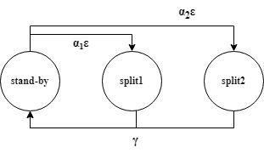

Figure 3‑1 Switches between functional splits

## Scenario 1

In this scenario, our attention is directed towards the delay priority setup. Here, high priority (HP) packets are given precedence over low priority (LP) packets in the queue, yet ongoing service to LP packets cannot be disrupted. Within each priority level, packets are served on a first-come, first-served (FCFS) basis.

### State balance equations

The system under consideration is described as a four-dimensional Markov chain denoted by $\left(i,j,k,l\right),$ where $i$ denotes the number of high-priority (HP) packets in the system, $j$ denotes the number of low-priority (LP) packets in the system, $k$ indicates the occupancy status of the server, distinguishing between idle ( $k$ = 0), serving an HP packet ( $k$ = 1), and serving an LP packet ( $k$ = 2), $l$ represents the current split the system occupies. The steady-state probability of the system is represented as $π_{(i,j,k,l)}$. This state space is defined accordingly:

$$S=\left\{\left(i,j,k,l\right)|0≤i+j≤N,0≤k≤2, 0≤l≤2\right\}$$

where the total number of feasible states is:

$$\left|S\right|=3N\left(N+1\right)+3$$

As per the model, the states of the system are categorized into 45 distinct cases. The corresponding equations representing the balance of states are as follows:

**Case 1**: For $i=0, j=0, k=0, and l=0$

$$\left(λ_{H}+λ_{L}+α_{1}ε+α_{2}ε\right)π_{\left(0,0,0,0\right)}=γ\left(π_{\left(0,0,0,1\right)}+π_{\left(0,0,0,2\right)}\right)$$

**Case 2:** For $i=1, j=0, k=1, and l=0$

$$\left(λ_{H}+λ_{L}+α_{1}ε+α_{2}ε\right)π_{\left(1,0,1,0\right)}=γ\left(π_{\left(1,0,1,1\right)}+π_{\left(1,0,1,2\right)}\right)+λ_{H}π_{\left(0,0,0,0\right)}+$$

$$β_{1}π_{\left(2,0,1,0\right)}+β_{2}π_{\left(1,1,1,0\right)}$$

**Case 3:** For $i=1, 0<j<N-1, k=1, and l=0$

$\left(λ_{H}+λ_{L}+α_{1}ε+α_{2}ε+β_{2}j\right)π_{\left(1,j,1,0\right)}=γ\left(π_{\left(1,j,1,1\right)}+π_{\left(1,j,1,2\right)}\right)+λ_{L}π_{\left(1,j-1,1,0\right)}+β_{1}π_{\left(2,j,1,0\right)}+β_{2}(j+1)π_{\left(1,j+1,1,0\right)}$

**Case 4:** For $i=1, j=N-1, k=1, and l=0$

$\left(α_{1}ε+ α_{2}ε+β_{2}j\right)π_{\left(1,j,1,0\right)}=γ\left(π_{\left(1,j,1,1\right)}+π_{\left(1,j,1,2\right)}\right)+λ_{L}π_{\left(1,j-1,1,0\right)}$

**Case 5:** For $1<i<N, j=0, k=1, and l=0$

$\left(λ_{H}+λ_{L}+α_{1}ε+ α_{2}ε+β_{1}(i-1)\right)π_{\left(i,0,1,0\right)}=γ\left(π_{\left(i,0,1,1\right)}+π_{\left(i,0,1,2\right)}\right)+λ_{H}π_{\left(i-1,0,1,0\right)}$ + $β_{1}iπ_{\left(i+1,0,1,0\right)}$ + $β_{2}π_{\left(i,1,1,0\right)}$

**Case 6:** For $1<i<N, 0<j<N-i, k=1, and l=0$

$\left(λ_{H}+λ_{L}+α_{1}ε+ α_{2}ε+β_{1}\left(i-1\right)+β_{2}j\right)π_{\left(i,j,1,0\right)}=γ\left(π_{\left(i,j,1,1\right)}+π_{\left(i,j,1,2\right)}\right)+λ_{H}π_{\left(i-1,j,1,0\right)}+λ_{L}π_{\left(i,j-1,1,0\right)}$ + $β_{1}iπ_{\left(i+1,j,1,0\right)}$ + $β_{2}π_{\left(i,j+1,1,0\right)}$

**Case 7:** For $1<i<N, j=N-i, k=1, and l=0$

$\left(α_{1}ε+ α_{2}ε+β_{1}\left(i-1\right)+β_{2}j\right)π_{\left(i,j,1,0\right)}=γ\left(π_{\left(i,j,1,1\right)}+π_{\left(i,j,1,2\right)}\right)+λ_{H}π_{\left(i-1,j,1,0\right)}+λ_{L}π_{\left(i,j-1,1,0\right)}$

**Case 8:** For $i=N, j=0, k=1, and l=0$

$\left(α_{1}ε+ α_{2}ε+β_{2}(i-1)\right)π_{\left(i,0,1,0\right)}=γ\left(π_{\left(i,0,1,1\right)}+π_{\left(i,0,1,2\right)}\right)+λ_{H}π_{\left(i-1,j,1,0\right)}$

**Case 9:** For $i=0, j=1, k=2, and l=0$

$\left({λ_{H}+λ_{L}+α}_{1}ε+ α_{2}ε\right)π_{\left(0,1,2,0\right)}=γ\left(π_{\left(0,1,2,1\right)}+π_{\left(0,1,2,2\right)}\right)+λ_{L}π_{\left(0,0,0,0\right)}$

**Case 10:** For $i=0,1<j<N, k=2, and l=0$

$$\left({λ_{H}+λ_{L}+α}_{1}ε+ α_{2}ε+β_{2}\left(j-1\right)\right)π_{\left(0,j,2,0\right)}=γ\left(π_{\left(0,j,2,1\right)}+π_{\left(0,j,2,2\right)}\right)+$$

$$λ_{L}π_{\left(0,j-1,2,0\right)}+β_{1}π_{\left(1,j,2,0\right)}+β_{2}jπ_{\left(0,j+1,2,0\right)}$$

**Case 11:** For $i=0, j=N, k=2, and l=0$

$$\left(α_{1}ε+ α_{2}ε+β_{2}(j-1)\right)π_{\left(0,j,2,0\right)}=γ\left(π_{\left(0,j,2,1\right)}+π_{\left(0,j,2,2\right)}\right)+λ_{L}π_{\left(0,j-1,2,0\right)}$$

**Case 12:** For 0 < $i<j-1, j=1, k=2, and l=0$

$$\left(λ_{H}+λ_{L}+α_{1}ε+ α_{2}ε+β_{1}i\right)π_{\left(i,1,2,0\right)}=γ\left(π_{\left(i,1,2,1\right)}+π_{\left(i,1,2,2\right)}\right)+λ_{H}π_{\left(i-1,12,0\right)}+$$

$$β_{1}\left(i+1\right)π_{\left(i+1,j,2,0\right)}+β_{2}π_{\left(i,2,2,0\right)}$$

**Case 13:** For $0<i<N-j, 1<j<N, k=2, and l=0$

$\left(λ_{H}+λ_{L}+α_{1}ε+ α_{2}ε+β_{1}i+β_{2}(j-1)\right)π_{\left(i,j,2,0\right)}=γ\left(π_{\left(i,j,2,1\right)}+π_{\left(i,j,2,2\right)}\right)+λ_{H}π_{\left(i-1,j,2,0\right)}+λ_{L}π_{\left(i,j-1,2,0\right)}+β_{1}\left(i+1\right)π_{\left(i+1,j,2,0\right)}+β_{2}jπ_{\left(i,j+1,2,0\right)}$

**Case 14:** For $i=N-j, 1<j<N, k=2, and l=0$

$\left(α_{1}ε+ α_{2}ε+β_{1}i+β_{2}(j-1)\right)π_{\left(i,j,2,0\right)}=γ\left(π_{\left(i,j,2,1\right)}+π_{\left(i,j,2,2\right)}\right)+λ_{H}π_{\left(i-1,j,2,0\right)}+λ_{L}π_{\left(i,j-1,2,0\right)}$

**Case 15:** For $i=N-1, j=1, k=2, and l=0$

$\left(α_{1}ε+ α_{2}ε+β_{1}i\right)π_{\left(i,1,2,0\right)}=γ\left(π_{\left(i,j,2,1\right)}+π_{\left(i,j,2,2\right)}\right)+λ_{L}π_{\left(i-1,1,2,0\right)}$

**Case 16:** For $i=0, j=0, k=0, and l=1$

$\left(λ_{H}+λ_{L}+γ\right)π_{\left(0,0,0,1\right)}={α_{1}επ}_{\left(0,0,0,0\right)}+μ_{1}\left(π_{\left(1,0,1,1\right)}+π_{\left(0,1,2,1\right)}\right)$

**Case 17:** For $i=1, j=0, k=1, and l=1$

$$\left(λ_{H}+λ_{L}+γ+μ_{1}\right)π_{\left(1,0,1,1\right)}={α_{1}επ}_{\left(1,0,1,0\right)}+μ_{1}\left(π_{\left(2,0,1,1\right)}+π_{\left(1,1,2,1\right)}\right)+$$

$$λ_{H}π_{\left(0,0,0,1\right)}+β_{1}π_{\left(2,0,1,1\right)}+β_{2}π_{\left(1,1,1,1\right)}$$

**Case 18:** For $i=1, 0<j<N-1, k=1, and l=1$

$\left(λ_{H}+λ_{L}+γ+μ_{1}+β_{2}j\right)π_{\left(1,j,1,1\right)}={α_{1}επ}_{\left(1,j,1,0\right)}+μ_{1}\left(π_{\left(2,j,1,1\right)}+π_{\left(1,j+1,2,1\right)}\right)+λ_{L}π_{\left(1,j-1,1,1\right)}+β_{1}π_{\left(2,j,1,1\right)}+β_{2}\left(j+1\right)π_{\left(1,j+1,1,1\right)}$

**Case 19:** For $i=1, j=N-1, k=1, and l=1$

$\left(γ+μ_{1}+β_{2}j\right)π_{\left(1,j,1,1\right)}={α_{1}επ}_{\left(1,j,1,0\right)}+λ_{L}π_{\left(1,j-1,1,1\right)}$

**Case 20:** For $1<i<N, j=0, k=1, and l=1$

$\left(λ_{H}+λ_{L}+γ+μ_{1}+β_{1}\left(i-1\right)\right)π_{\left(i,0,1,1\right)}={α_{1}επ}_{\left(i,0,1,0\right)}+μ_{1}\left(π_{\left(i+1,0,1,1\right)}+π_{\left(i,1,2,1\right)}\right)+λ_{H}π_{\left(i-1,0,1,1\right)}+β_{1}iπ_{\left(i+1,j,1,1\right)}+β_{2}π_{\left(i,j+1,1,1\right)}$

**Case 21:** For $1<i<N, 0<j<N-i, k=1, and l=1$

$\left(λ_{H}+λ_{L}+γ+μ_{1}+β_{1}\left(i-1\right)+β_{2}j\right)π_{\left(i,j,1,1\right)}={α_{1}επ}_{\left(i,j,1,0\right)}+μ_{1}\left(π_{\left(i+1,j,1,1\right)}+π_{\left(i,j+1,2,1\right)}\right)+λ_{H}π_{\left(i-1,j,1,1\right)}+λ_{L}π_{\left(i,j-1,1,1\right)}+$ $β_{1}iπ_{\left(i+1,j,1,1\right)}+β_{2}π_{\left(i,j+1,1,1\right)}$

**Case 22:** For $1<i<N, j=N-i, k=1, and l=1$

$$\left(γ+μ_{1}{+β}_{1}\left(i-1\right)+β_{2}j\right)π_{\left(i,j,1,1\right)}={α_{1}επ}_{\left(i,j,1,0\right)}+λ_{H}π_{\left(i-1,j,1,1\right)}+λ_{L}π_{\left(i,j-1,1,1\right)}$$

**Case 23:** For

**Case 24:** For

**Case 25:** *For*

**Case 26:** For

**Case 27:** For

**Case 28:** For

**Case 29:** For

**Case 30:** For

**Case 31:** For

**Case 32:** For

+

**Case 33:** For

**Case 34:** For

**Case 35:** For $1<i<N, j=0, k=1, and l=2$

$\left(λ_{H}+λ_{L}+γ+μ_{2}+β_{1}(i-1\right)π_{\left(i,0,1,2\right)}={α_{2}επ}_{\left(i,0,1,0\right)}+μ_{2}\left(π_{\left(i+1,0,1,2\right)}+π_{\left(i,1,2,2\right)}\right)+λ_{H}π_{\left(i-1,0,1,2\right)}+β_{1}iπ_{\left(i+1,0,1,2\right)}+β_{2}π_{\left(i,1,1,2\right)}$

**Case 36:** For $1<i<N, 0<j<N-i, k=1, and l=2$

$\left(λ_{H}+λ_{L}+γ+μ_{2}+β_{1}\left(i-1\right)+β_{2}j\right)π_{\left(i,j,1,2\right)}={α_{2}επ}_{\left(i,j,1,0\right)}+μ_{2}\left(π_{\left(i+1,j,1,2\right)}+π_{\left(i,j+1,2,2\right)}\right)+λ_{H}π_{\left(i-1,j,1,2\right)}+λ_{L}π_{\left(i,j-1,1,2\right)}+β_{1}iπ_{\left(i+1,j,1,2\right)}+β_{2}\left(j+1\right)π_{\left(i,j+1,1,2\right)}$

**Case 37:** For $1<i<N, j=N-i, k=1, and l=2$

$\left(γ+μ_{2}+β_{1}\left(i-1\right)+β_{2}j\right)π_{\left(i,j,1,2\right)}={α_{2}επ}_{\left(i,j,1,0\right)}+λ_{H}π_{\left(i-1,j,1,2\right)}+λ_{L}π_{\left(i,j-1,1,2\right)}$

**Case 38:** For $i=N, j=0, k=1, and l=2$

$\left(γ+μ_{2}\right)π_{\left(i,0,1,2\right)}={α_{2}επ}_{\left(i,0,1,0\right)}+λ_{H}π_{\left(i-1,0,1,2\right)}$

**Case 39:** For $i=0, j=1, k=2, and l=2$

$\left(λ_{H}+λ_{L}+γ+μ_{2}\right)π_{\left(0,1,2,2\right)}={α_{2}επ}_{\left(0,j,2,0\right)}+μ_{2}\left(π_{\left(0,j+1,2,2\right)}+π_{\left(1,j,1,2\right)}\right)+λ_{L}π_{\left(0,0j-12,2\right)}+β_{1}π_{\left(1,1,2,2\right)}＋β_{2}jπ_{\left(0,j+1,2,2\right)}$

**Case 40:** For $i=0,1<j<N, k=2, and l=2$

$$\left(λ_{H}+λ_{L}+γ+μ_{2}+β_{2}\left(j-1\right)\right)π_{\left(i,1,2,2\right)}={α_{2}επ}_{\left(0,j,2,0\right)}+λ_{L}π_{\left(0,j-1,2,2\right)}+$$

$$μ_{2}\left(π_{\left(0,j+1,2,2\right)}+π_{\left(1,j,1,2\right)}\right)+β_{1}π_{\left(1,,j,2,2\right)}+β_{2}jπ_{\left(0,j+1,2,2\right)}$$

**Case 41:** For $i=0, j=Ν, k=2, and l=2$

$\left(γ+μ_{2}+β_{2}(j-1)\right)π_{\left(i,1,2,2\right)}={α_{2}επ}_{\left(0,j,2,0\right)}+λ_{L}π_{\left(0,j-1,2,2\right)}$

**Case 42:** For $0<i<N-1,j=1, k=2, and l=2$

$$\left(λ_{H}+λ_{L}+γ+μ_{2}+β_{1}i\right)π_{\left(0,j,2,2\right)}={α_{2}επ}_{\left(i,1,2,0\right)}+λ_{H}π_{\left(i-1,1,2,2\right)}+$$

$$β_{1}\left(i+1\right)π_{\left(i+1,1,2,2\right)}＋β_{2}π_{\left(i,2,2,2,\right)}$$

**Case 43:** For $0<i<N-j, 1<j<N, k=2, and l=2$

$$\left(λ_{H}+λ_{L}+γ+μ_{2}+β_{1}i+β_{2}\left(j-1\right)\right)π_{\left(i,j,2,2\right)}={α_{2}επ}_{\left(i,j,2,0\right)}+$$

$$λ_{L}π_{\left(i,j-1,2,2\right)}+λ_{H}π_{\left(i-1,j,2,2\right)}+β_{1}\left(i+1\right)π_{\left(i+1,j,2,2\right)}＋β_{2}π_{\left(i,j+1,2,2,\right)}$$

**Case 44:** For $i=N-j, 1<j<N, k=2, and l=2$

$\left(γ+μ_{2}+β_{1}i+β_{2}(j-1\right)π_{\left(i,j,2,2\right)}={α_{2}επ}_{\left(i,j,2,0\right)}+λ_{L}π_{\left(i,j-1,2,2\right)}+λ_{H}π_{\left(i-1,j,2,2\right)}$

**Case 45:** For $i=N-1, j=1, k=2, and l=2$

$$\left(γ+μ_{2}+β_{1}i\right)π_{\left(i,1,2,2\right)}={α_{2}επ}_{\left(i,1,2,0\right)}+λ_{H}π_{\left(i-1,1,2,2\right)}$$

### Iterative algorithm

By employing an iterative algorithm, we derive the steady-state probability distribution from the equilibrium equations. The process involves the following steps:

1. Select the initial state probability value. For $π_{(i,j,k,l)}^{(old)}=\frac{1}{|S|},∀i,j,k,l$, $|S|$ represents the total number of feasible states.
2. Substitute $π_{(i,j,k,l)}^{(old)}$ into cases 1 to 45 to find $π_{(i,j,k,l)}^{(new)}$*, $∀ i, j, k,l$*.
3. Normalize $π_{(i,j,k,l)}^{(new)},∀ i, j, k,l$.
4. If $\sqrt{\sum{\sum{\sum{\sum_{(i,j,k,l)∈S}{{\left|π_{(i,j,k,l)}^{(old)}-π_{(i,j,k,l)}^{(new)}\right|}^{2}}}}}}<ϵ$, terminate the iterative algorithm when ϵ, the stopping criterion, is reached. Otherwise, set $π_{(i,j,k,l)}^{(old)}=π_{(i,j,k,l)}^{(new)}$, and return to step 2.

In the analytical experiments, we establish $ϵ={10}^{-8}$ as the convergence threshold. It typically takes approximately 200 to 400 iterations for the algorithm to converge.

### Performance measures

Following the iterative algorithm to acquire the steady-state probability , we proceeded to compute several performance metrics to assess the system's efficacy.

Initially, we determine the average number of all (HP, LP) packets in the system, denoted as $L(L_{H},L_{L})$

$$L=\sum_{i=0}^{N}{\sum_{j=0}^{N-i}{\sum_{k=0}^{2}{\sum_{l=0}^{2}{{(i+j)π}_{\left(i,j,k,l\right)}}}}}$$

( 3‑1 )

$$L_{H}=\sum_{i=0}^{N}{\sum_{j=0}^{N-i}{\sum_{k=0}^{2}{\sum_{l=0}^{2}{iπ_{\left(i,j,k,l\right)}}}}}$$

( 3‑2 )

$$L_{L}=\sum_{i=0}^{N}{\sum_{j=0}^{N-i}{\sum_{k=0}^{2}{\sum_{l=0}^{2}{jπ_{\left(i,j,k,l\right)}}}}}$$

( 3‑3 )

Second, the average number of all (HP, LP) packets in the queue, denoted as $Lq ({Lq}_{H},{Lq}_{L})$

$$Lq=\sum_{i=0}^{N}{\sum_{j=0}^{N-i}{\sum_{k=0}^{2}{\sum_{l=0}^{2}{{(i+j-1)π}_{\left(i,j,k,l\right)}}}}}$$

( 3‑4 )

$${Lq}_{H}=\sum_{i=0}^{N}{\sum_{j=0}^{N-i}{\sum_{l=0}^{2}{(i-1)π_{\left(i,j,1,l\right)}}}}+\sum_{i=0}^{N}{\sum_{j=0}^{N-i}{\sum_{l=0}^{2}{iπ_{\left(i,j,2,l\right)}}}}$$

( 3‑5 )

$${Lq}_{L}=\sum_{i=0}^{N}{\sum_{j=0}^{N-i}{\sum_{l=0}^{2}{jπ_{\left(i,j,1,l\right)}+\sum_{i=0}^{N}{\sum_{j=0}^{N-i}{\sum_{l=0}^{2}{(j-1)π_{\left(i,j,2,l\right)}}}}}}}$$

( 3‑6 )

Third, the blocking probability ($pb$) is given by

$$pb=\sum_{i=0}^{N}{\sum_{k=0}^{2}{\sum_{l=0}^{2}{π_{\left(i,N-i,k,l\right)}}}}$$

( 3‑7 )

Fourth, the impatience probability ($Pimp$) of all (HP, LP) packets is calculated as follows:

$$P_{imp}=\frac{β_{1}Lq_{H}+β_{2}Lq_{L}}{(λ_{H}+λ_{L})(1-pb)}$$

( 3‑8 )

$${Pimp}_{H}=\frac{β_{1}Lq_{H}}{λ_{H}(1-pb)}$$

( 3‑9 )

$${Pimp}_{L}=\frac{β_{2}Lq_{L}}{λ_{L}(1-pb)}$$

( 3‑10 )

Fifth, the average waiting time of all packets (HP and LP) packets in the system, denoted as $W\left(W_{H},W_{L}\right)$

$$W=\frac{L}{\left(λ_{H}+λ_{L}\right)\left(1-pb\right)}$$

( 3‑11 )

$$W_{H}=\frac{L_{H}}{λ_{H}\left(1-pb\right)}$$

( 3‑12 )

$$W_{L}=\frac{L_{L}}{λ_{L}\left(1-pb\right)}$$

( 3‑13 )

Sixth, the throughput of all packets (HP and LP) packets, denoted as $TH$ $\left({TH}_{H}, {TH}_{L}\right)$, is provided below

$$TH=\sum_{i=1}^{N}{\sum_{j=0}^{N-i}{{(μ}_{1}π_{\left(i,j,1,1\right)}+μ_{2}π_{\left(i,j,1,2\right)})}}+\sum_{j=1}^{N}{\sum_{i=0}^{N-j}{{(μ}_{1}π_{\left(i,j,2,1\right)}+μ_{2}π_{\left(i,j,2,2\right)})}}$$

( 3‑14 )

$${TH}_{H}=\sum_{i=1}^{N}{\sum_{j=0}^{N-i}{(μ_{1}π_{\left(i,j,1,1\right)}+μ_{2}π_{\left(i,j,1,2\right)})}}$$

( 3‑15 )

$${TH}_{L}=\sum_{j=1}^{N}{\sum_{i=0}^{N-j}{(μ_{1}π_{\left(i,j,2,1\right)}+μ_{2}π_{\left(i,j,2,2\right)})}}$$

( 3‑16 )

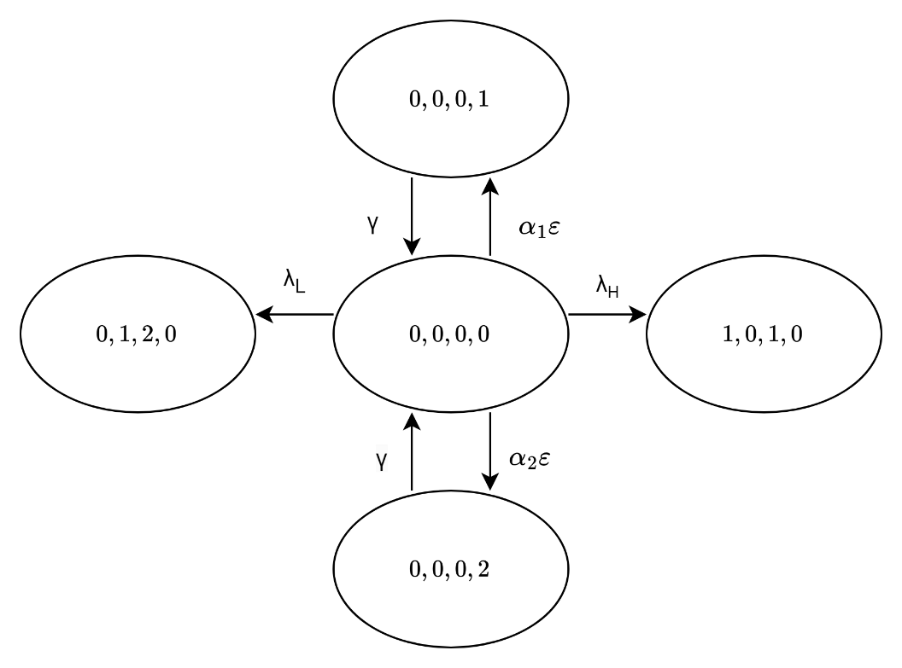

Figure 3‑2 The state transition diagram of

**Case 1**: $i=0,j=0,k=0,$ and $l=0$

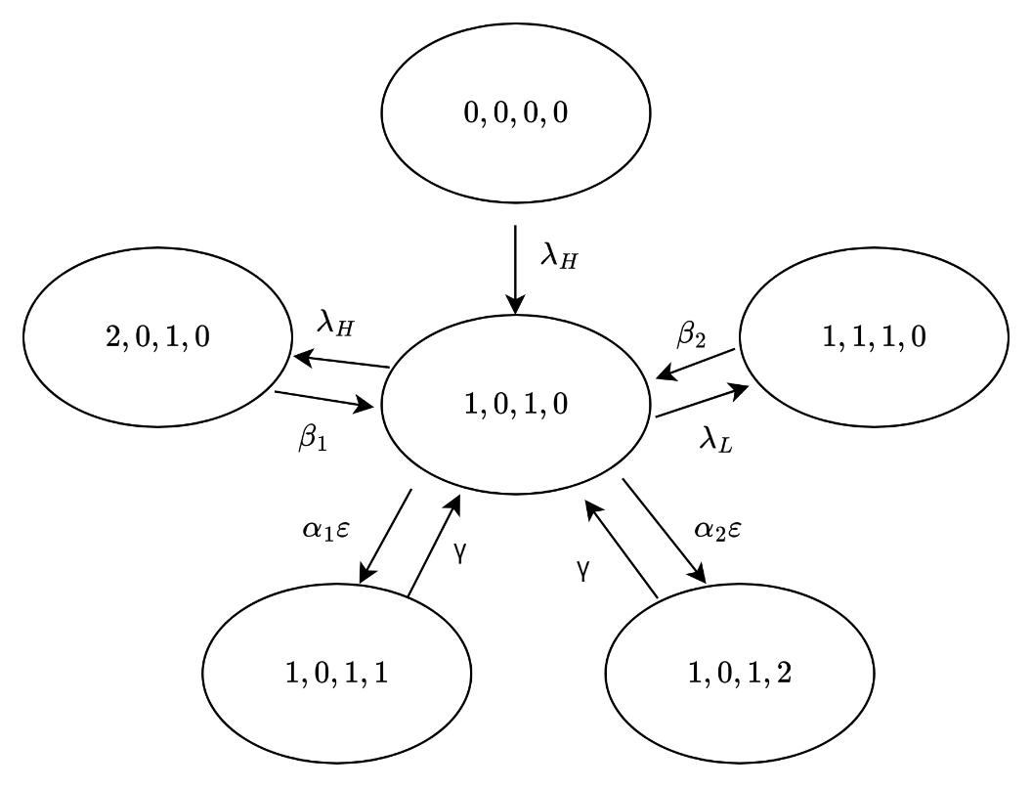

Figure 3‑3 The state transition diagram of

**Case 2**: $i=0,j=0,k=1,$ and $l=0$

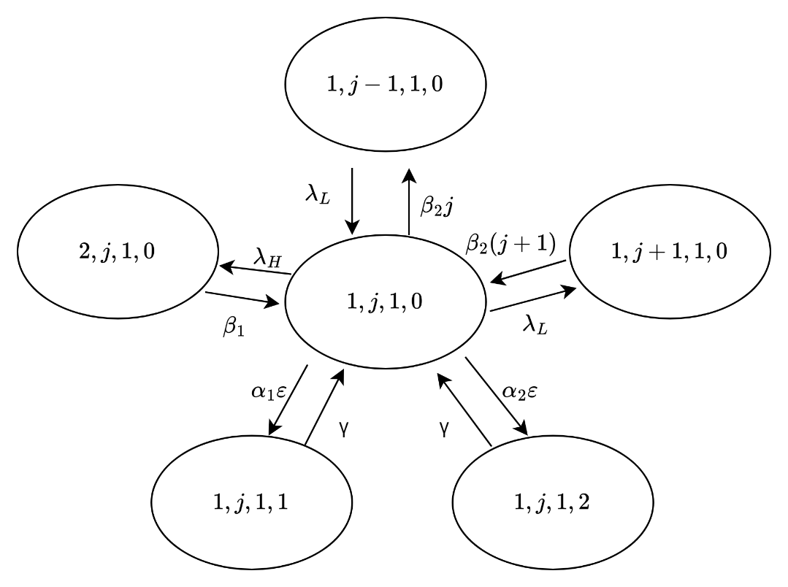

Figure 3‑4 The state transition diagram of

**Case 3**: $i=0,0<j<N-1,k=1,$ and $l=0$

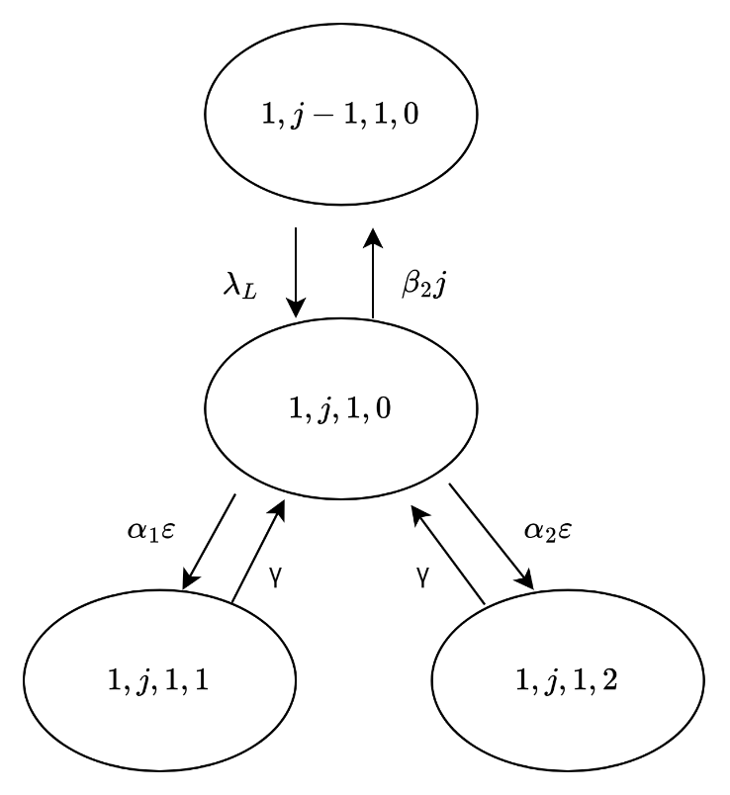

Figure 3‑5 The state transition diagram of

**Case 4**: $i=0,j=N-1,k=1,$ and $l=0$

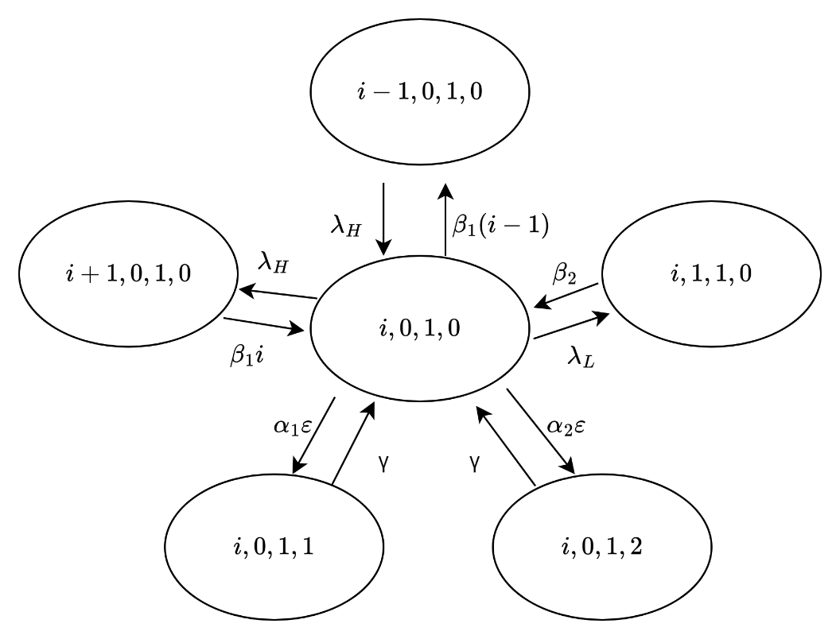

Figure 3‑6 The state transition diagram of

**Case 5**: $1<i<N,j=0,k=1,$ and $l=0$

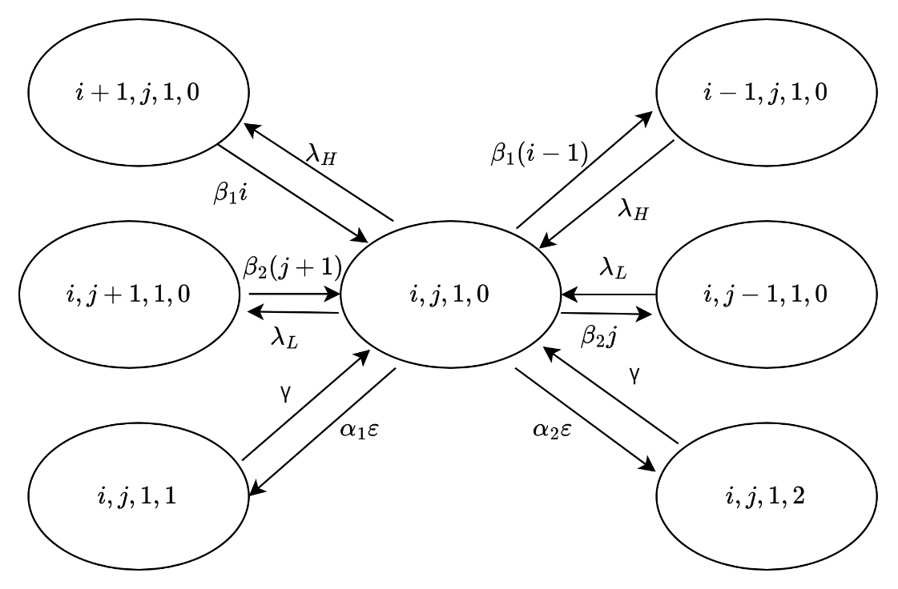

Figure 3‑7 The state transition diagram of

**Case 6**: $1<i<N,0<j<N-i,k=1,$ and $l=0$

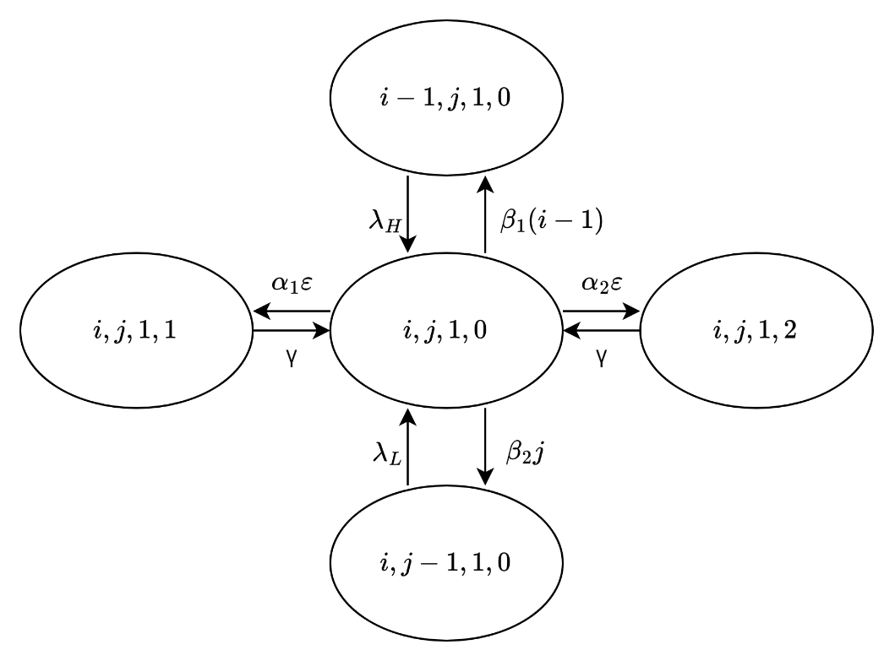

Figure 3‑8 The state transition diagram of

**Case 7**: $1<i<N,j=N-i,k=1,$ and $l=0$

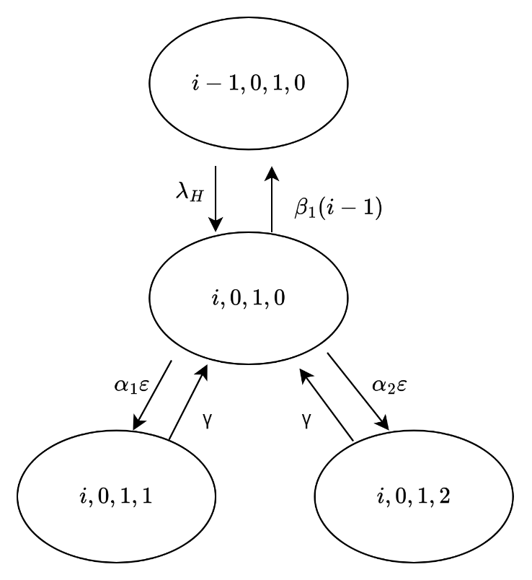

Figure 3‑9 The state transition diagram of

**Case 8**: $i=N,j=0,k=1,$ and $l=0$

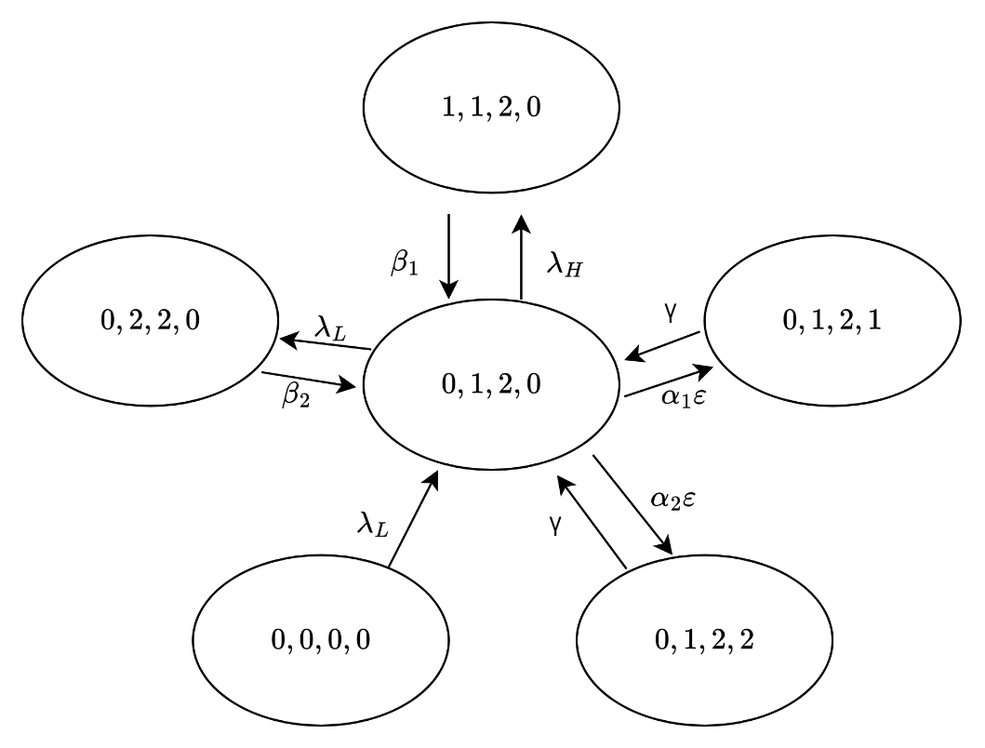

Figure 3‑10 The state transition diagram of

**Case 9**: $i=0,j=1,k=2,$ and $l=0$

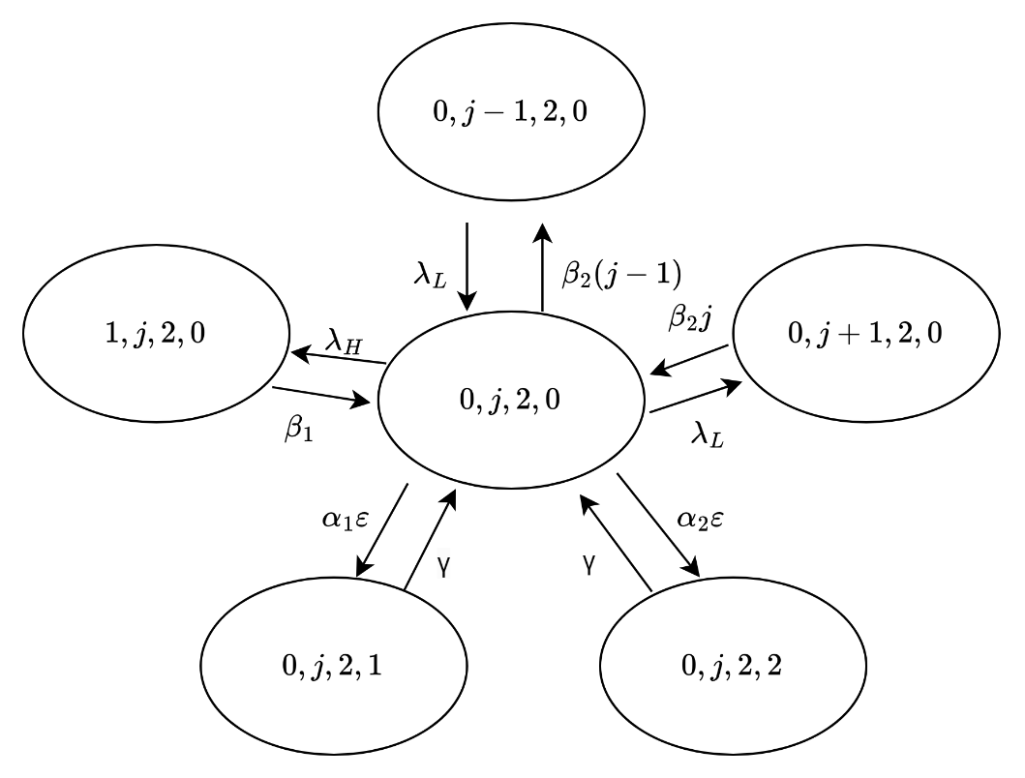

Figure 3‑11 The state transition diagram of

**Case 10**: $i=0,1<j<N,k=2,$ and $l=0$

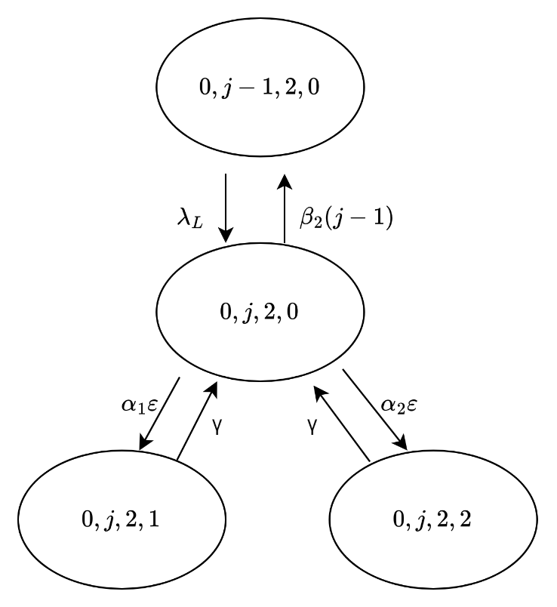

Figure 3‑12 The state transition diagram of

**Case 11**: $i=0,j=N,k=2,$ and $l=0$

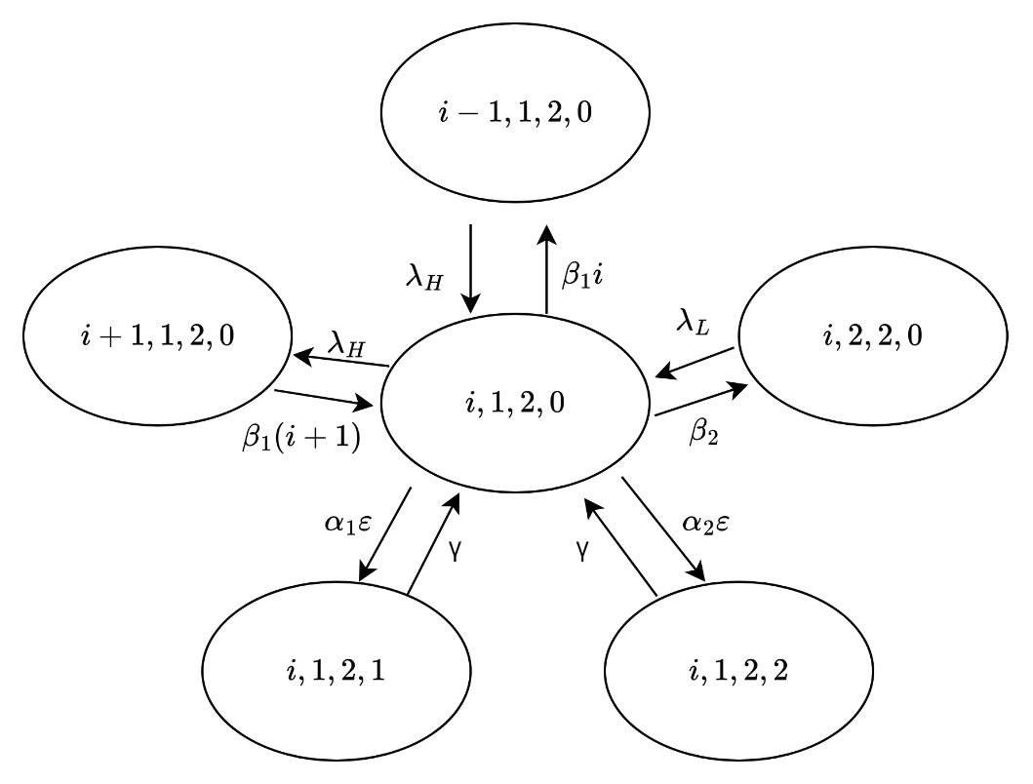

Figure 3‑13 The state transition diagram of

**Case 12**: $0<i<N-1,j=1,k=2,$ and $l=0$

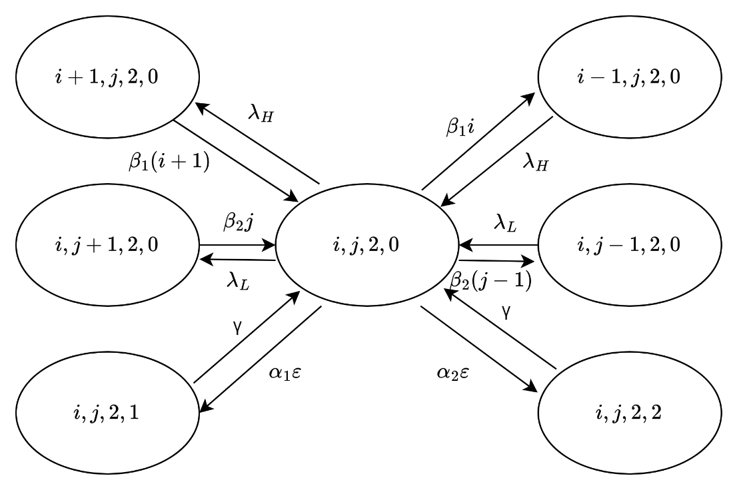

Figure 3‑14 The state transition diagram of

**Case 13**: $0<i<N-j,1<j<N,k=2,$ and $l=0$

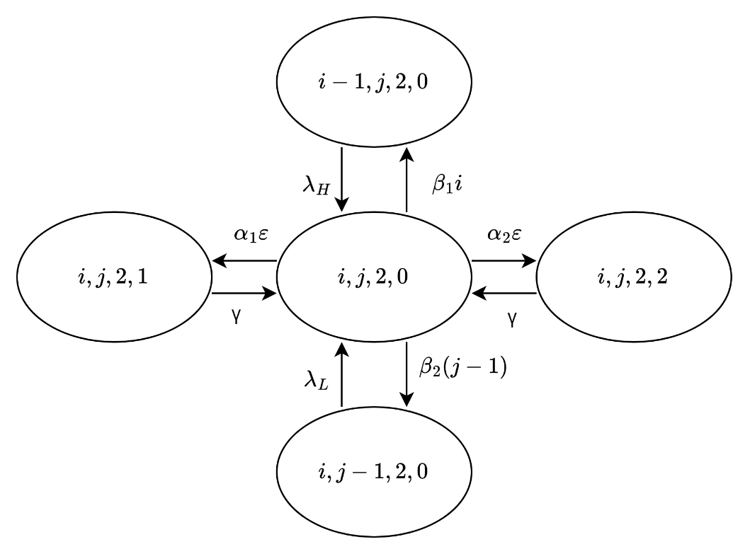

Figure 3‑15 The state transition diagram of

**Case 14**: $i=N-j,1<j<N,k=2,$ and $l=0$

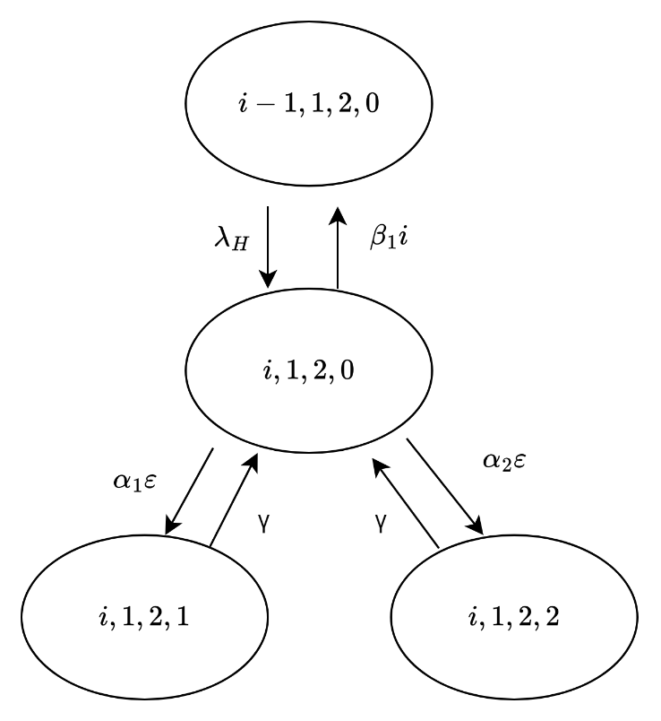

Figure 3‑16 The state transition diagram of

**Case 15**: $i =N-1,j=1,k=2,$ and $l=0$

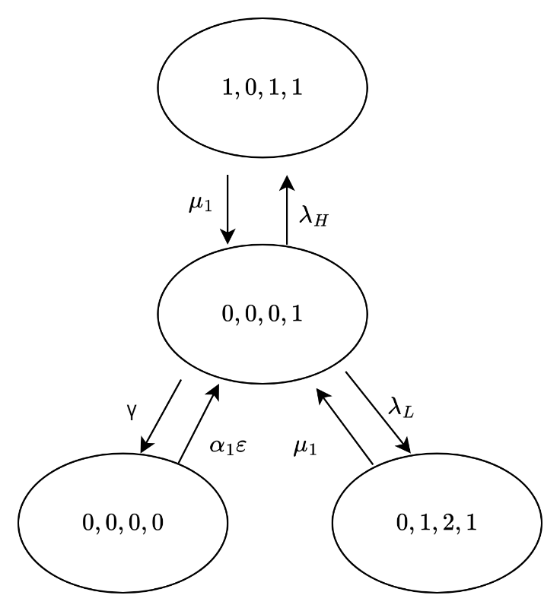

Figure 3‑17 The state transition diagram of

**Case 16**: $i=0,j=0,k=0,$ and $l=1$

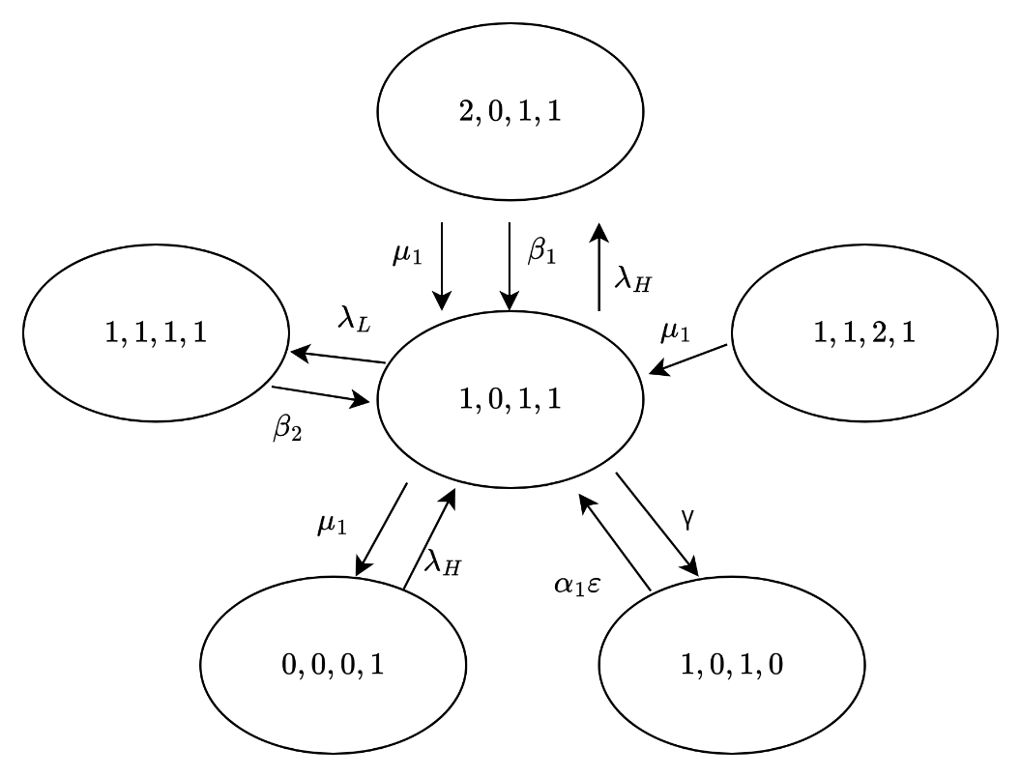

Figure 3‑18 The state transition diagram of

**Case 17**: $i=1,j=0,k=1,$ and $l=1$

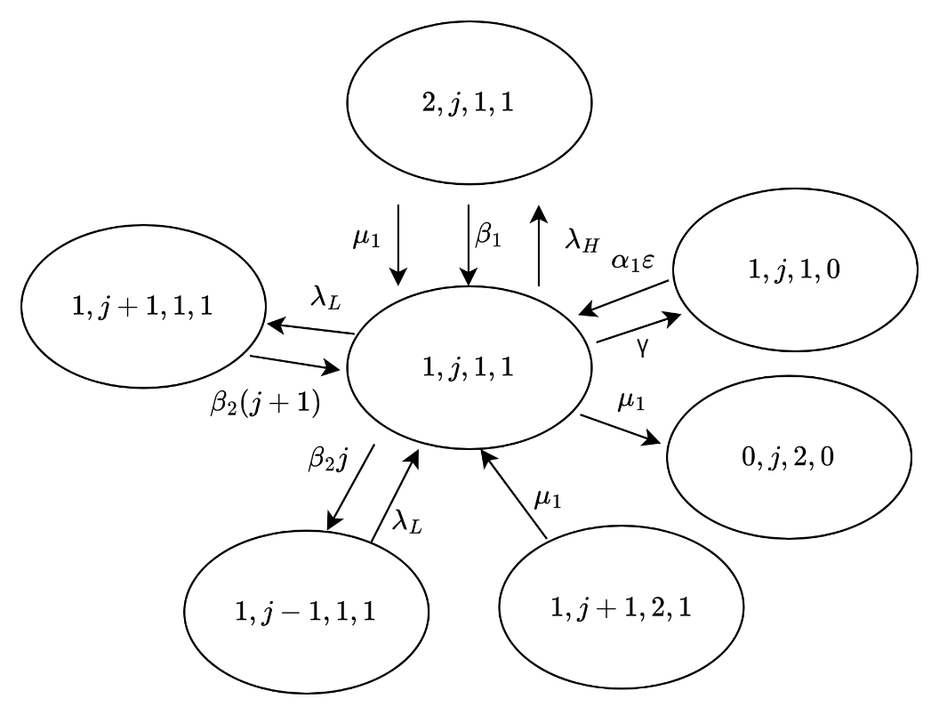

Figure 3‑19 The state transition diagram of

**Case 18**: $i=1,0<j<N-1,k=1,$ and $l=1$

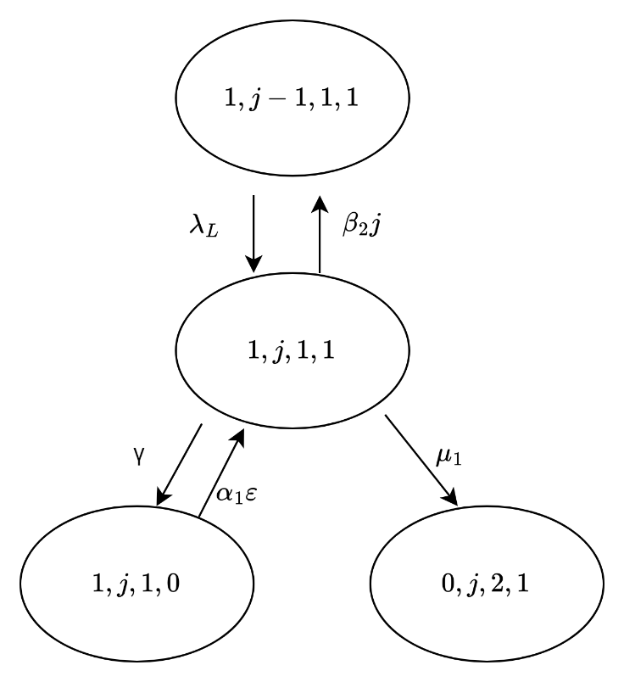

Figure 3‑20 The state transition diagram of

**Case 19**: $i=1,j=N-1,k=1,$ and $l=1$

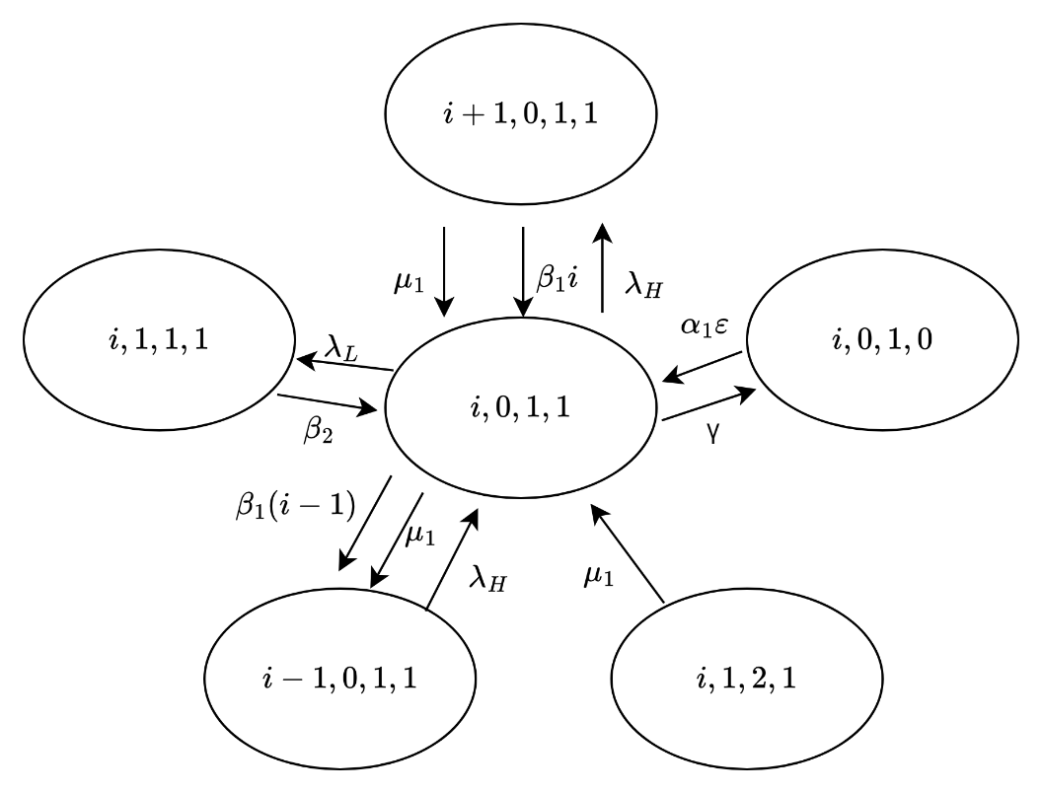

Figure 3‑21 The state transition diagram of

**Case 20**: $1<i<N,j=0,k=1,$ and $l=1$

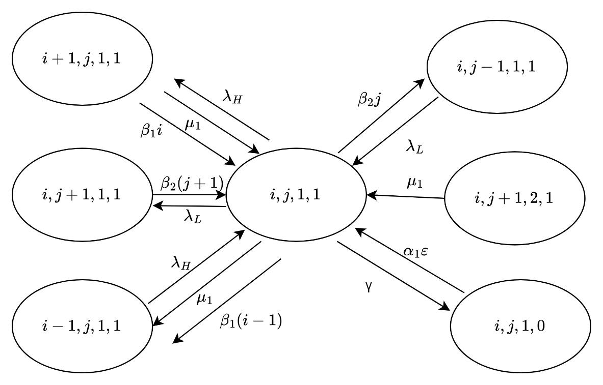

Figure 3‑22 The state transition diagram of

**Case 21**: $1<i<N,0<j<N-i,k=1,$ and $l=1$

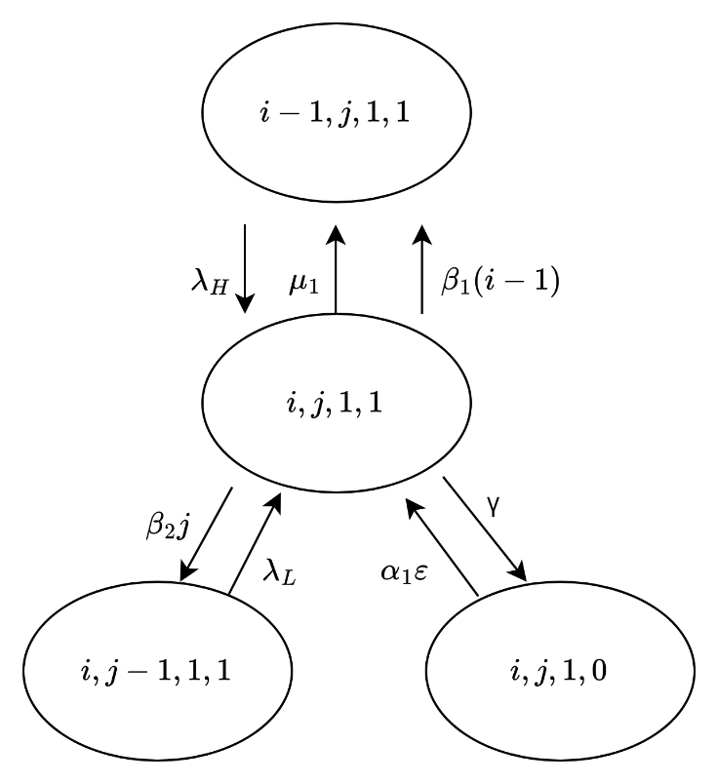

Figure 3‑23 The state transition diagram of

**Case 22**: $1<i<N,j=N-i,k=1,$ and $l=1$

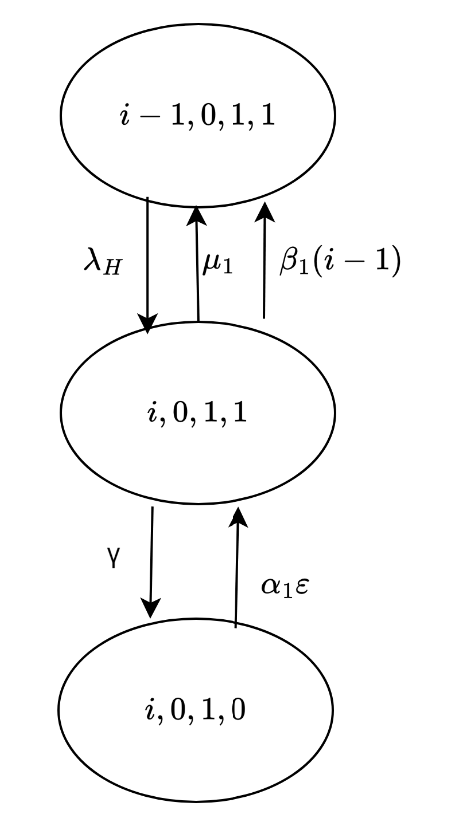

Figure 3‑24 The state transition diagram of

**Case 23**: $i=N,j=0,k=1,$ and $l=1$

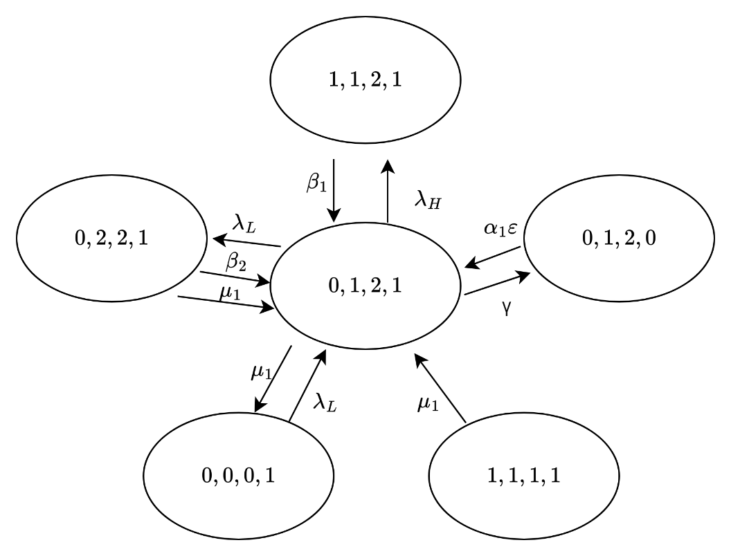

Figure 3‑25 The state transition diagram of

**Case 24**: $i=0,j=1,k=2,$ and $l=1$

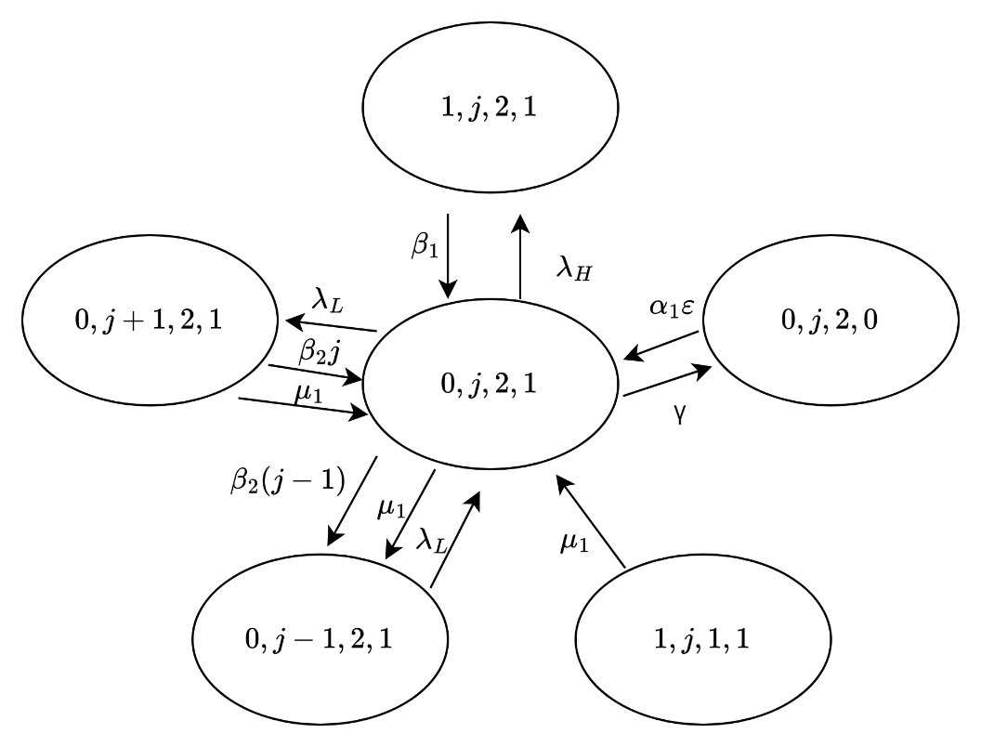

Figure 3‑26 The state transition diagram of

**Case 25**: $i=0,1<j<N,k=2,$ and $l=1$

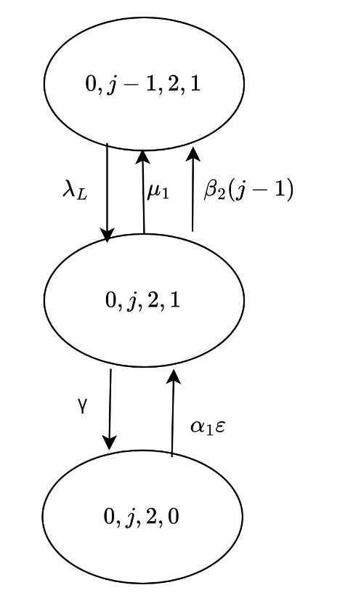

Figure 3‑27 The state transition diagram of

**Case 26**: $i=0,j=N,k=2,$ and $l=1$

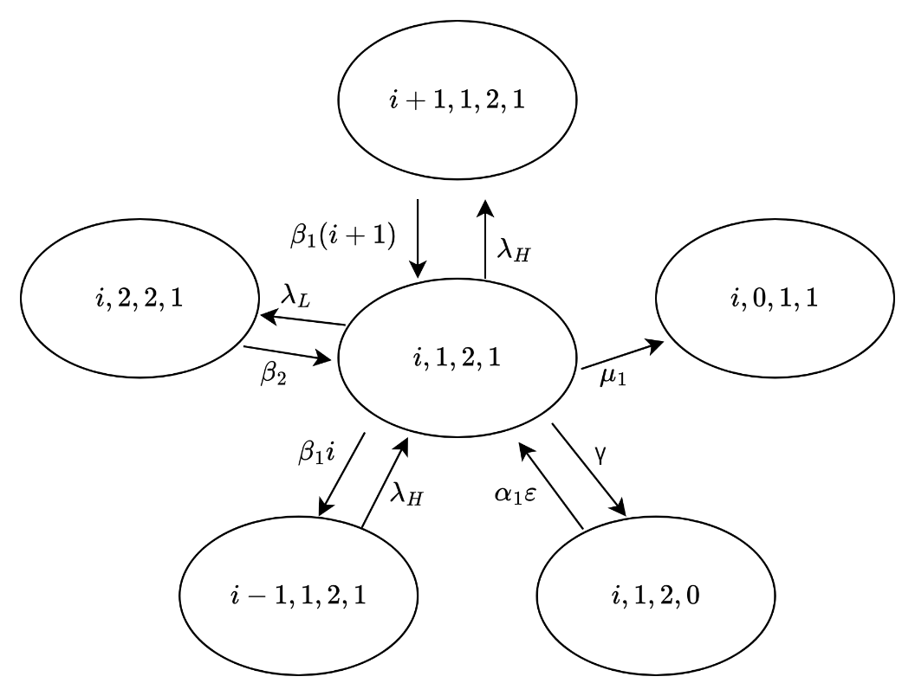

Figure 3‑28 The state transition diagram of

**Case 27**: $0<i<N-1,j=1,k=2,$ and $l=1$

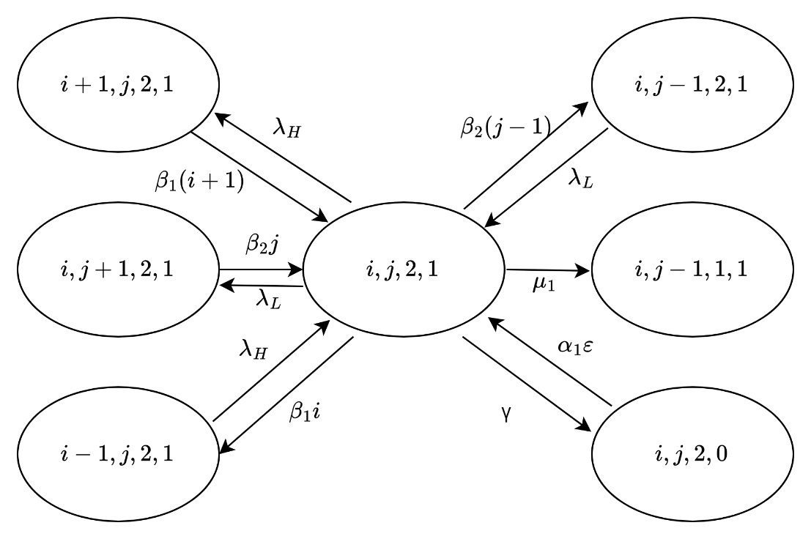

Figure 3‑29 The state transition diagram of

**Case 28**: $0<i<N-j,1<j<N,k=2,$ and $l=1$

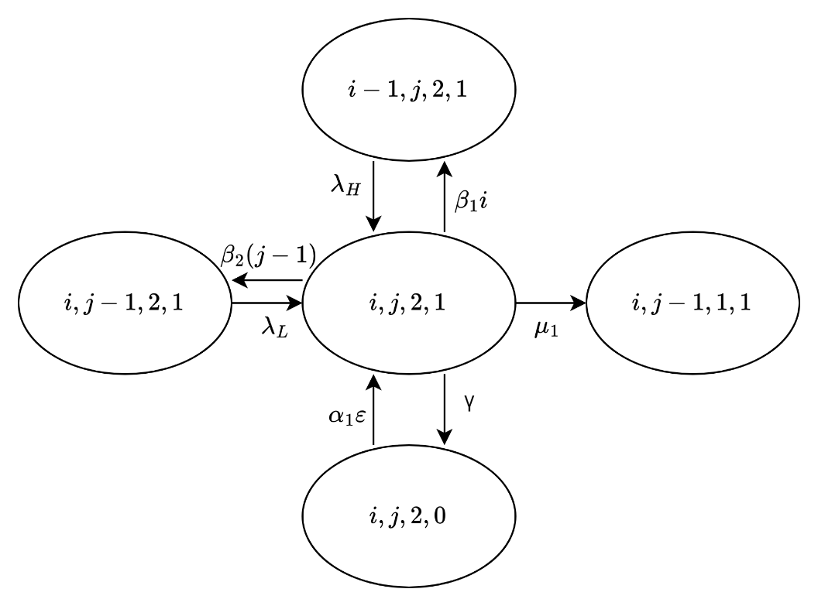

Figure 3‑30 The state transition diagram of

**Case 29**: $i=N-j,1<j<N,k=2,$ and $l=1$

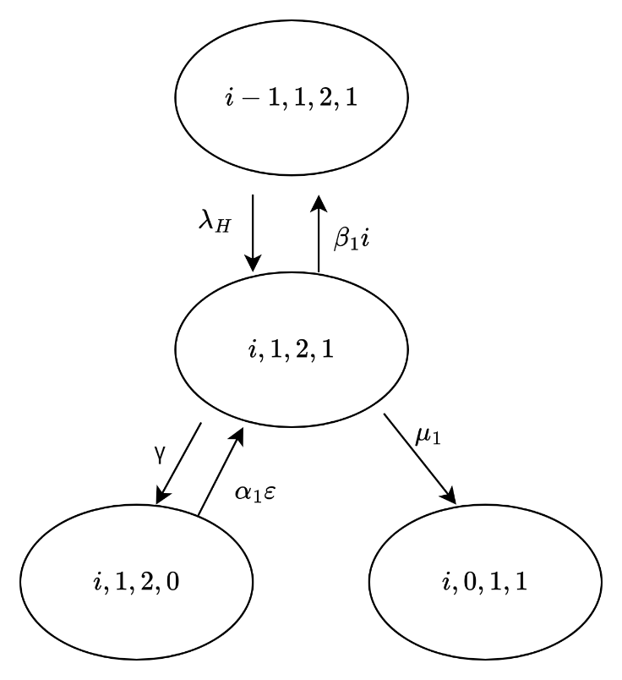

Figure 3‑31 The state transition diagram of

**Case 30**: $i=N-1,j=1,k=2,$ and $l=1$

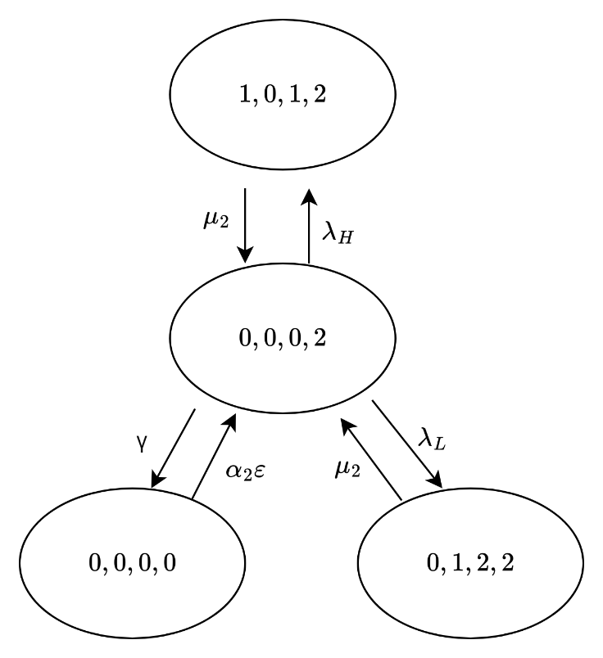

Figure 3‑32 The state transition diagram of

**Case 31**: $i=0,j=0,k=0,$ and $l=2$

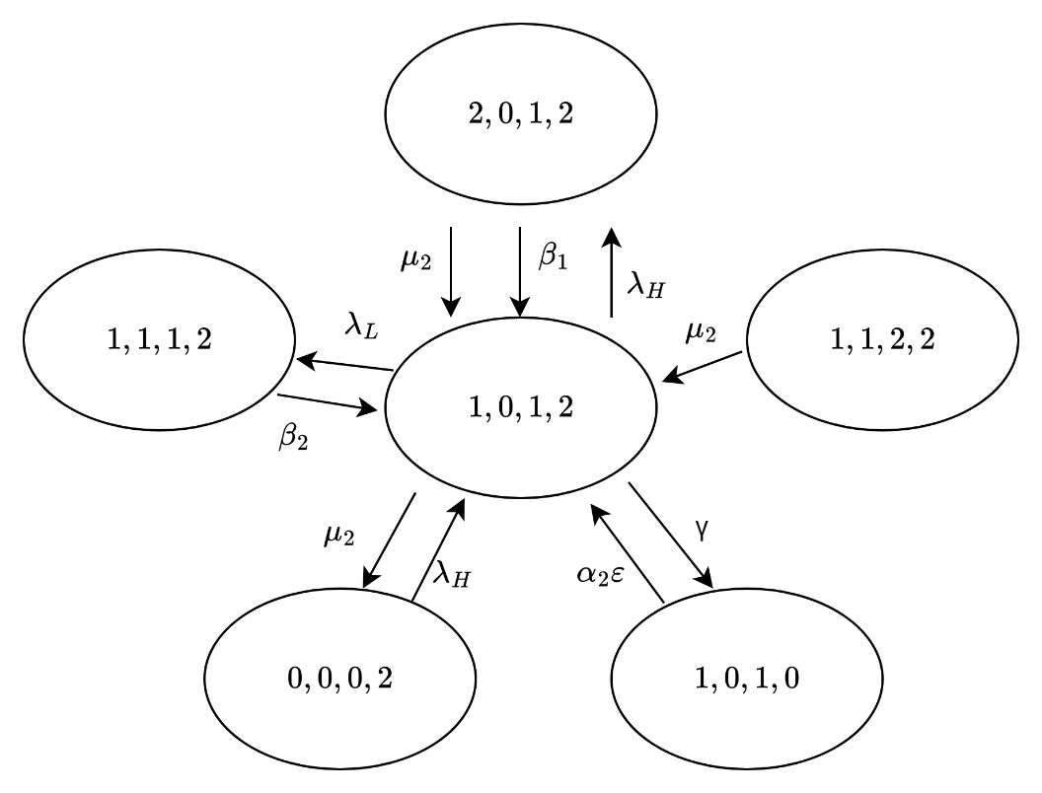

Figure 3‑33 The state transition diagram of

**Case 32**: $i=1,j=0,k=1,$ and $l=2$

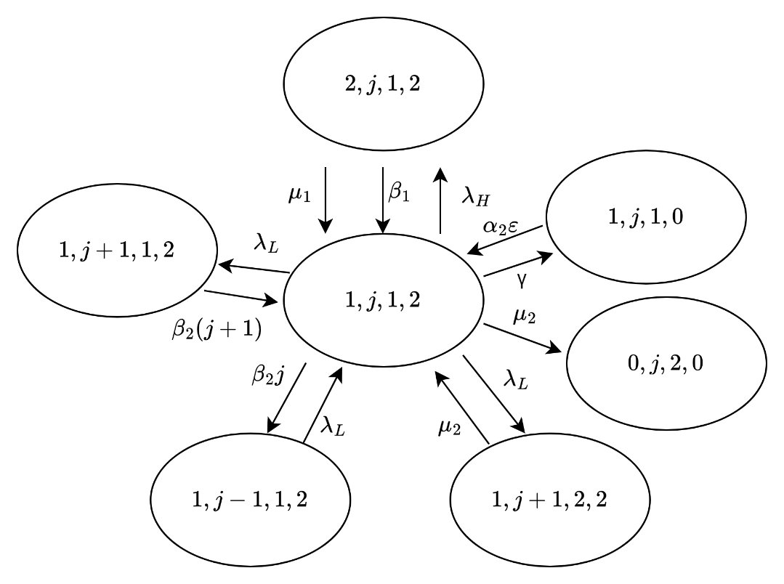

Figure 3‑34 The state transition diagram of

**Case 33**: $i=1,1<j<N-1,k=1,$ and $l=2$

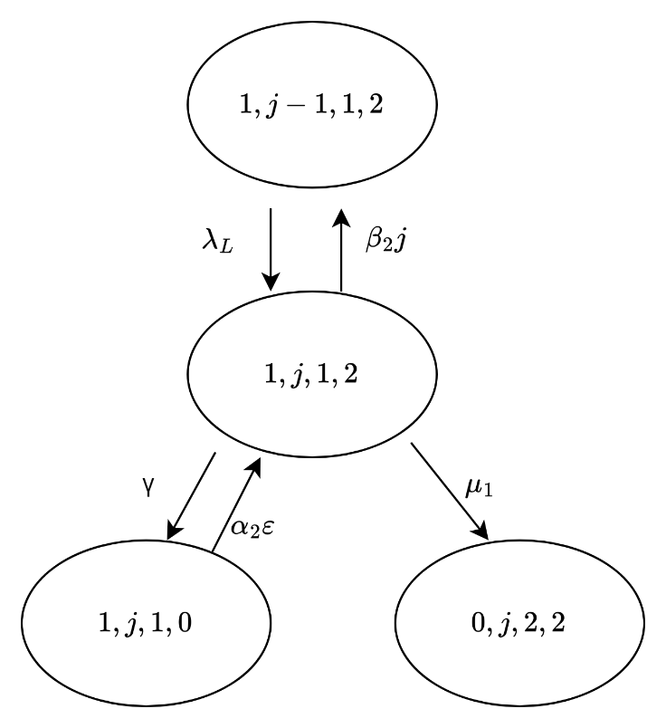

Figure 3‑35 The state transition diagram of

**Case 34**: $i=1,j=N-1,k=1,$ and $l=2$

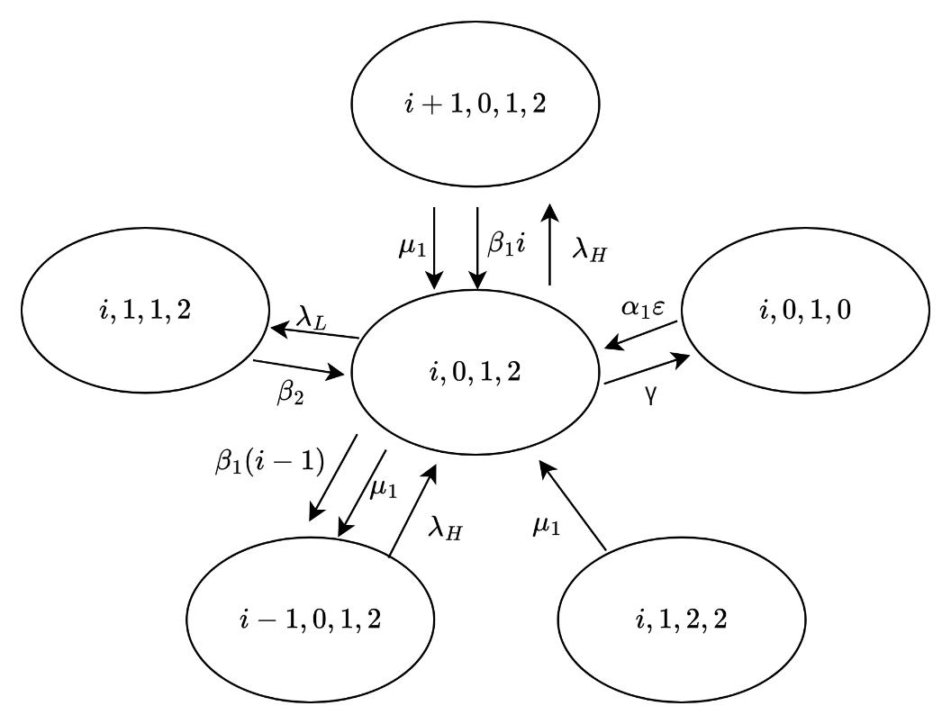

Figure 3‑36 The state transition diagram of

**Case 35**: $1<i<N,j=0,k=1,$ and $l=2$

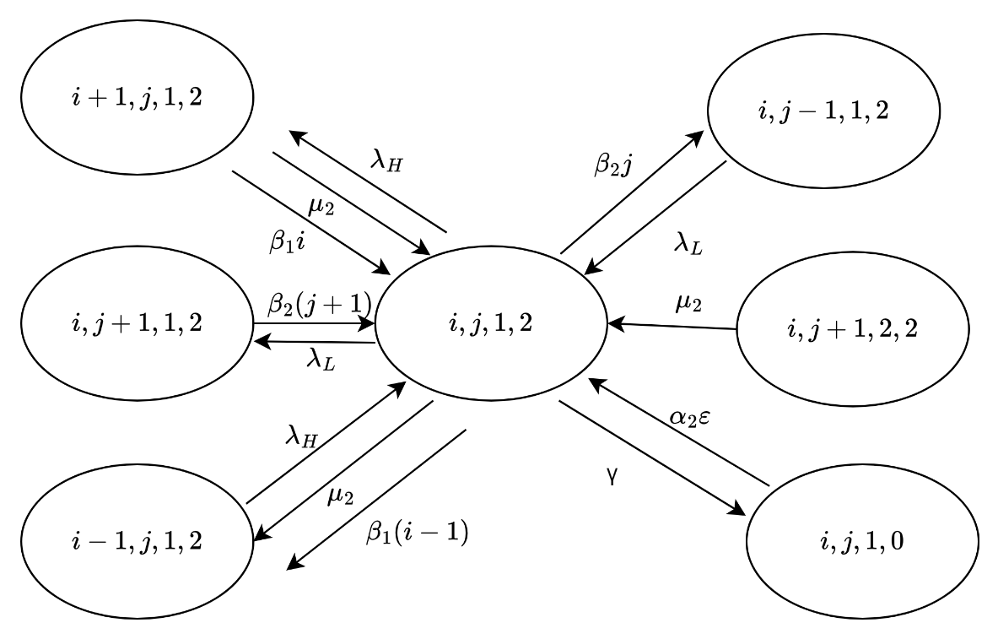

Figure 3‑37 The state transition diagram of

**Case 36**: $1<i<N,0<j<N-i,k=1,$ and $l=2$

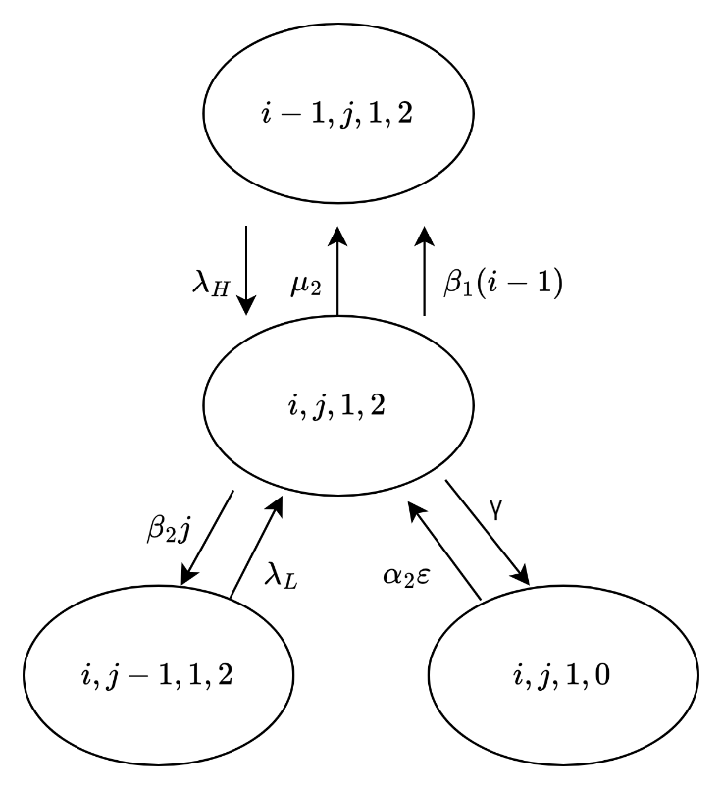

Figure 3‑38 The state transition diagram of

**Case 37**: $1<i<N,j=N-i,k=1,$ and $l=2$

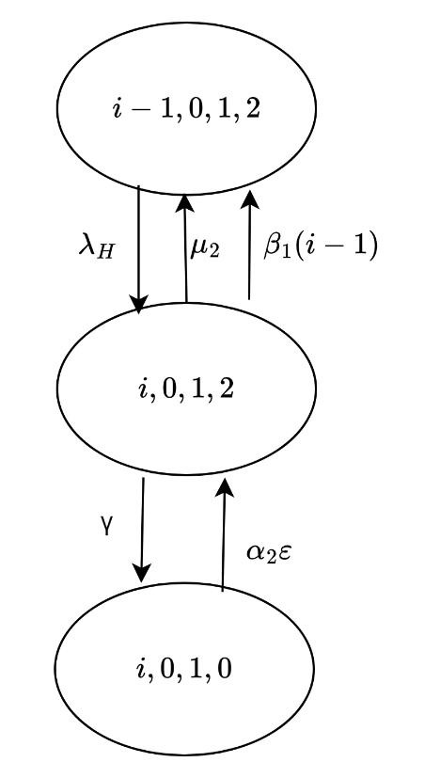

Figure 3‑39 The state transition diagram of

**Case 38**: $i=N,j=0,k=1,$ and $l=2$

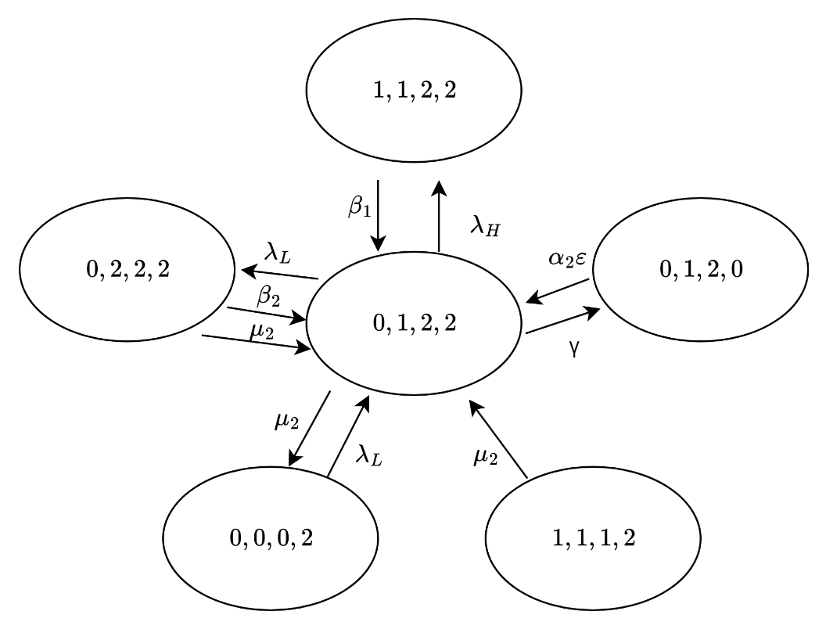

Figure 3‑40 The state transition diagram of

**Case 39**: $i=0,j=1,k=2,$ and $l=2$

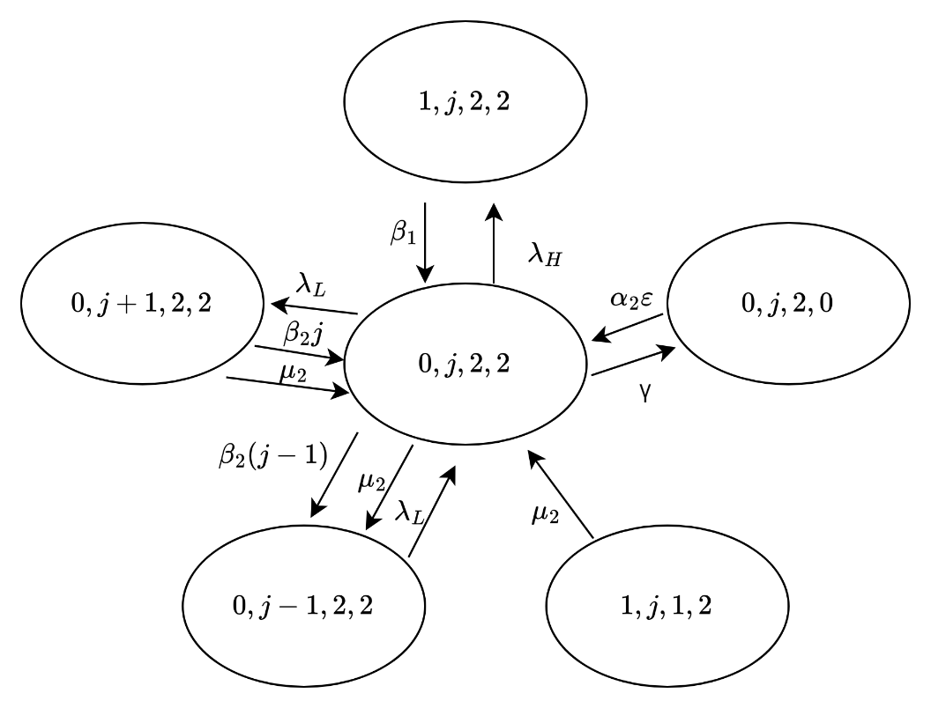

Figure 3‑41 The state transition diagram of

**Case 40**: $i=0,1<j<N,k=2,$ and $l=2$

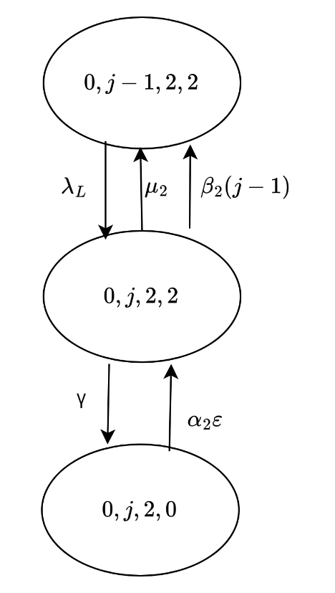

Figure 3‑42 The state transition diagram of

**Case 41**: $i=0,j=N,k=2,$ and $l=2$

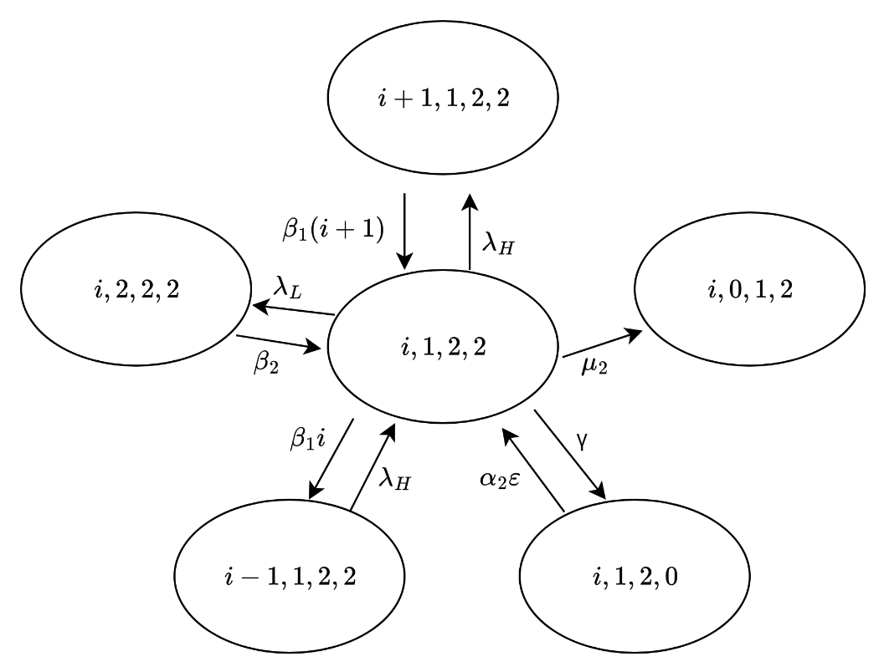

Figure 3‑43 The state transition diagram of

**Case 42**: $0<i<N-1,j=1,k=2,$ and $l=2$

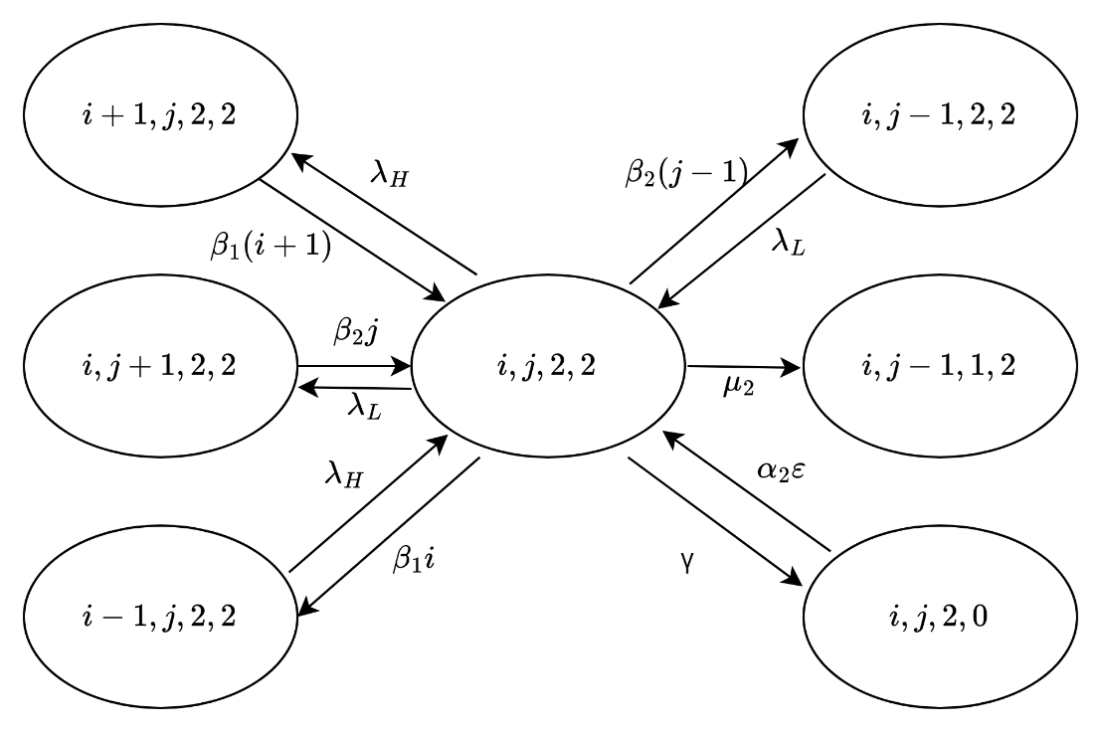

Figure 3‑44 The state transition diagram of

**Case 43**: $0<i<N-j,1<j<sys size,k=2,$ and $l=2$

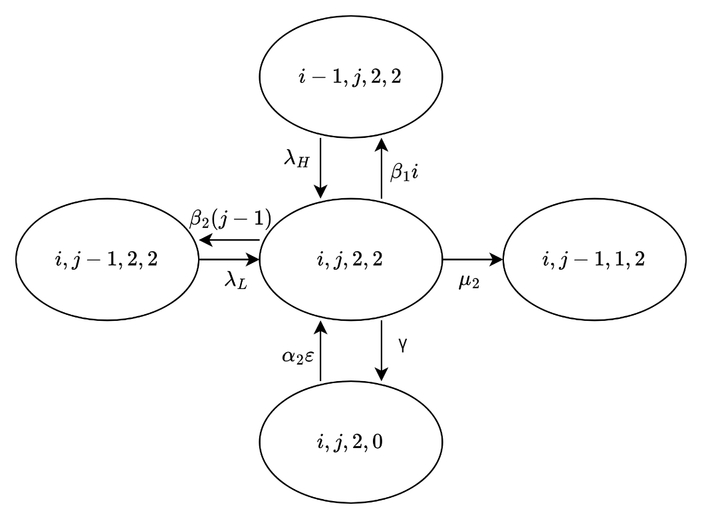

Figure 3‑45 The state transition diagram of

**Case 44**: $i=N-j,1<j<sys size,k=2,$ and $l=2$

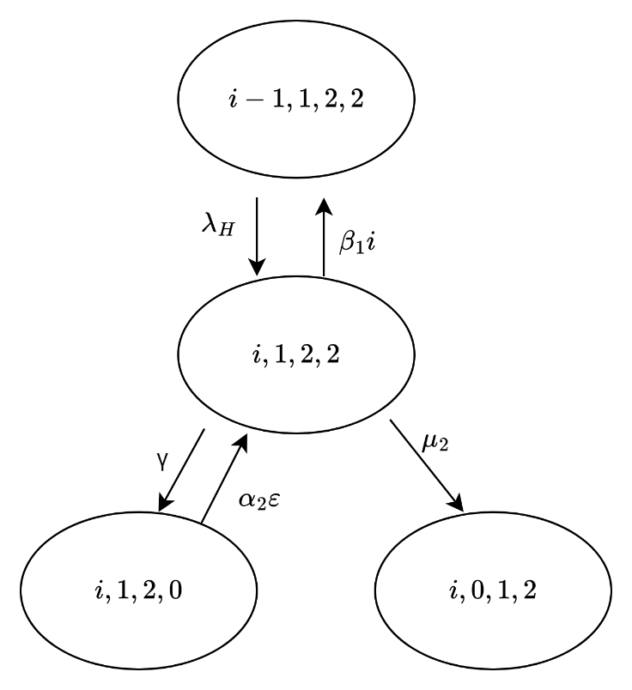

Figure 3‑46 The state transition diagram of

**Case 45**: $i=N-1,j=1,k=2,$ and $l=2$

## 3.2 Scenario 2

In this scenario, we consider both loss priority and delay priority. Specifically, HP packets are queued ahead of LP packets, but LP packets currently being served cannot be interrupted. Packets with the same priority follow a first-come, first-served (FCFS) discipline. Besides, when the waiting time of any packet in queue is higher than an associated impatience time, it will be removed from the queue immediately. Additionally, a threshold is established such that when the total number of HP and LP packets in the system reaches this limit, only HP packets are allowed to join the queue, while LP packets will be blocked.

### 3.2.1 State balance equations

We define the considered system as a four-dimensional Markov chain denoted by $\left(i,j,k,l\right)$, where $i$ indicates the number of HP packets in the system, $j$ indicates the number of LP packets in the system, $k$ signifies the server's status, specifying whether it is idle (k = 0), serving an HP packet (k = 1), or serving an LP packet (k = 2), and $l$ identifies the current split.

Furthermore, R represents the reserved number of queue positions, meaning the threshold is N-R. Once the combined number of HP and LP packets in the system reaches N-R, only HP packets are allowed to join the queue, and LP packets will be blocked. The steady-state probability of the system is represented as $π_{\left(i,j,k,l\right)}$. The state space is defined accordingly:

$$S=\left\{\left(i,j,k,l\right)|0≤i≤N,0≤j≤N-R,0≤i+j≤N,0≤k≤2, 0≤l≤2\right\}$$

The total number of feasible states is:

$$\left|S\right|=3N\left(N+1\right)+3-3R(R+1)$$

Based on the model, the system's total states are categorized into 75 distinct cases. The corresponding state balance equations are as follows:

**Case 1**: For $i=0, j=0, k=0, and l=0$

$$\left(α_{1}ε+α_{2}ε+λ_{H}+λ_{L}\right)π_{\left(0,0,0,0\right)}=γ\left(π_{\left(0,0,0,1\right)}+π_{\left(0,0,0,2\right)}\right)$$

**Case 2**: For $i=1, j=0, k=1, and l=0$

$$\left(α_{1}ε+α_{2}ε+λ_{H}+λ_{L}\right)π_{\left(1,0,1,0\right)}=γ\left(π_{\left(1,0,1,1\right)}+π_{\left(1,0,1,2\right)}\right)+λ_{H}π_{\left(0,0,0,0\right)}+β_{1}π_{\left(2,0,1,0\right)}$$

$$+β_{2}π_{\left(1,1,1,0\right)}$$

**Case 3**: For $1<i<N-R, j=0, k=1, and l=0$

$$\left(α_{1}ε+α_{2}ε+λ_{H}+λ_{L}+β_{1}\left(i-1\right)\right)π_{\left(i,0,1,0\right)}=γ\left(π_{\left(i,0,1,1\right)}+π_{\left(i,0,1,2\right)}\right)+$$

$$β_{1}iπ_{\left(i+1,0,1,0\right)}+β_{2}π_{\left(i,1,1,0\right)}$$

**Case 4**: For $N-R≤i<N, j=0, k=1, and l=0$

$$\left(α_{1}ε+α_{2}ε+λ_{H}+β_{1}\left(i-1\right)\right)π_{\left(i,0,1,0\right)}=γ\left(π_{\left(i,0,1,1\right)}+π_{\left(i,0,1,2\right)}\right)+λ_{H}π_{\left(i-1,0,1,0\right)}$$

$$β_{1}iπ_{\left(i+1,0,1,0\right)}+β_{2}π_{\left(i,1,1,0\right)}$$

**Case 5**: For $i=N, j=0, k=1, and l=0$

$$\left(α_{1}ε+α_{2}ε+β_{1}\left(i-1\right)\right)π_{\left(i,0,1,0\right)}=γ\left(π_{\left(i,0,1,1\right)}+π_{\left(i,0,1,2\right)}\right)+λ_{H}π_{\left(i-1,0,1,0\right)}$$

**Case 6**: For $i=1, 0<j<N-R-1, k=1, and l=0$

$$\left(α_{1}ε+α_{2}ε+λ_{H}+λ_{L}+β_{2}j\right)π_{\left(i,j,1,0\right)}=γ\left(π_{\left(i,j,1,1\right)}+π_{\left(i,j,1,2\right)}\right)+λ_{L}π_{\left(i,j-1,1,0\right)}+$$

$$β_{1}π_{\left(2,j,1,0\right)}+β_{2}(j+1)π_{\left(1,j+1,1,0\right)}$$

**Case 7**: For $1<i<N-R-j, 0<j<N-R-1, k=1, and l=0$

$$\left(α_{1}ε+α_{2}ε+λ_{H}+λ_{L}{+β_{1}\left(i-1\right)+β}_{2}j\right)π_{\left(i,j,1,0\right)}=γ\left(π_{\left(i,j,1,1\right)}+π_{\left(i,j,1,2\right)}\right)+$$

$$λ_{H}π_{\left(i-1,j,1,0\right)}+λ_{L}π_{\left(i,j-1,1,0\right)}+β_{1}iπ_{\left(i+1,j,1,0\right)}+β_{2}(j+1)π_{\left(i,j+1,1,0\right)}$$

**Case 8**: For $i=N-R-j, 0<j<N-R-1, k=1, and l=0$

$$\left(α_{1}ε+α_{2}ε+λ_{H}{+β_{1}\left(i-1\right)+β}_{2}j\right)π_{\left(i,j,1,0\right)}=γ\left(π_{\left(i,j,1,1\right)}+π_{\left(i,j,1,2\right)}\right)+$$

$$λ_{H}π_{\left(i-1,j,1,0\right)}+λ_{L}π_{\left(i,j-1,1,0\right)}+β_{1}iπ_{\left(i+1,j,1,0\right)}+β_{2}(j+1)π_{\left(i,j+1,1,0\right)}$$

**Case 9**: For $N-R-j<i<N-j, 0<j<N-R-1, k=1, and l=0$

$$\left(α_{1}ε+α_{2}ε+λ_{H}λ_{H}{+β_{1}\left(i-1\right)+β}_{2}j\right)π_{\left(i,j,1,0\right)}=γ\left(π_{\left(i,j,1,1\right)}+π_{\left(i,j,1,2\right)}\right)+$$

$$λ_{H}π_{\left(i-1,j,1,0\right)}+β_{1}iπ_{\left(i+1,j,1,0\right)}+β_{2}(j+1)π_{\left(i,j+1,1,0\right)}$$

**Case 10**: For $i=N-j, 0<j<N-R-1, k=1, and l=0$

$\left(α_{1}ε+α_{2}ε{+β_{1}\left(i-1\right)+β}_{2}j\right)π_{\left(i,j,1,0\right)}=γ\left(π_{\left(i,j,1,1\right)}+π_{\left(i,j,1,2\right)}\right)+λ_{H}π_{\left(i-1,j,1,0\right)}$ +

$$+β_{1}iπ_{\left(i+1,j,1,0\right)}+β_{2}(j+1)π_{\left(i,j+1,1,0\right)}$$

**Case 11**: For $i=1, j=N-R-1, k=1, and l=0$

$$\left(α_{1}ε+α_{2}ε+λ_{H}{+β}_{2}j\right)π_{\left(i,j,1,0\right)}=γ\left(π_{\left(i,j,1,1\right)}+π_{\left(i,j,1,2\right)}\right)+λ_{L}π_{\left(i,j-1,1,0\right)}+$$

$$+β_{1}iπ_{\left(i+1,j,1,0\right)}$$

**Case 12**: For $1<i<N-j, j=N-R-1, k=1, and l=0$

$$\left(α_{1}ε+α_{2}ε+λ_{H}{+β_{1}\left(i-1\right)+β}_{2}j\right)π_{\left(i,j,1,0\right)}=γ\left(π_{\left(i,j,1,1\right)}+π_{\left(i,j,1,2\right)}\right)+λ_{H}π_{\left(i-1,j,1,0\right)}$$

$$+β_{1}iπ_{\left(i+1,j,1,0\right)}$$

**Case 13**: For $i=N-j, j=N-R-1, k=1, and l=0$

$\left(α_{1}ε+α_{2}ε{+β_{1}\left(i-1\right)+β}_{2}j\right)π_{\left(i,j,1,0\right)}=γ\left(π_{\left(i,j,1,1\right)}+π_{\left(i,j,1 ,2\right)}\right)+λ_{H}π_{\left(i-1,j,1,0\right)}$

**Case 14**: For $i=0, j=1, k=2, and l=0$

$$\left(α_{1}ε+α_{2}ε+λ_{H}+λ_{L}\right)π_{\left(0,1,2,0\right)}=γ\left(π_{\left(0,1,2,1\right)}+π_{\left(0,1,2,2\right)}\right)+λ_{L}π_{\left(0,0,0,0\right)}+$$

$$β_{1}π_{\left(1,1,2,0\right)}+β_{2}π_{\left(0,2,2,0\right)}$$

**Case 15**: For $0<i<N-R-1, j=1, k=2, and l=0$

$$\left(α_{1}ε+α_{2}ε+λ_{H}+λ_{L}+β_{1}i\right)π_{\left(i,1,2,0\right)}=γ\left(π_{\left(i,1,2,1\right)}+π_{\left(i,1,2,2\right)}\right)+λ_{H}π_{\left(i-1,1,2,0\right)}+$$

$$β_{1}(i+1)π_{\left(i+1,1,2,0\right)}+β_{2}π_{\left(i,2,2,0\right)}$$

**Case 16**: For $N-R-1≤i<N-1, j=1, k=2, and l=0$

$$\left(α_{1}ε+α_{2}ε+λ_{H}+β_{1}i\right)π_{\left(i,1,2,0\right)}=γ\left(π_{\left(i,1,2,1\right)}+π_{\left(i,1,2,2\right)}\right)+λ_{H}π_{\left(i-1,1,2,0\right)}+$$

$$β_{1}(i+1)π_{\left(i+1,1,2,0\right)}+β_{2}π_{\left(i,2,2,0\right)}$$

**Case 17**: For $i=N-1, j=1, k=2, and l=0$

$$\left(α_{1}ε+α_{2}ε+β_{1}i\right) π_{\left(i,1,2,0\right)}=γ\left(π_{\left(i,1,2,1\right)}+π_{\left(i,1,2,2\right)}\right)+λ_{H}π_{\left(i-1,1,2,0\right)}$$

**Case 18**: For $i=0, 1<j<N-R, k=2, and l=0$

$$\left(α_{1}ε+α_{2}ε+λ_{H}+λ_{L}+β_{2}\left(j-1\right)\right) π_{\left(0,j,2,0\right)}=γ\left(π_{\left(0,j,2,1\right)}+π_{\left(0,j,2,2\right)}\right)+$$

$$λ_{L}π_{\left(0,j-1,2,0\right)}+β_{1}(i+1)π_{\left(1,j,2,0\right)}+β_{2}jπ_{\left(0,j+1,2,0\right)}$$

**Case 19**: For $0<i<N-R-j, 1<j<N-R, k=2, and l=0$

$$\left(α_{1}ε+α_{2}ε+λ_{H}+λ_{L}+β_{1}i+β_{2}\left(j-1\right)\right) π_{\left(i,j,2,0\right)}=γ\left(π_{\left(i,j,2,1\right)}+π_{\left(i,j,2,2\right)}\right)+$$

$$λ_{H}π_{\left(i-1,j,2,0\right)}+λ_{L}π_{\left(i,j-1,2,0\right)}+β_{1}(i+1)π_{\left(i+1,j,2,0\right)}+β_{2}jπ_{\left(i,j+1,2,0\right)}$$

**Case 20**: For $i=N-R-j, 1<j<N-R, k=2, and l=0$

$$\left(α_{1}ε+α_{2}ε+λ_{H}+β_{1}i+β_{2}\left(j-1\right)\right) π_{\left(i,j,2,0\right)}=γ\left(π_{\left(i,j,2,1\right)}+π_{\left(i,j,2,2\right)}\right)+$$

$$λ_{H}π_{\left(i-1,j,2,0\right)}+λ_{L}π_{\left(i,j-1,2,0\right)}+β_{1}(i+1)π_{\left(i+1,j,2,0\right)}+β_{2}jπ_{\left(i,j+1,2,0\right)}$$

**Case 21**: For $N-R-j<i<N-j, 1<j<N-R, k=2, and l=0$

$$\left(α_{1}ε+α_{2}ε+λ_{H}+β_{1}i+β_{2}\left(j-1\right)\right) π_{\left(i,j,2,0\right)}=γ\left(π_{\left(i,j,2,1\right)}+π_{\left(i,j,2,2\right)}\right)+$$

$$λ_{H}π_{\left(i-1,j,2,0\right)}+β_{1}(i+1)π_{\left(i+1,j,2,0\right)}+β_{2}jπ_{\left(i,j+1,2,0\right)}$$

**Case 22**: For $i=N-j, 1<j<N-R, k=2, and l=0$

$\left(α_{1}ε+α_{2}ε+β_{1}i+β_{2}\left(j-1\right)\right) π_{\left(i,j,2,0\right)}=γ\left(π_{\left(i,j,2,1\right)}+π_{\left(i,j,2,2\right)}\right)+λ_{H}π_{\left(i-1,j,2,0\right)}$

**Case 23**: For

**Case 24**: For

**Case 25**: For

**Case 26:** For

**Case 27:** For

**Case 28:** For

**Case 29:** For

**Case 30:** For

**Case 31:** For

**Case 32:** For

**Case 33:** For

**Case 34:** For

**Case 35:** For $i=N-j, 0<j<N-R-1, k=1, and l=1$

$\left(γ+μ_{1}+β_{1}\left(i-1\right)+β_{2}j\right)π_{\left(i,j,1,1\right)}=α_{1}επ_{\left(i,j,1,0\right)}+λ_{H}π_{\left(i-1,j,1,1\right)}$

**Case 36:** For $i=1, j=N-R-1, k=1, and l=1$

$$\left(γ+μ_{1}+λ_{H}+β_{2}j\right)π_{\left(1,j,1,1\right)}=α_{1}επ_{\left(1,j,1,0\right)}+μ_{1}\left(π_{\left(2,j,1,1\right)}+π_{\left(1,j+1,2,1\right)}\right)+$$

$$λ_{L}π_{\left(1,j-1,1,1\right)}+β_{1}π_{\left(i+1,j,1,1\right)}$$

**Case 37:** For $1<i<N-j, j=N-R-1, k=1, and l=1$

$$\left(γ+μ_{1}+λ_{H}+β_{1}\left(i-1\right)+β_{2}j\right)π_{\left(i,j,1,1\right)}=α_{1}επ_{\left(i,j,1,0\right)}+$$

$$μ_{1}\left(π_{\left(i+1,j,1,1\right)}+π_{\left(i,j+1,2,1\right)}\right)+λ_{H}π_{\left(i-1,j,1,1\right)}+β_{1}π_{\left(i+1,j,1,1\right)}$$

**Case 38:** For $i=N-j, j=N-R-1, k=1, and l=1$

$\left(γ+μ_{1}+β_{1}\left(i-1\right)+β_{2}j\right)π_{\left(i,j,1,1\right)}=α_{1}επ_{\left(i,j,1,0\right)}+λ_{H}π_{\left(i-1,j,1,1\right)}$

**Case 39:** For $i=0, j=1, k=2, and l=1$

$$\left(γ+μ_{1}+λ_{H}+λ_{L}\right)π_{\left(0,1,2,1\right)}=α_{1}επ_{\left(0,1,2,0\right)}+μ_{1}\left(π_{\left(1,1,1,1\right)}+π_{\left(0,2,2,1\right)}\right)+$$

$$λ_{L}π_{\left(0,0,0,1\right)}+β_{1}π_{\left(1,1,2,1\right)}+β_{2}π_{\left(0,2,2,1\right)}$$

**Case 40:** For $0<i<N-R-1, j=1, k=2, and l=1$

$$\left(γ+μ_{1}+λ_{H}+λ_{L}+β_{1}\left(i+1\right)+β_{2}\right)π_{\left(i,1,2,1\right)}=α_{1}επ_{\left(i,1,2,0\right)}+λ_{H}π_{\left(i-1,1,2,1\right)}+$$

$$β_{1}\left(i+1\right)π_{\left(i+1,1,2,1\right)}+β_{2}π_{\left(i,2,2,1\right)}$$

**Case 41:** For $N-R-1≤i<N-1, j=1, k=2, and l=1$

$$\left(γ+μ_{1}+λ_{Η}+β_{1}i\right)π_{\left(i,1,2,1\right)}=a_{1}επ_{\left(i,1,2,0\right)}+λ_{Η}π_{\left(i-1,1,2,1\right)}+$$

$$β_{1}\left(i+1\right)π_{\left(i+1,1,2,1\right)}+β_{2}π_{\left(i,2,2,1\right)}$$

**Case 42:** For $i=N-1, j=1, k=2, and l=1$

$\left(γ+μ_{1}+β_{1}i\right)π_{\left(i,12,1\right)}=α_{1}επ_{\left(i,1,2,0\right)}+λ_{H}π_{\left(i-1,1,2,1\right)}$

**Case 43:** For $i=0, 1<j<N-R, k=2, and l=1$

$$\left(γ+μ_{1}+λ_{H}+λ_{L}+β_{2}\left(j-1\right)\right)π_{\left(0,j,2,1\right)}=α_{1}επ_{\left(0,j,2,0\right)}+λ_{L}π_{\left(0,j-1,2,1\right)}+$$

$$μ_{1}\left(π_{\left(0,j+1,2,1\right)}+π_{\left(1,j,1,1\right)}\right)+β_{1}π_{\left(1,j,2,1\right)}+β_{2}jπ_{\left(0,j+1,2,1\right)}$$

**Case 44:** For $0<i<N-R-j, 1<j<N-R, k=2, and l=1$

$$\left(γ+μ_{1}+λ_{H}+λ_{L}+β_{1}i+β_{2}\left(j-1\right)\right)π_{\left(i,j,2,1\right)}=α_{1}επ_{\left(i,j,2,0\right)}+λ_{H}π_{\left(i-1,j,2,1\right)}+$$

$$λ_{L}π_{\left(i,j-1,2,1\right)}+β_{1}{(i+1)π}_{\left(i+1,j,2,1\right)}+β_{2}jπ_{\left(i,j+1,2,1\right)}$$

**Case 45:** For $i=N-R-j, 1<j<N-R, k=2, and l=1$

$$\left(γ+μ_{1}+λ_{H}+β_{1}i+β_{2}\left(j-1\right)\right)π_{\left(i,j,2,1\right)}=α_{1}επ_{\left(i,j,2,0\right)}+λ_{H}π_{\left(i-1,j,2,1\right)}+$$

$$λ_{L}π_{\left(i,j-1,2,1\right)}+β_{1}{(i+1)π}_{\left(i+1,j,2,1\right)}+β_{2}jπ_{\left(i,j+1,2,1\right)}$$

**Case 46:** For $N-R-j<i<N-j, 1<j<N-R, k=2, and l=1$

$$\left(γ+μ_{1}+λ_{H}+β_{1}i+β_{2}\left(j-1\right)\right)π_{\left(i,j,2,1\right)}=α_{1}επ_{\left(i,j,2,0\right)}+λ_{H}π_{\left(i-1,j,2,1\right)}+$$

$$β_{1}{(i+1)π}_{\left(i+1,j,2,1\right)}+β_{2}jπ_{\left(i,j+1,2,1\right)}$$

**Case 47:** For $i=N-j, 1<j<N-R, k=2, and l=1$

$\left(γ+μ_{1}+β_{1}i+β_{2}\left(j-1\right)\right)π_{\left(i,j,2,1\right)}=α_{1}επ_{\left(i,j,2,0\right)}+λ_{H}π_{\left(i-1,j,2,1\right)}$

**Case 48:** For $i=0, j=N-R, k=2, and l=1$

$$\left(γ+μ_{1}+λ_{H}+β_{2}\left(j-1\right)\right)π_{\left(0,j,2,1\right)}=α_{1}επ_{\left(0,j,2,0\right)}+μ_{1}π_{\left(1,j,1,1\right)}+λ_{L}π_{\left(0,j-1,2,1\right)}+$$

$$β_{1}{iπ}_{\left(1,j,2,1\right)}$$

**Case 49:** For $0<i<N-j, j=N-R, k=2, and l=1$

$$\left(γ+μ_{1}+λ_{H}+β_{1}i+β_{2}\left(j-1\right)\right)π_{\left(i,j,2,1\right)}=α_{1}επ_{\left(i,j,2,0\right)}+λ_{H}π_{\left(i-1,j,2,1\right)}+$$

$$β_{1}(i+1){iπ}_{\left(i+1,j,2,1\right)}$$

**Case 50:** For $i=N-j, j=N-R-1, k=2, and l=1$

$$\left(γ+μ_{1}+β_{1}i+β_{2}\left(j-1\right)\right)π_{\left(i,j,2,1\right)}=α_{1}επ_{\left(i,j,2,0\right)}+λ_{H}π_{\left(i-1,j,2,1\right)}$$

**Case 51:** For $i=0, j=0, k=0, and l=2$

$\left({γ+λ}_{H}+λ_{L}\right)π_{\left(0,0,0,2\right)}=α_{2}επ_{\left(0,0,0,0\right)}+μ_{2}\left(π_{\left(1,0,1,2\right)}+π_{\left(0,1,2,2\right)}\right)$

**Case 52:** For $i=1, j=0, k=1, and l=2$

$$\left(γ+μ_{2}+λ_{H}+λ_{L}\right)π_{\left(1,0,1,2\right)}=α_{2}επ_{\left(1,0,1,0\right)}+μ_{2}\left(π_{\left(2,0,1,2\right)}+π_{\left(1,1,2,2\right)}\right)+$$

$$λ_{H}π_{\left(0,0,0,2\right)}+β_{1}π_{\left(2,0,1,2\right)}+β_{2}π_{\left(1,1,1,2\right)}$$

**Case 53:** For $1<i<N-R, j=0, k=1, and l=2$

$$\left(γ+μ_{2}+λ_{H}+λ_{L}+β_{1}\left(i-1\right)\right)π_{\left(i,0,1,2\right)}=α_{2}επ_{\left(i,0,1,0\right)}+$$

$$μ_{2}\left(π_{\left(i+1,0,1,2\right)}+π_{\left(i,1,2,2\right)}\right)+λ_{H}π_{\left(i-1,0,1,2\right)}+β_{1}π_{\left(i+1,0,1,2\right)}+β_{2}π_{\left(i,1,1,2\right)}$$

**Case 54:** For $N-R≤i<N, j=0, k=1, and l=2$

$$\left(γ+μ_{2}+λ_{H}+β_{1}\left(i-1\right)\right)π_{\left(i,0,1,2\right)}=α_{2}επ_{\left(i,0,1,0\right)}+μ_{2}\left(π_{\left(i+1,0,1,2\right)}+π_{\left(i,1,2,2\right)}\right)+$$

$$λ_{H}π_{\left(i-1,0,1,2\right)}+β_{1}π_{\left(i+1,0,1,2\right)}+β_{2}π_{\left(i,1,1,2\right)}$$

**Case 55:** For $i=N, j=0, k=1, and l=2$

$\left(γ+μ_{2}+β_{1}\left(i-1\right)\right)π_{\left(N,0,1,2\right)}=α_{2}επ_{\left(N,0,1,0\right)}+λ_{H}π_{\left(N-1,0,1,2\right)}$

**Case 56:** For $i=1, 0<j<N-R-1, k=1, and l=2$

$$\left(γ+μ_{2}+λ_{H}+λ_{L}+β_{2}j\right)π_{\left(1,j,1,2\right)}=α_{2}επ_{\left(1,j,1,0\right)}+μ_{2}\left(π_{\left(2,j,1,2\right)}+π_{\left(1,j+1,2,2\right)}\right)+$$

$$λ_{L}π_{\left(1,j-1,1,2\right)}+β_{1}π_{\left(2,j,1,2\right)}+β_{2}\left(j+1\right)π_{\left(1,j+1,1,2\right)}$$

**Case 57:** For $1<i<N-R-j, 0<j<N-R-1, k=1, and l=2$

$\left(γ+μ_{2}+λ_{H}+λ_{L}+β_{1}\left(i-1\right)+β_{2}j\right)π_{\left(i,j,1,2\right)}=α_{2}επ_{\left(i,j,1,0\right)}+μ_{2}\left(π_{\left(i+1,j,1,2\right)}+π_{\left(i,j+1,2,2\right)}\right)+λ_{H}π_{\left(i-1,j,1,2\right)}+λ_{L}π_{\left(i,j-1,1,2 \right)}+β_{1}iπ_{\left(i+1,j,1,2\right)}+β_{2}\left(j+1\right)π_{\left(1,j+1,1,2\right)}$

**Case 58:** For $i=N-R-j, 0<j<N-R-1, k=1, and l=2$

$$\left(γ+μ_{2}+λ_{H}+β_{1}\left(i-1\right)+β_{2}j\right)π_{\left(i,j,1,2\right)}=α_{2}επ_{\left(i,j,1,0\right)}+$$

$$μ_{2}\left(π_{\left(i+1,j,1,2\right)}+π_{\left(i,j+1,2,2\right)}\right)+λ_{H}π_{\left(i-1,j,1,2\right)}+λ_{L}π_{\left(i,j-1,1,2\right)}+β_{1}iπ_{\left(i+1,j,1,2\right)}+$$

$$β_{2}\left(j+1\right)π_{\left(1,j+1,1,2\right)}$$

**Case 59:** For $N-R-j<i<N-j, 0<j<N-R-1, k=1, and l=2$

$$\left(γ+μ_{2}+λ_{H}+β_{1}\left(i-1\right)+β_{2}j\right)π_{\left(i,j,1,2\right)}=α_{2}επ_{\left(i,j,1,0\right)}+$$

$$μ_{2}\left(π_{\left(i+1,j,1,2\right)}+π_{\left(i,j+1,2,2\right)}\right)+λ_{H}π_{\left(i-1,j,1,2\right)}+β_{1}iπ_{\left(i+1,j,1,2\right)}+β_{2}\left(j+1\right)π_{\left(1,j+1,1,2\right)}$$

**Case 60:** For $i=N-j, 0<j<N-R-1, k=1, and l=2$

$\left(γ+μ_{2}+β_{1}\left(i-1\right)+β_{2}j\right)π_{\left(i,j,1,2\right)}=α_{2}επ_{\left(i,j,1,0\right)}+λ_{H}π_{\left(i-1,j,1,2\right)}$

**Case 61:** For $i=1, j=N-R-1, k=1, and l=2$

$$\left(γ+μ_{2}+λ_{H}+β_{2}j\right)π_{\left(1,j,1,2\right)}=α_{2}επ_{\left(1,j,1,0\right)}+μ_{2}\left(π_{\left(2,j,1,2\right)}+π_{\left(1,j+1,2,2\right)}\right)+$$

$$λ_{L}π_{\left(1,j-1,1,2\right)}+β_{1}iπ_{\left(2,j,1,2\right)}$$

**Case 62:** For $1<i<N-j, j=N-R-1, k=1, and l=2$

$$\left(γ+μ_{2}+λ_{H}+β_{1}\left(i-1\right)+β_{2}j\right)π_{\left(i,j,1,2\right)}=α_{2}επ_{\left(i,j,1,0\right)}+μ_{2}(π_{\left(i+1,j,1,2\right)}+$$

$$π_{\left(i,j+1,2,2\right)})+λ_{H}π_{\left(i-1,j,1,2\right)}+β_{1}iπ_{\left(i+1,j,1,2\right)}$$

**Case 63:** For $i=N-j, j=N-R-1, k=1, and l=2$

$\left(γ+μ_{2}+β_{1}\left(i-1\right)+β_{2}j\right)π_{\left(i,j,1,2\right)}=α_{2}επ_{\left(i,j,1,0\right)}+λ_{H}π_{\left(i-1,j,1,2\right)}$

**Case 64:** For $i=0, j=1, k=2, and l=2$

$$\left(γ+μ_{2}+λ_{H}+λ_{L}\right)π_{\left(0,1,2,2\right)}=α_{2}επ_{\left(0,1,2,0\right)}+μ_{2}\left(π_{\left(1,1,1,2\right)}+π_{\left(0,2,2,2\right)}\right)+$$

$$λ_{L}π_{\left(0,0,0,2\right)}+β_{1}π_{\left(1,1,1,2\right)}+β_{2}π_{\left(0,2,2,2\right)}$$

**Case 65:** For $0<i<N-R-1, j=1, k=2, and l=2$

$$\left(γ+μ_{2}+λ_{H}+λ_{L}+β_{1}i\right)π_{\left(i,1,2,2\right)}=α_{2}επ_{\left(i,1,2,0\right)}+λ_{H}π_{\left(i-1,1,2,2\right)}+$$

$$β_{1}(i+1)π_{\left(1,1,1,2\right)}+β_{2}π_{\left(0,2,2,2\right)}$$

**Case 66:** For $N-R-1≤i<N-1, j=1, k=2, and l=2$

$$\left(γ+μ_{2}+λ_{H}+β_{1}i\right)π_{\left(i,1,2,2\right)}=α_{2}επ_{\left(i,1,2,0\right)}+λ_{H}π_{\left(i-1,1,2,2\right)}+$$

$$β_{1}(i+1)π_{\left(1,1,1,2\right)}+β_{2}π_{\left(0,2,2,2\right)}$$

**Case 67:** For $i=N-1, j=1, k=2, and l=2$

$\left(γ+μ_{2}+β_{1}i\right)π_{\left(i,1,2,2\right)}=α_{2}επ_{\left(i,1,2,0\right)}+λ_{H}π_{\left(i-1,1,2,2\right)}$

**Case 68:** For $i=0, 1<j<N-R, k=2, and l=2$

$$\left(γ+μ_{2}+λ_{H}+λ_{L}+β_{2}\left(j-1\right)\right)π_{\left(0,j,2,2\right)}=α_{2}επ_{\left(0,j,2,0\right)}+$$

$$μ_{2}\left(π_{\left(0,j+1,2,2\right)}+π_{\left(1,j,1,2\right)}\right)+λ_{L}π_{\left(0,j-1,2,2\right)}+β_{1}π_{\left(1,j,2,2\right)}+β_{2}jπ_{\left(0,j+1,2,2\right)}$$

**Case 69:** For $0<i<N-R-j, 1<j<N-R, k=2, and l=2$

$$\left(γ+μ_{2}+λ_{H}+λ_{L}+β_{1}i+β_{2}\left(j-1\right)\right)π_{\left(i,j,2,2\right)}=α_{2}επ_{\left(i,j,2,0\right)}+λ_{H}π_{\left(i-1,j,2,2\right)}+$$

$$λ_{L}π_{\left(i,j-1,2,2\right)}+β_{1}(i+1)π_{\left(i+1,j,2,2\right)}+β_{2}jπ_{\left(i,j+1,2,2\right)}$$

**Case 70:** For $i=N-R-j, 1<j<N-R-1, k=2, and l=2$

$$\left(γ+μ_{2}+λ_{H}+β_{1}i+β_{2}\left(j-1\right)\right)π_{\left(i,j,2,2\right)}=α_{2}επ_{\left(i,j,2,0\right)}+λ_{H}π_{\left(i-1,j,2,2\right)}+$$

$$λ_{L}π_{\left(i,j-1,2,2\right)}+β_{1}(i+1)π_{\left(i+1,j,2,2\right)}+β_{2}jπ_{\left(i,j+1,2,2\right)}$$

**Case 71:** For $N-R-j<i<N-j, 1<j<N-R-1, k=2, and l=2$

$$\left(γ+μ_{2}+λ_{H}+β_{1}i+β_{2}\left(j-1\right)\right)π_{\left(i,j,2,2\right)}=α_{2}επ_{\left(i,j,2,0\right)}+λ_{H}π_{\left(i-1,j,2,2\right)}+$$

$$β_{1}(i+1)π_{\left(i+1,j,2,2\right)}+β_{2}jπ_{\left(i,j+1,2,2\right)}$$

**Case 72:** For $i=N-j, 1<j<N-R-1, k=2, and l=2$

$\left(γ+μ_{2}+β_{1}i+β_{2}\left(j-1\right)\right)π_{\left(i,j,2,2\right)}=α_{2}επ_{\left(i,j,2,0\right)}+λ_{H}π_{\left(i-1,j,2,2\right)}$

**Case 73:** For $i=0, j=N-R-1, k=2, and l=2$

$$\left(γ+μ_{2}+λ_{H}+β_{2}\left(j-1\right)\right)π_{\left(0,j,2,2\right)}=α_{2}επ_{\left(0,j,2,0\right)}+μ_{2}π_{\left(1,j,1,2\right)}+$$

$$λ_{L}π_{\left(0,j-1,2,2\right)}+β_{1}π_{\left(1,j,2,2\right)}$$

**Case 74:** For $0<i<N-j, j=N-R-1, k=2, and l=2$

$$\left(γ+μ_{2}+λ_{H}+β_{1}i+β_{2}\left(j-1\right)\right)π_{\left(i,j,2,2\right)}=α_{2}επ_{\left(i,j,2,0\right)}+λ_{H}π_{\left(i-1,j,2,2\right)}+$$

$$β_{1}(i+1)π_{\left(i+1,j,2,2\right)}$$

**Case 75:** For $i=N-j, j=N-R-1, k=2, and l=2$

$\left(γ+μ_{2}+β_{1}i+β_{2}\left(j-1\right)\right)π_{\left(i,j,2,2\right)}=α_{2}επ_{\left(i,j,2,0\right)}+λ_{H}π_{\left(i-1,j,2,2\right)}$

### 3.2.2 Iterative algorithm

By employing an iterative algorithm, we derive the steady-state probability distribution from the equilibrium equations. The process involves the following steps:

1. Select the initial state probability value. For $π_{(i,j,k,l)}^{(old)}=\frac{1}{|S|},∀i,j,k,l$, $|S|$ represents the total number entirety of feasible states.
2. Substitute $π_{(i,j,k,l)}^{(old)}$ into cases 1 to 75 to find $π_{(i,j,k,l)}^{(new)}$*, $∀ i, j, k,l$*.
3. Normalize $π_{(i,j,k,l)}^{(new)},∀ i, j, k,l$.
4. If $\sqrt{\sum{\sum{\sum{\sum_{(i,j,k,l)∈S}{{\left|π_{(i,j,k,l)}^{(old)}-π_{(i,j,k,l)}^{(new)}\right|}^{2}}}}}}<ϵ$, terminate the iterative algorithm where ϵ is the stopping criterion. Otherwise, set $π_{(i,j,k,l)}^{(old)}=π_{(i,j,k,l)}^{(new)}$, and return to step 2.

In the analytical experiments, we establish $ϵ={10}^{-8}$ as the convergence threshold. It typically takes approximately 200 to 400 iterations for the algorithm to converge.

### Performance measures

Following the iterative algorithm to acquire the steady-state probability , we proceeded to compute several performance metrics to assess the system's efficacy.

Initially, we determine the average number of all (HP, LP) packets events in the system, denoted as $L(L_{H},L_{L})$.

$$L=\sum_{j=0}^{N-R}{\sum_{i=0}^{N-j}{\sum_{k=0}^{2}{\sum_{l=0}^{2}{{(i+j)π}_{\left(i,j,k,l\right)}}}}}$$

( 3‑17)

$$L_{H}=\sum_{j=0}^{N-R}{\sum_{i=0}^{N-j}{\sum_{k=0}^{2}{\sum_{l=0}^{2}{iπ_{\left(i,j,k,l\right)}}}}}$$

( 3‑18)

$$L_{L}=\sum_{j=0}^{N-R}{\sum_{i=0}^{N-j}{\sum_{k=0}^{2}{\sum_{l=0}^{2}{jπ_{\left(i,j,k,l\right)}}}}}$$

( 3‑19)

Second, the average number of all (HP, LP) packets events in the queue, denoted as $Lq ({Lq}_{H},{Lq}_{L})$, is given by

$$Lq=\sum_{j=0}^{N-R}{\sum_{i=0}^{N-j}{\sum_{k=0}^{2}{\sum_{l=0}^{2}{{(i+j-1)π}_{\left(i,j,k,l\right)}}}}}$$

( 3‑20 )

$${Lq}_{H}=\sum_{j=0}^{N-R}{\sum_{i=0}^{N-j}{\sum_{l=0}^{2}{(i-1)π_{\left(i,j,1,l\right)}}}}+\sum_{j=0}^{N-R}{\sum_{i=0}^{N-j}{\sum_{l=0}^{2}{iπ_{\left(i,j,2,l\right)}}}}$$

( 3‑21 )

$${Lq}_{L}=\sum_{j=0}^{N-R}{\sum_{i=0}^{N-j}{\sum_{l=0}^{2}{jπ_{\left(i,j,1,l\right)}+\sum_{j=0}^{N-R}{\sum_{i=0}^{N-j}{\sum_{l=0}^{2}{(j-1)π_{\left(i,j,2,l\right)}}}}}}}$$

( 3‑22 )

Third, the blocking probability of all (HP, LP) packets events, $pb$ (${Pb}_{H}$, ${Pb}_{L}$), is given by

$${Pb}_{H}=\sum_{j=0}^{N-R}{\sum_{k=0}^{2}{\sum_{l=0}^{2}{π_{\left(N-j,j,k,l\right)}}}}$$

( 3‑23)

$${Pb}_{L}=\sum_{j=0}^{N-R}{\sum_{i=N-R-j}^{N-j}{\sum_{k=0}^{2}{\sum_{l=0}^{2}{π_{\left(i,j,k,l\right)}}}}}$$

( 3‑24)

$$Pb=\frac{λ_{H}{Pb}_{H}+λ_{L}{Pb}_{L}}{λ_{H}+λ_{L}}$$

( 3‑25)

Fourth, the impatience probability of all (HP, LP) packets events, $Pimp$ (${Pimp}_{H},{Pimp}_{L}$), is calculated as follows:

$$Pimp=\frac{β_{1}Lq_{H}+β_{2}Lq_{L}}{(λ_{H}+λ_{L})(1-pb)}$$

( 3‑26 )

$${Pimp}_{H}=\frac{β_{1}Lq_{H}}{λ_{H}(1-pb)}$$

( 3‑27 )

$${Pimp}_{L}=\frac{β_{2}Lq_{L}}{λ_{L}(1-pb)}$$

( 3‑28 )

Fifth, the average waiting time of all (HP and LP) packets in the system, denoted as $W\left(W_{H},W_{L}\right)$, is given by

$$W=\frac{L}{\left(λ_{H}+λ_{L}\right)\left(1-pb\right)}$$

( 3‑29 )

$$W_{H}=\frac{L_{H}}{λ_{H}\left(1-{Pb}_{H}\right)}$$

( 3‑30 )

$$W_{L}=\frac{L_{L}}{λ_{L}\left(1-{Pb}_{L}\right)}$$

( 3‑31 )

Sixth, the throughput of all (HP and LP) packets, denoted as $TH$ $\left({TH}_{H}, {TH}_{L}\right)$, is provided below

$$TH=\sum_{j=0}^{N-R}{\sum_{i=1}^{N-j}{{(μ}_{1}π_{\left(i,j,1,1\right)}+μ_{2}π_{\left(i,j,1,2\right)})}}+\sum_{j=1}^{N-R}{\sum_{i=0}^{N-j}{{(μ}_{1}π_{\left(i,j,2,1\right)}+μ_{2}π_{\left(i,j,2,2\right)})}}$$

( 3‑32 )

$${TH}_{H}=\sum_{j=0}^{N-R}{\sum_{i=1}^{N-j}{(μ_{1}π_{\left(i,j,1,1\right)}+μ_{2}π_{\left(i,j,1,2\right)})}}$$

( 3‑33 )

$${TH}_{L}=\sum_{j=1}^{N-R}{\sum_{i=0}^{N-j}{(μ_{1}π_{\left(i,j,2,1\right)}+μ_{2}π_{\left(i,j,2,2\right)})}}$$

( 3‑34 )

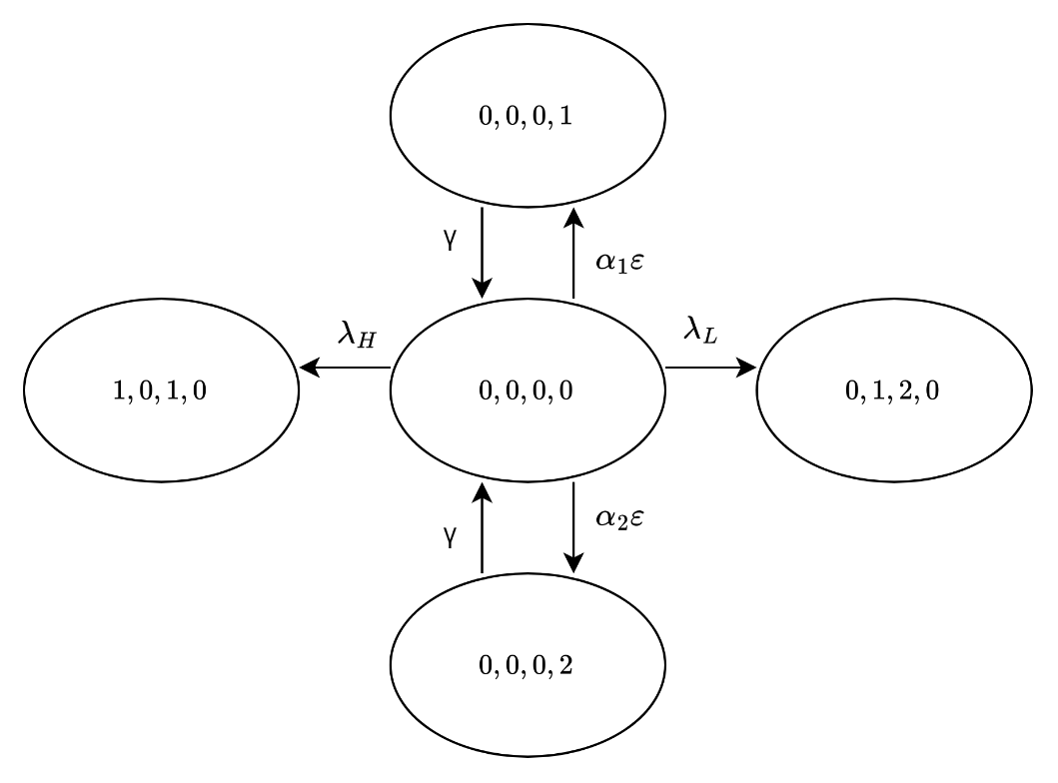

Figure 3‑47 The state transition diagram of

**Case 1**: $i=0, j=0, k=0, and l=0$

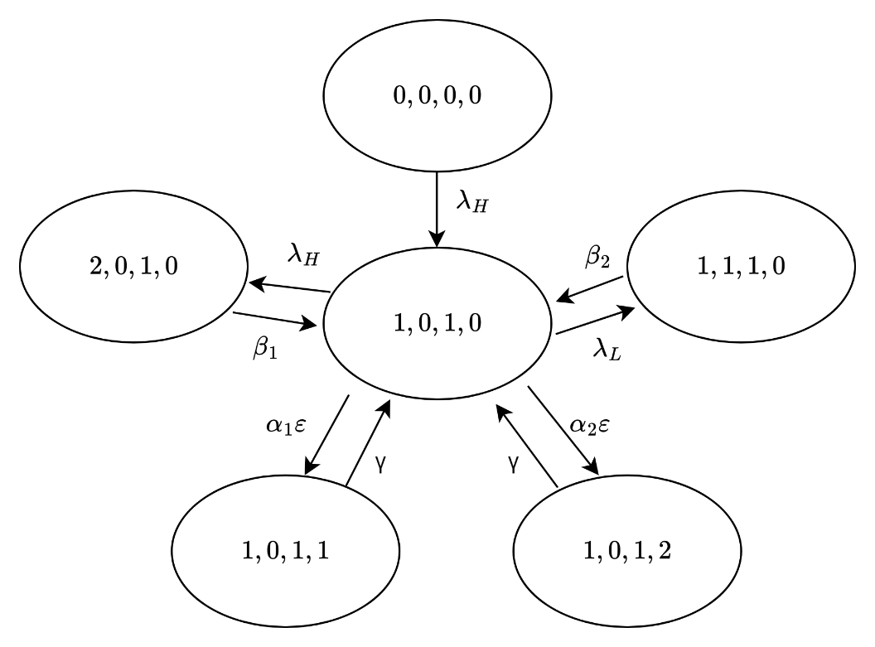

Figure 3‑48 The state transition diagram of

**Case 2**: $i=1, j=0, k=1, and l=0$

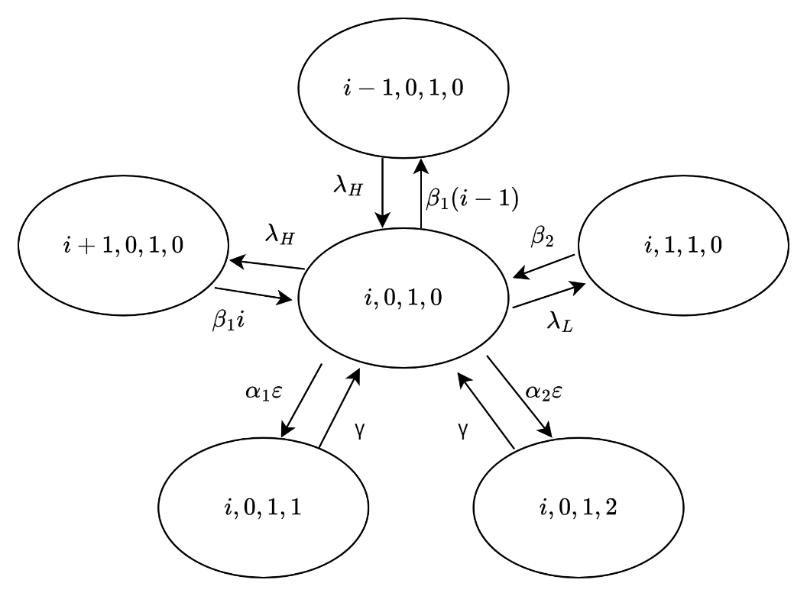

Figure 3‑49 The state transition diagram of

**Case 3**: $1<i<N-R, j=0, k=1, and l=0$

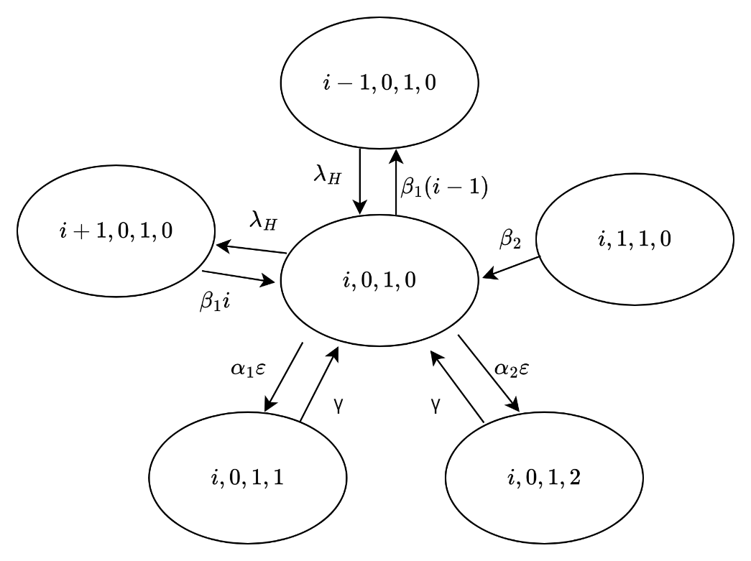

Figure 3‑50 The state transition diagram of

**Case 4**: $N-R<i<N, j=0, k=1, and l=0$

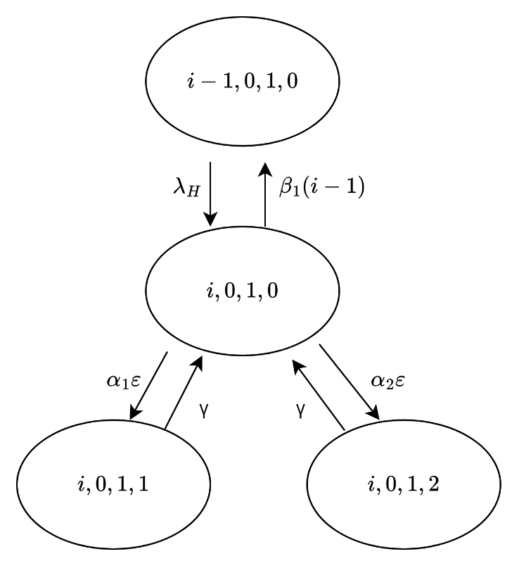

Figure 3‑51 The state transition diagram of

**Case 5**: $i=N, j=0, k=1, and l=0$

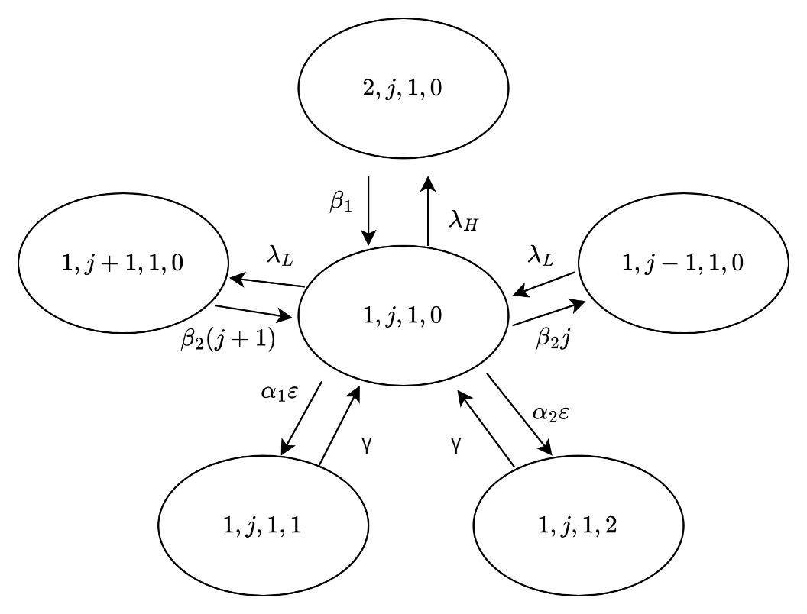

Figure 52 The state transition diagram of

**Case 6**: $i=1, 0<j<N-R-1, k=1, and l=0$

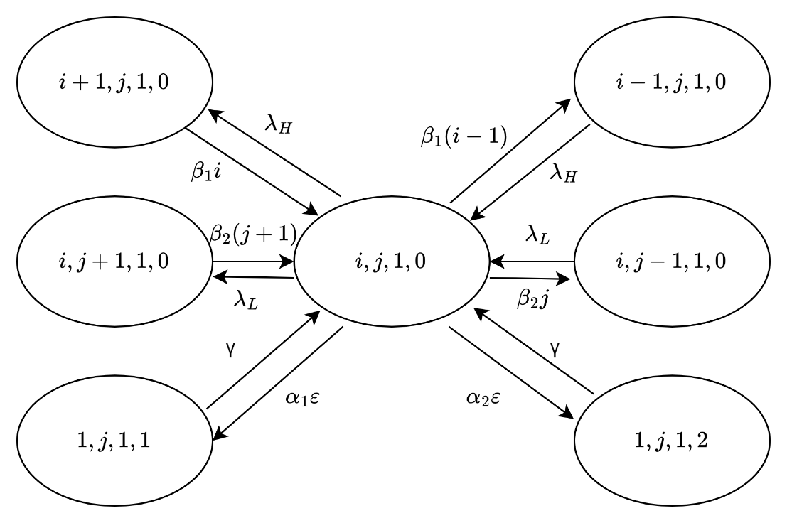

Figure 53 The state transition diagram of

**Case 7**: $1<i<N-R-j, 0<j<N-R-1, k=1, and l=0$

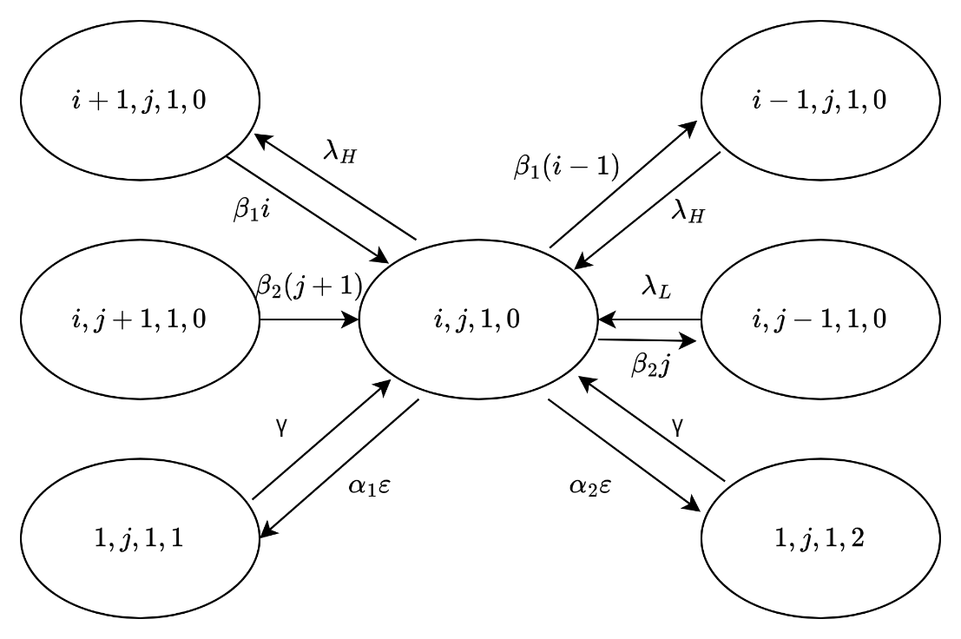

Figure 54 The state transition diagram of

**Case 8**: $i=N-R-j, 0<j<N-R-1, k=1, and l=0$

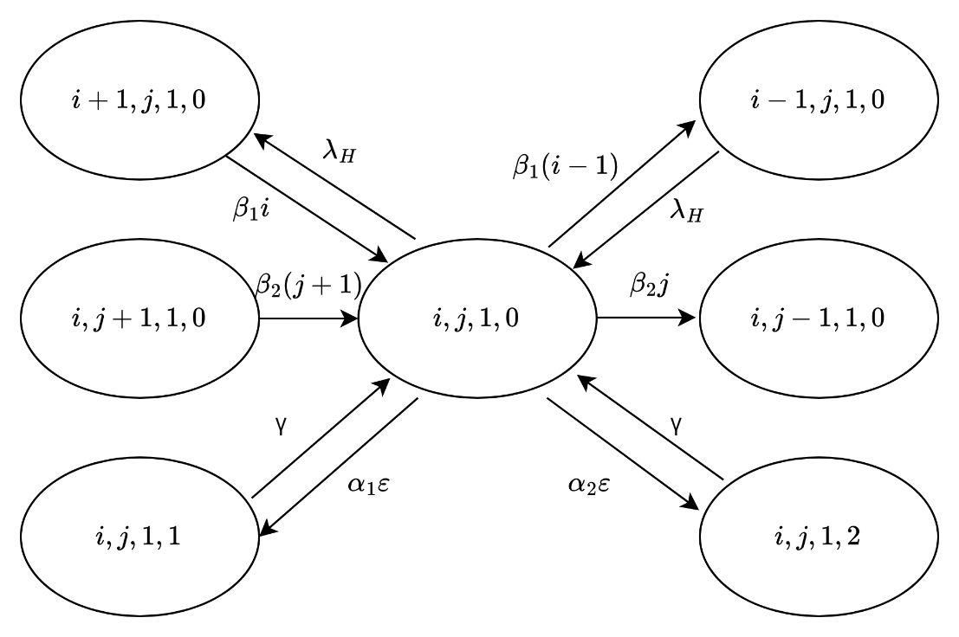

Figure 55 The state transition diagram of

**Case 9**: $N-R-j<i<N-j, 0<j<N-R-1, k=1, and l=0$

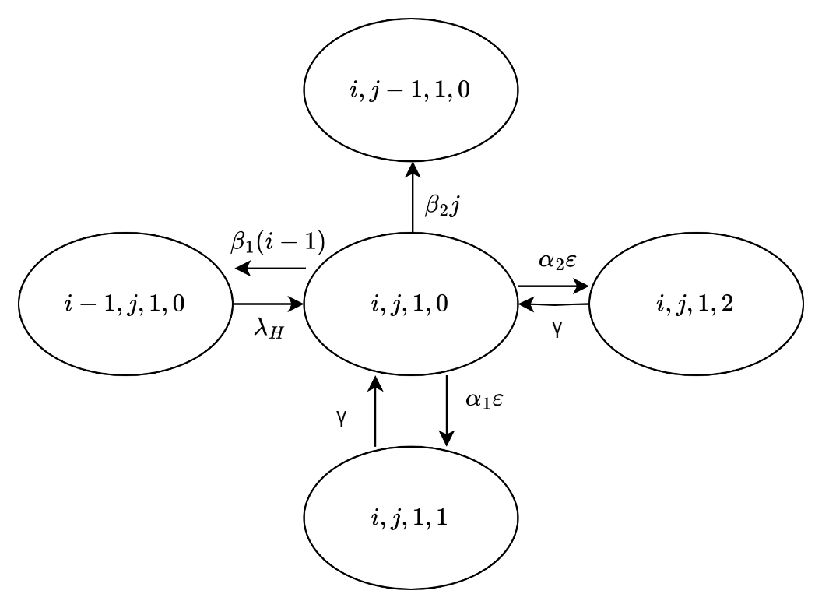

Figure 56 The state transition diagram of

**Case 10**: $i=N-j, 0<j<N-R-1, k=1, and l=0$

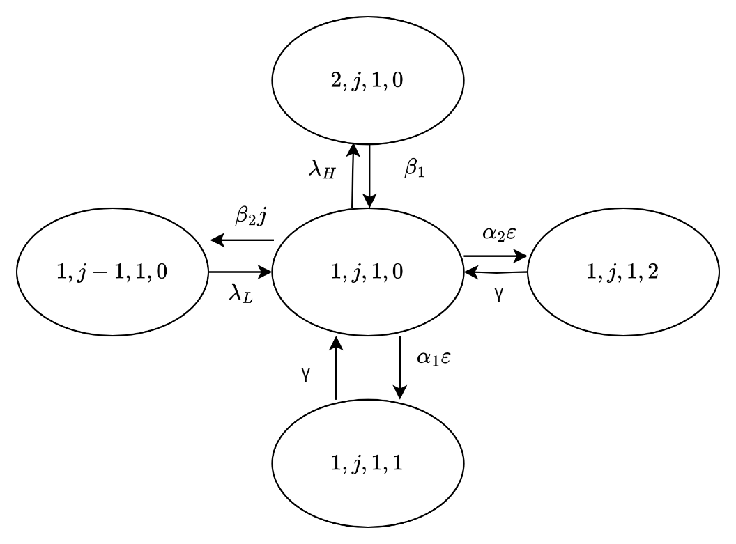

Figure 57 The state transition diagram of

**Case 11**: $i=1, j=N-R-1, k=1, and l=0$

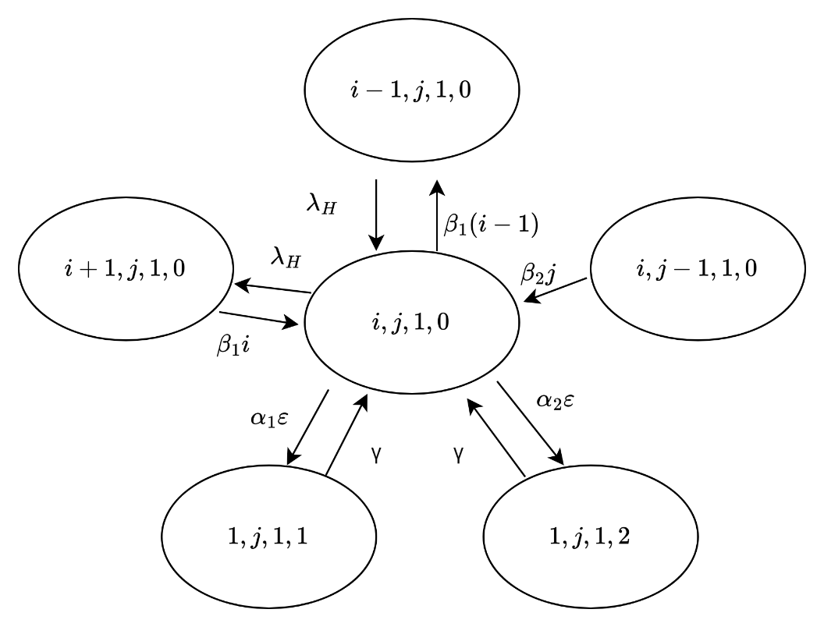

Figure 58 The state transition diagram of

**Case 12**: $1<i<N-j, j=N-R-1, k=1, and l=0$

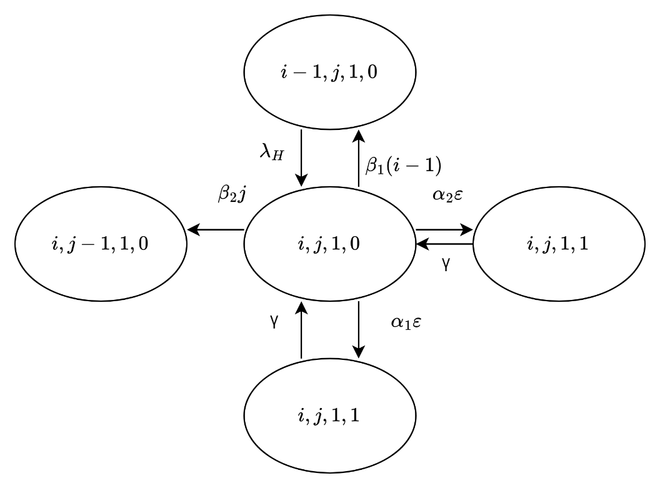

Figure 59 The state transition diagram of

**Case 13**: $i=N-j, j=N-R-1, k=1, and l=0$

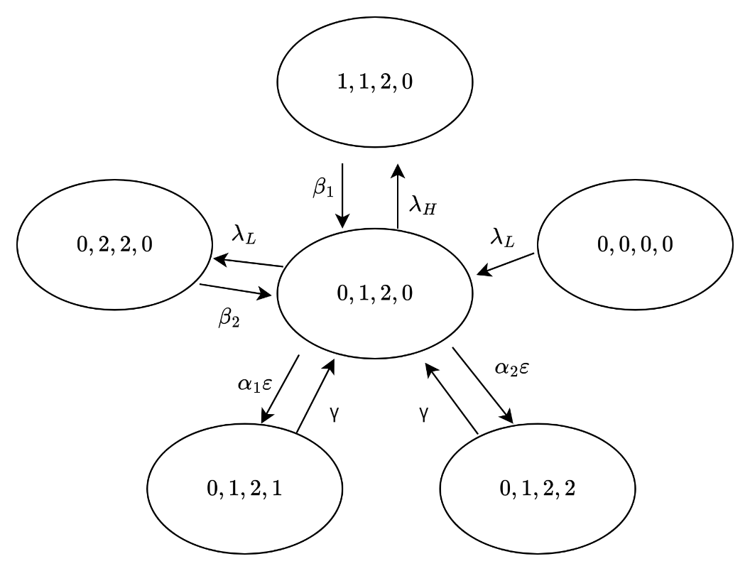

Figure 60 The state transition diagram of

**Case 14**: $i=0, j=1, k=2, and l=0$

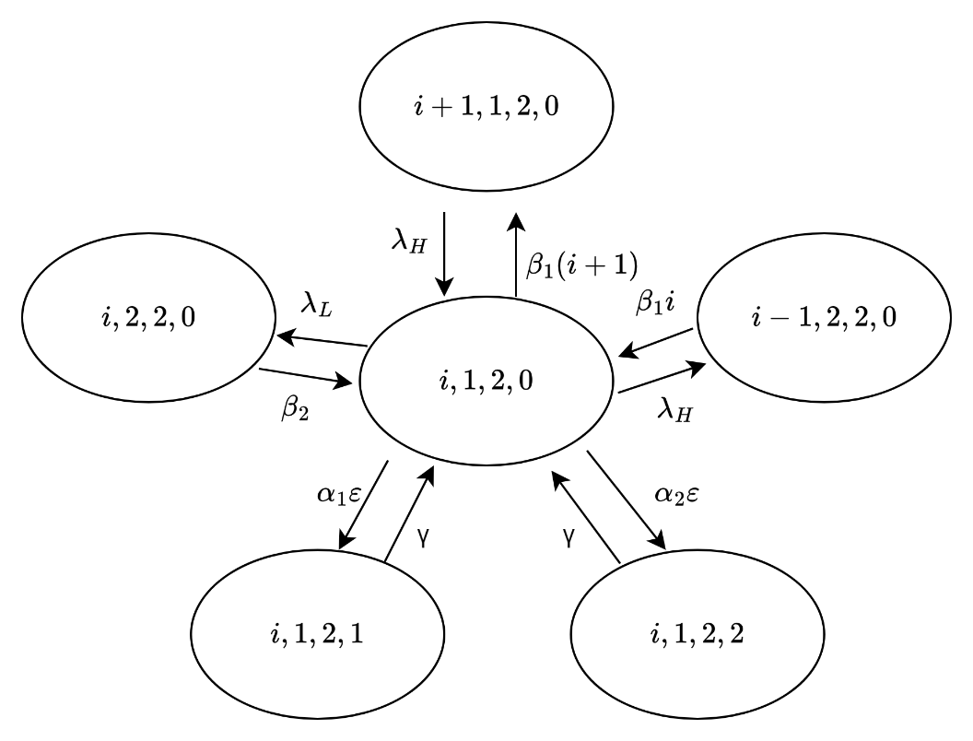

Figure 61 The state transition diagram of

**Case 15**: $0<i<N-R-1, j=1, k=2, and l=0$

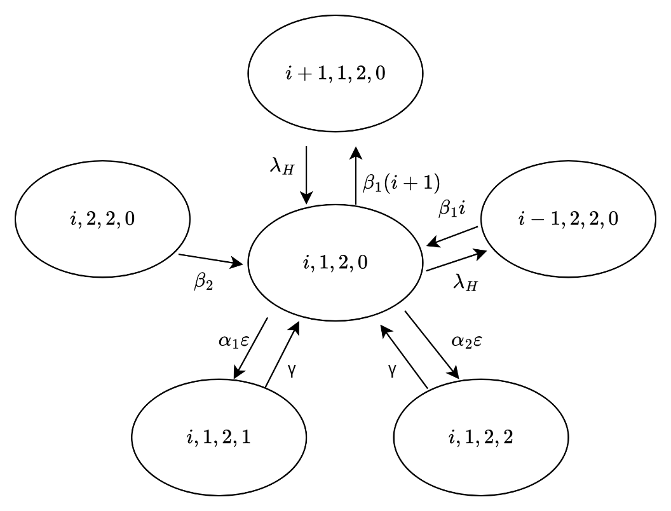

Figure 62 The state transition diagram of

**Case 16**: $N-R-1≤i<N-1, j=1, k=2, and l=0$

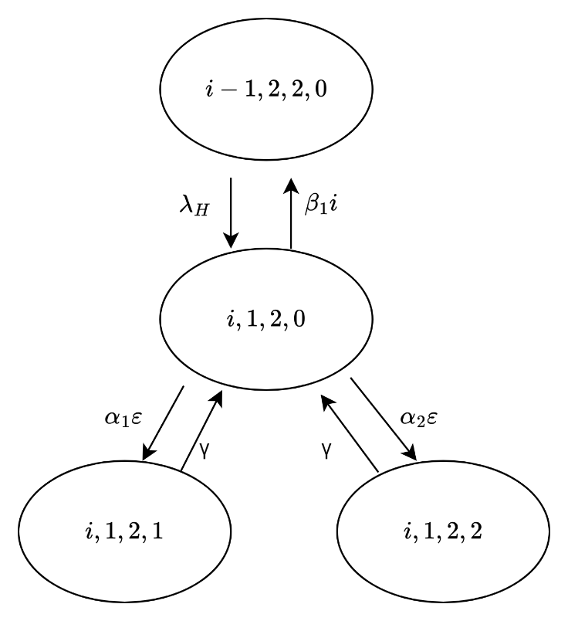

Figure 63 The state transition diagram of

**Case 17**: $i=N-1, j=1, k=2, and l=0$

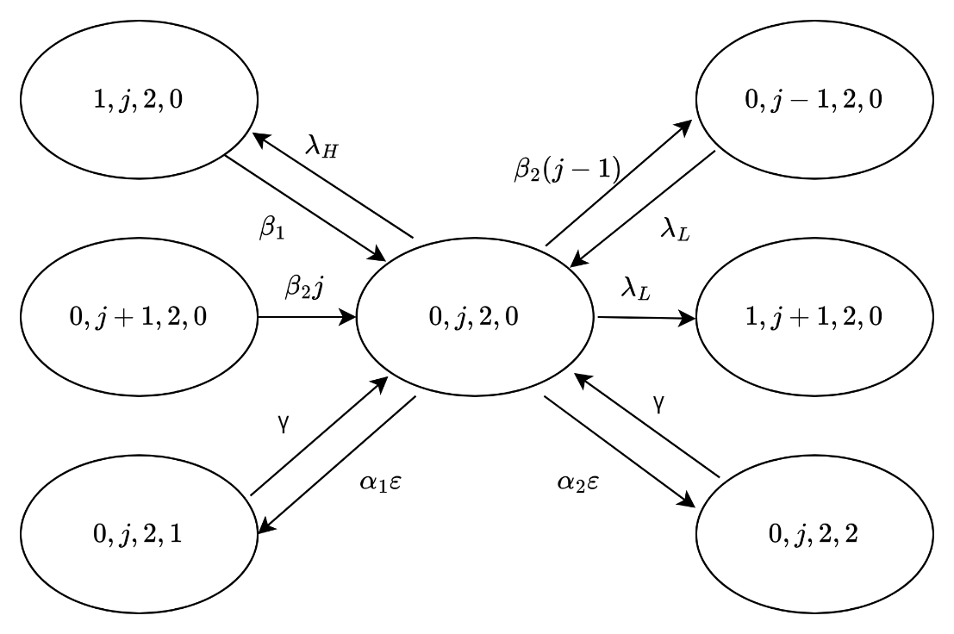

Figure 64 The state transition diagram of

**Case 18**: $i=0, 1<j<N-R, k=2, and l=0$

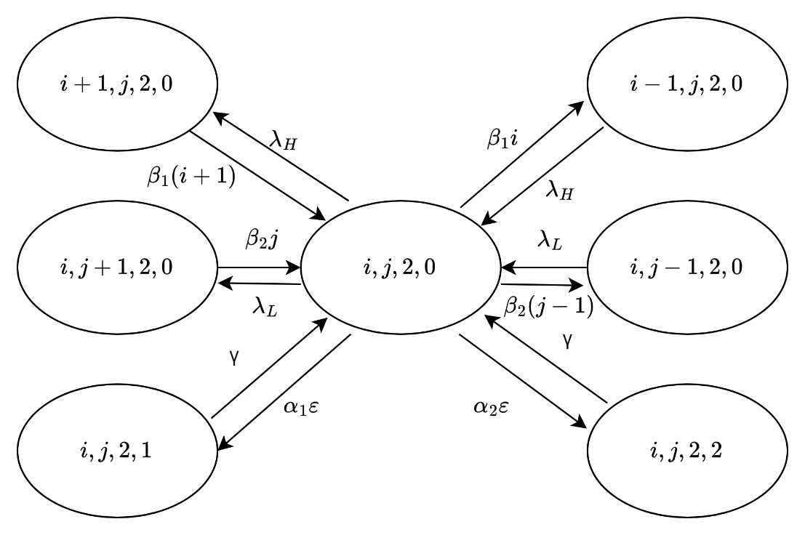

Figure 65 The state transition diagram of

**Case 19**: $0<i<N-R-j, 1<j<N-R, k=2, and l=0$

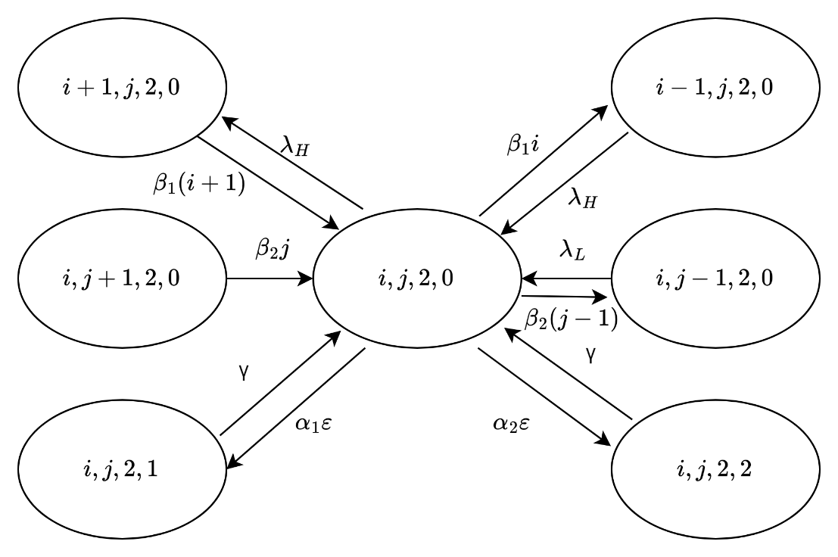

Figure 66 The state transition diagram of

**Case 20**: $i=N-R-j, 1<j<N-R, k=2, and l=0$

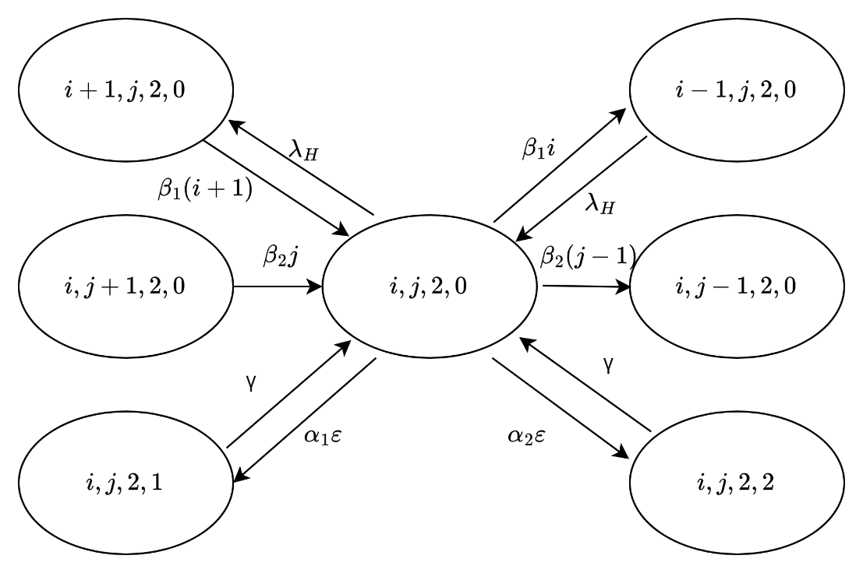

Figure 67 The state transition diagram of

**Case 21**: $N-R-j<i<N-j, 1<j<N-R, k=2, and l=0$

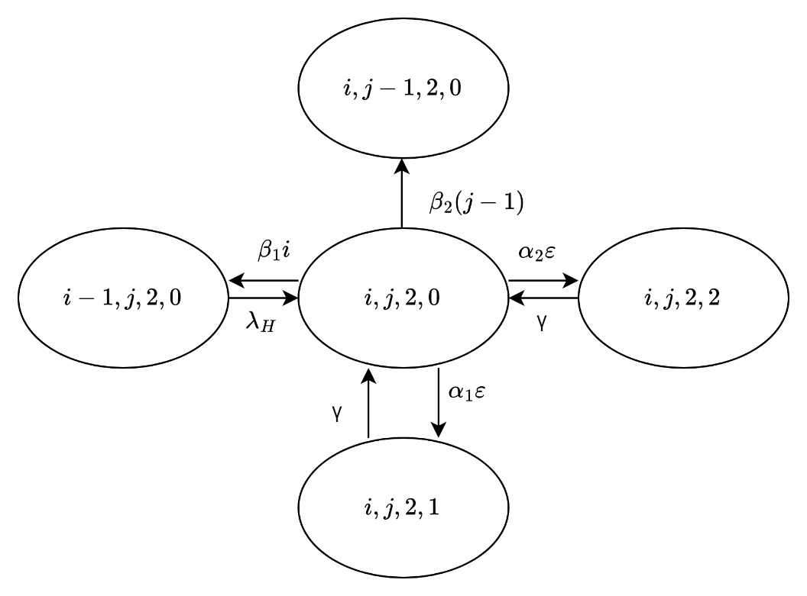

Figure 68 The state transition diagram of

**Case 22**: $i=N-j, 1<j<N-R, k=2, and l=0$

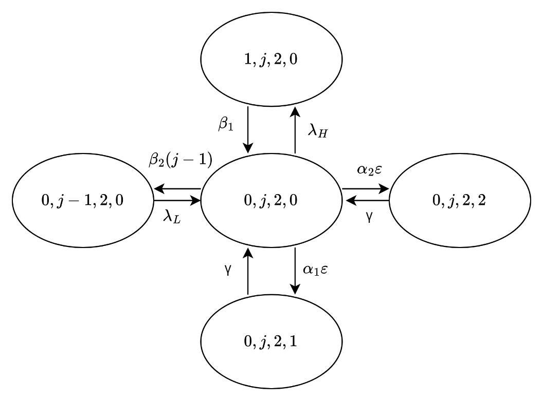

Figure 69 The state transition diagram of

**Case 23**: $i=0, j=N-R, k=2, and l=0$

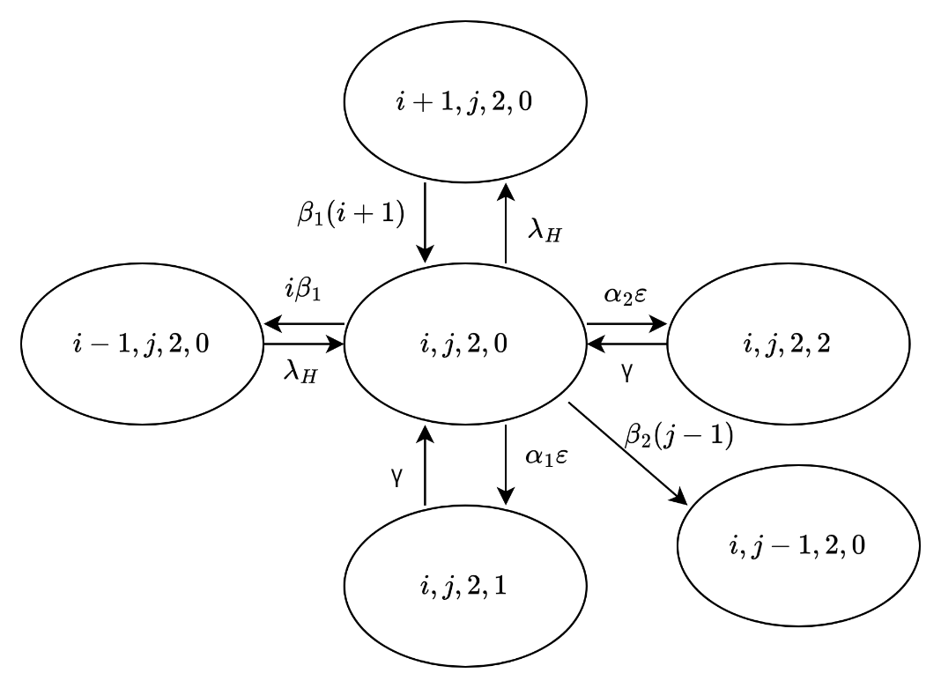

Figure 70 The state transition diagram of

**Case 24**: $0<i<N-j, j=N-R, k=2, and l=0$

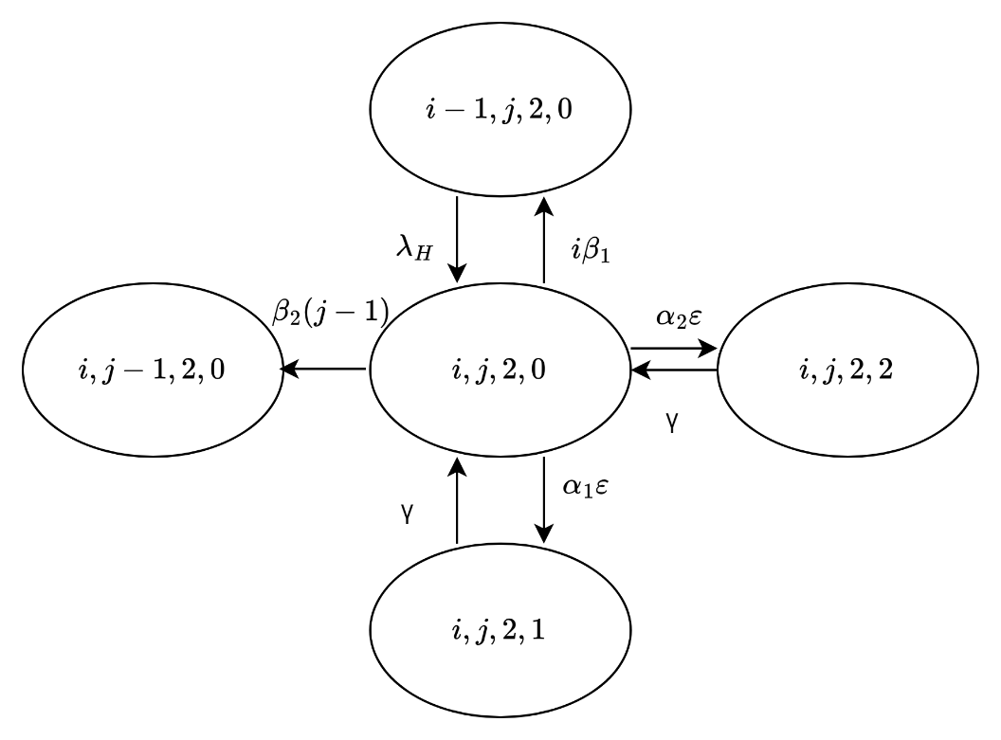

Figure 71 The state transition diagram of

**Case 25**: $i=N-j, j=N-R, k=2, and l=0$

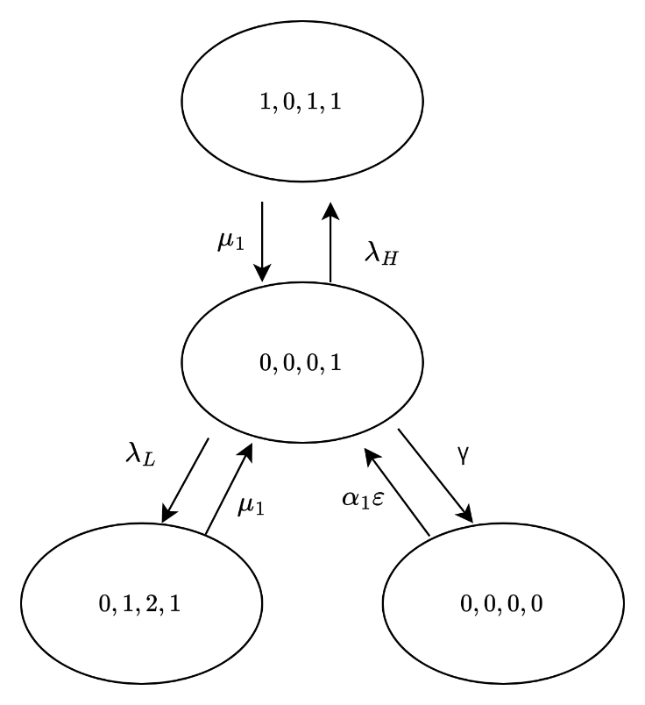

Figure 72 The state transition diagram of

**Case 26**: $i=0, j=0, k=0, and l=1$

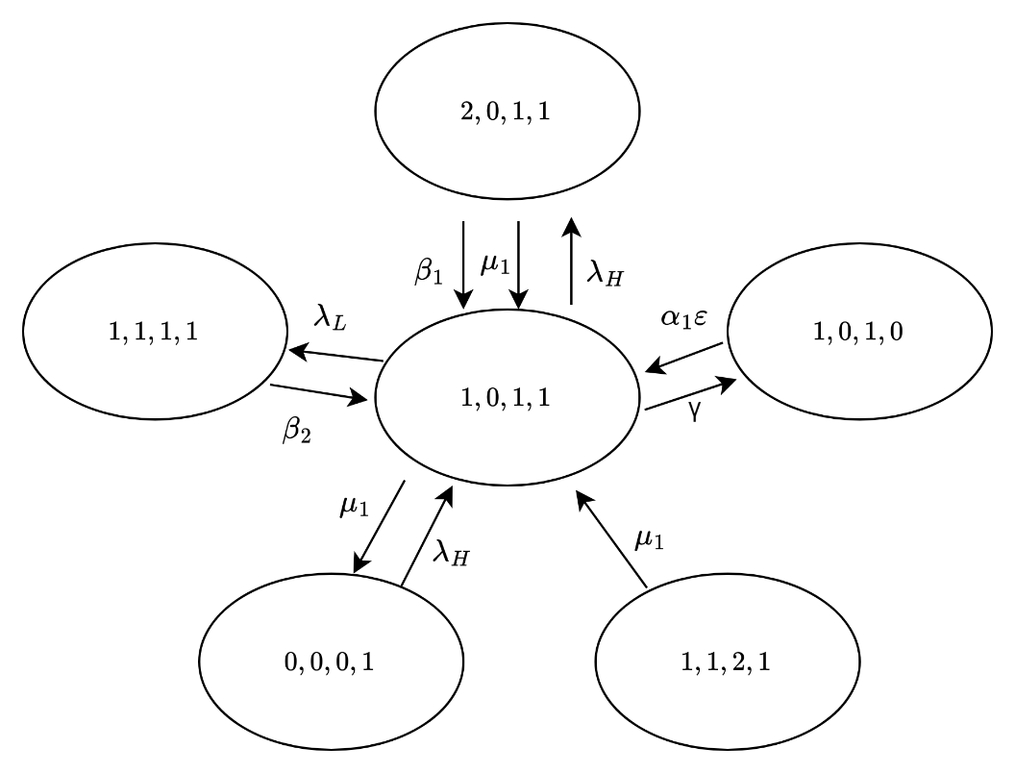

Figure 73 The state transition diagram of

**Case 27**: $i=1, j=0, k=1, and l=1$

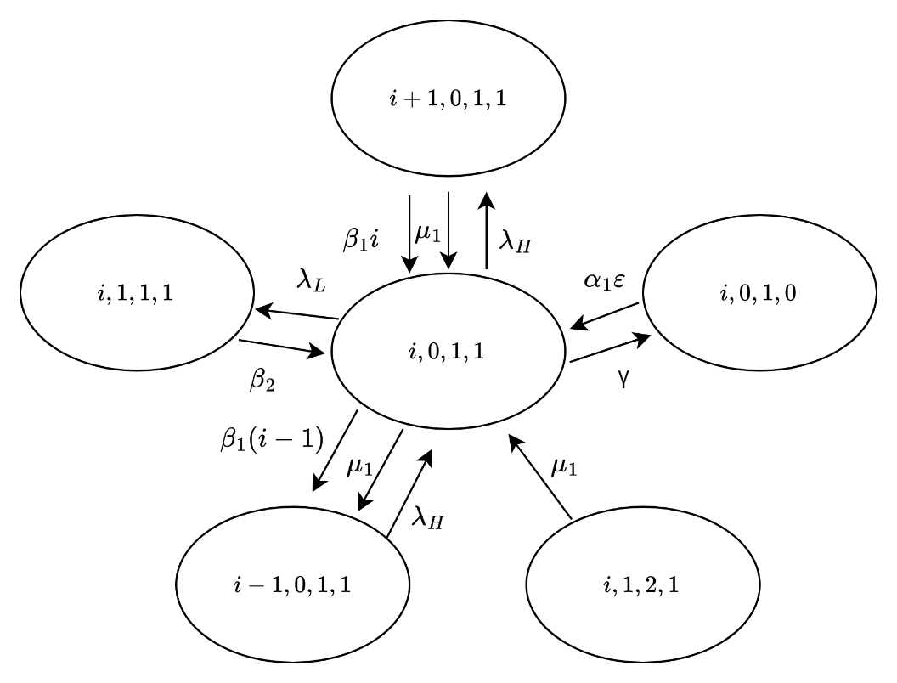

Figure 74 The state transition diagram of

**Case 28**: $1<i<N-R, j=0, k=1, and l=1$

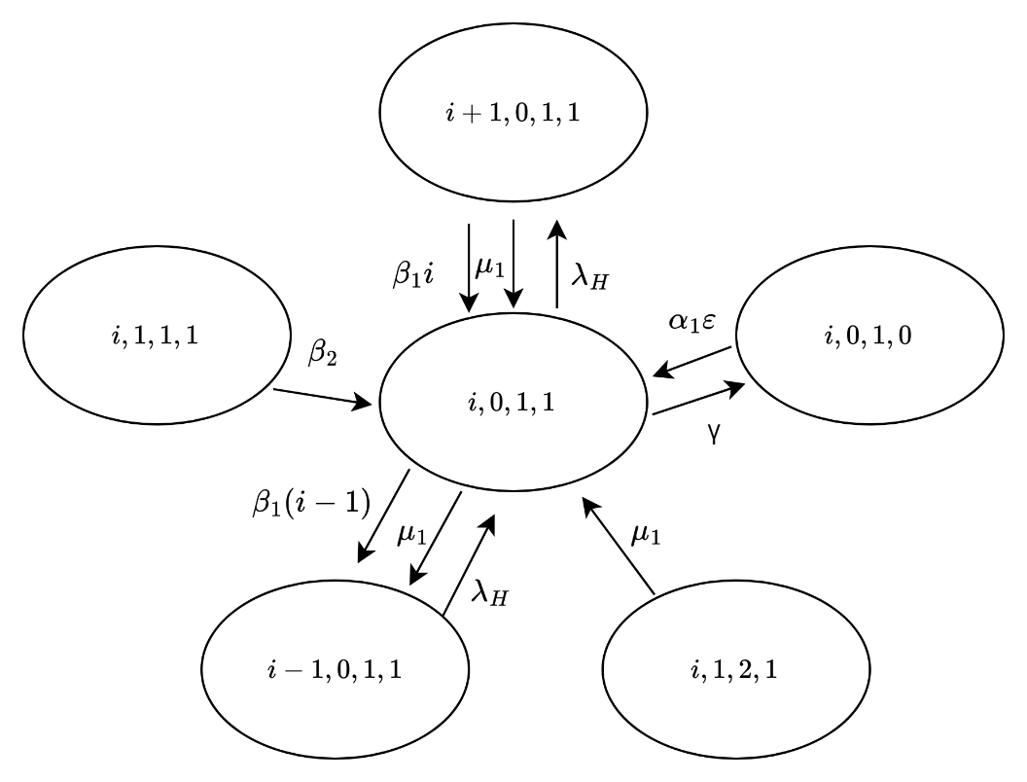

Figure 75 The state transition diagram of

**Case 29**: $N-R≤i<N, j=0, k=1, and l=1$

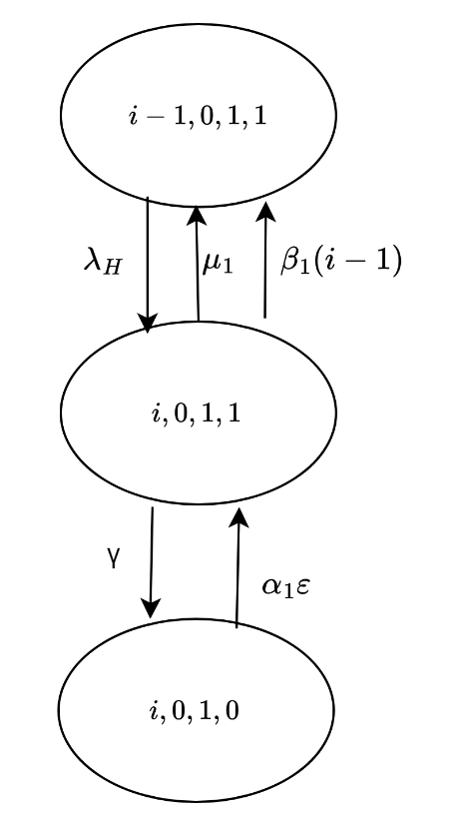

Figure 76 The state transition diagram of

**Case 30**: $i=N, j=0, k=1, and l=1$

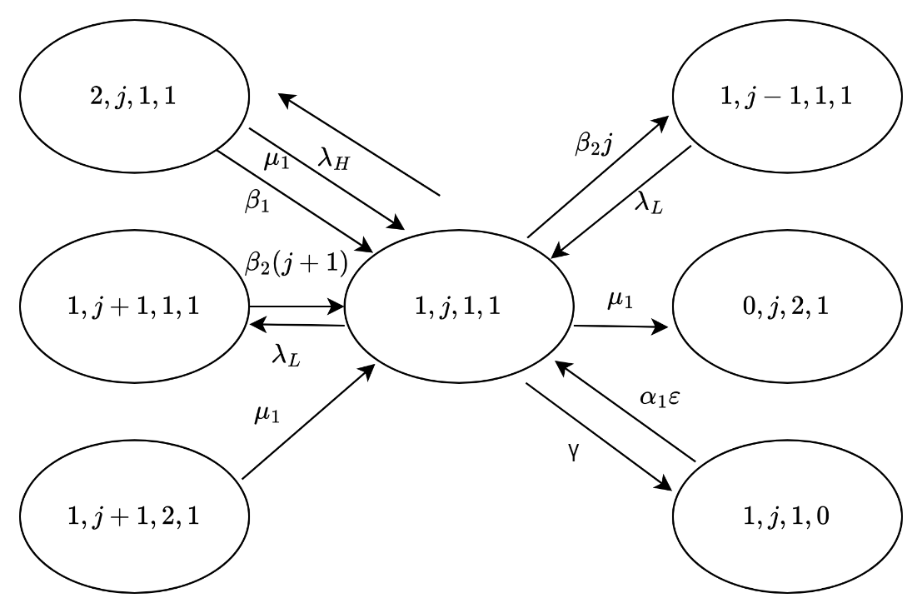

Figure 77 The state transition diagram of

**Case 31**: $i=1, 0<j<Ν-R-1, k=1, and l=1$

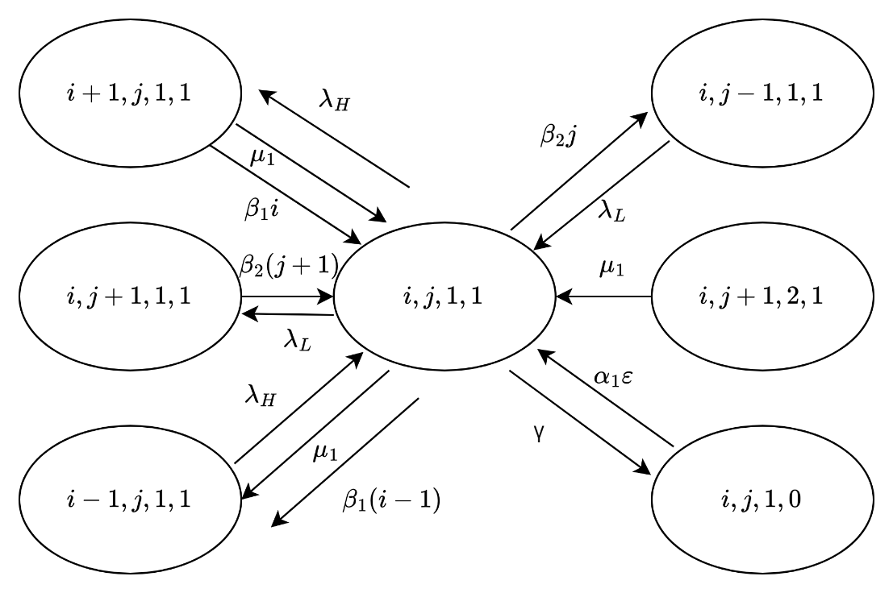

Figure 78 The state transition diagram of

**Case 32**: $1<i<Ν-R-j, 0<j<Ν-R-1, k=1, and l=1$

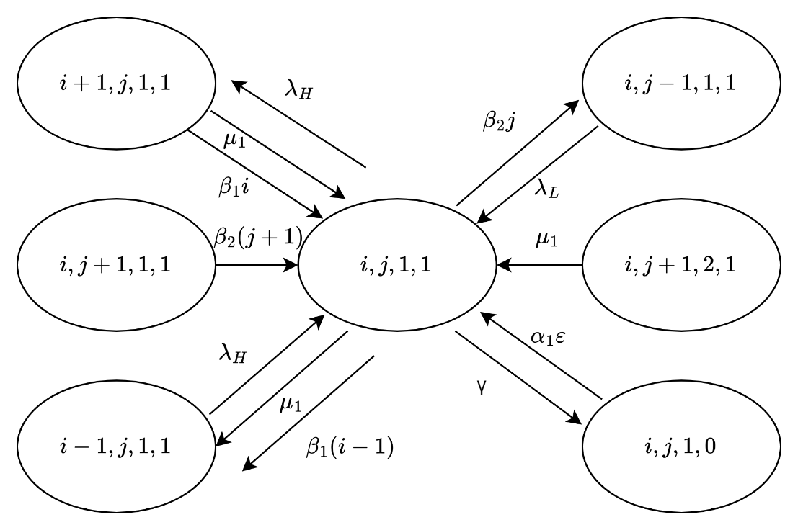

Figure 79 The state transition diagram of

**Case 33**: $i=Ν-R-j, 0<j<Ν-R-1, k=1, and l=1$

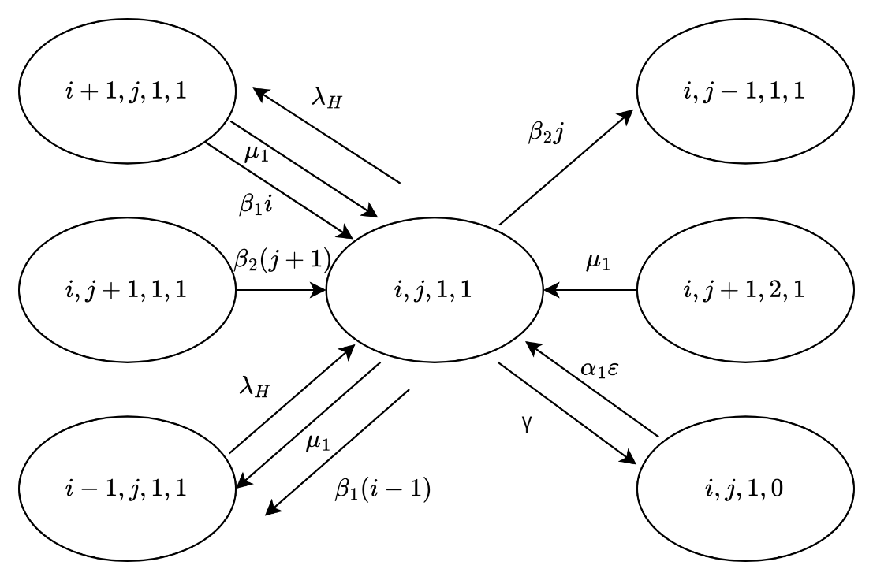

Figure 80 The state transition diagram of

**Case 34**: $N-R-j<i<Ν-j, 0<j<Ν-R-1, k=1, and l=1$

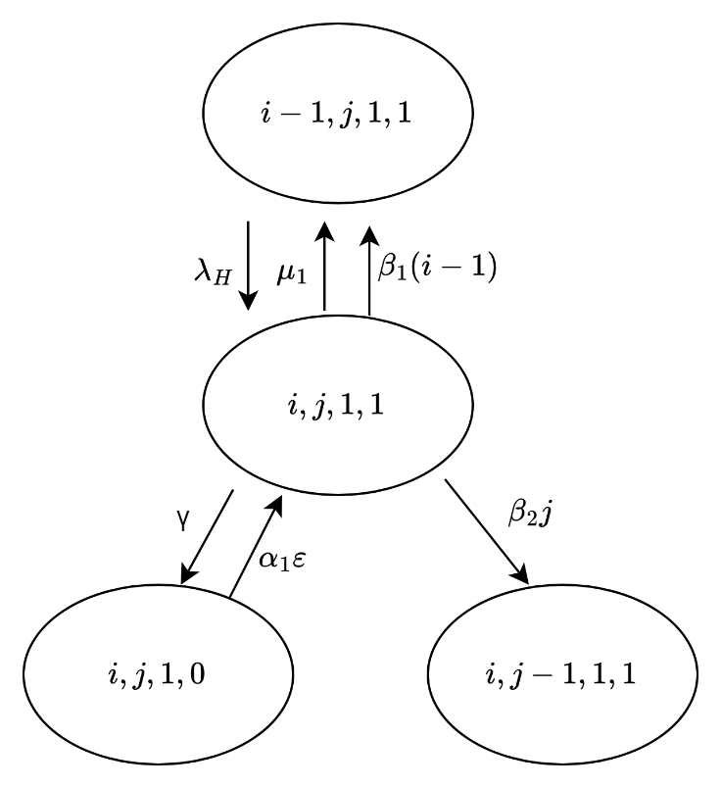

Figure 81 The state transition diagram of

**Case 35**: $i=Ν-j, 0<j<Ν-R-1, k=1, and l=1$

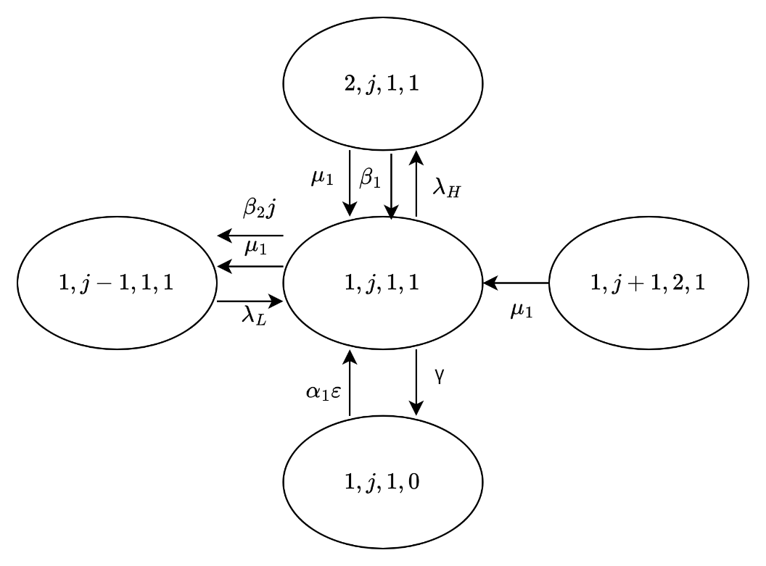

Figure 82 The state transition diagram of

**Case 36**: $i=1, j=Ν-R-1, k=1, and l=1$

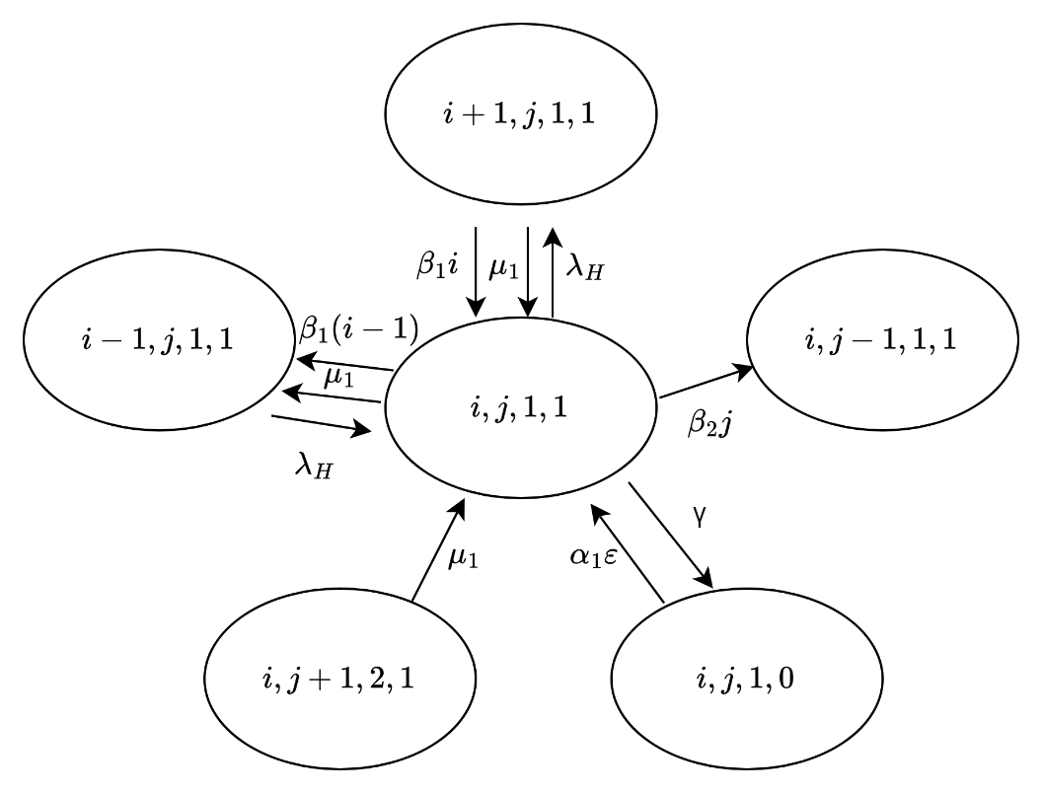

Figure 83 The state transition diagram of

**Case 37**: $1<i<Ν-j, j=Ν-R-1, k=1, and l=1$

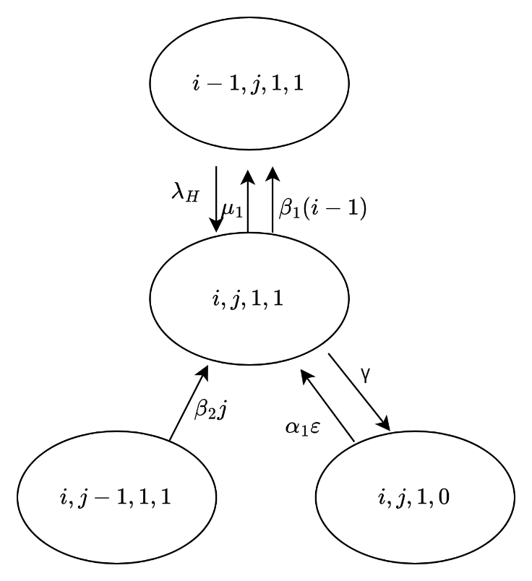

Figure 84 The state transition diagram of

**Case 38**: $i=Ν-j, j=Ν-R-1, k=1, and l=1$

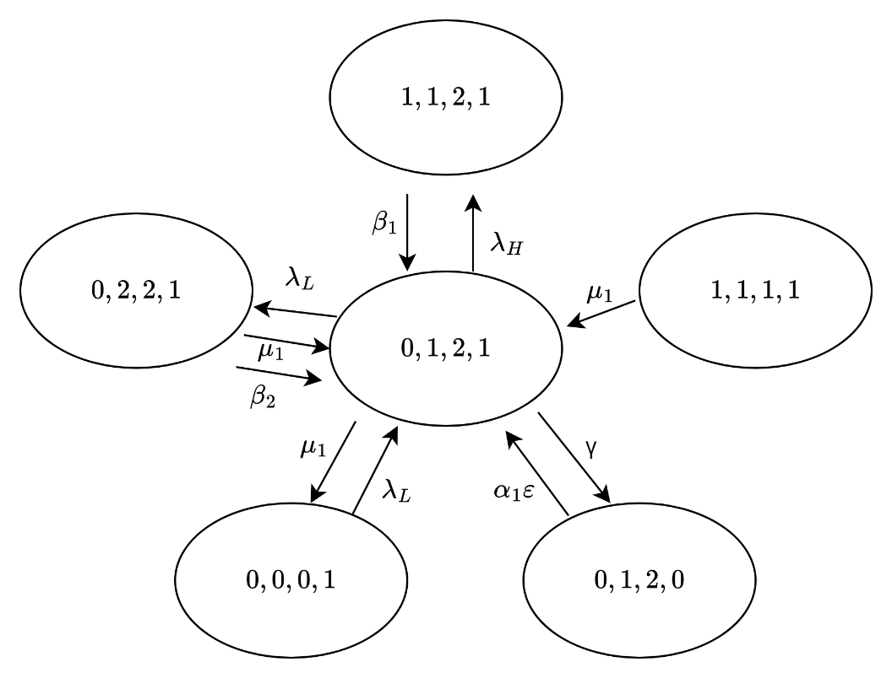

Figure 85 The state transition diagram of

**Case 39**: $i=0, j=1, k=2, and l=1$

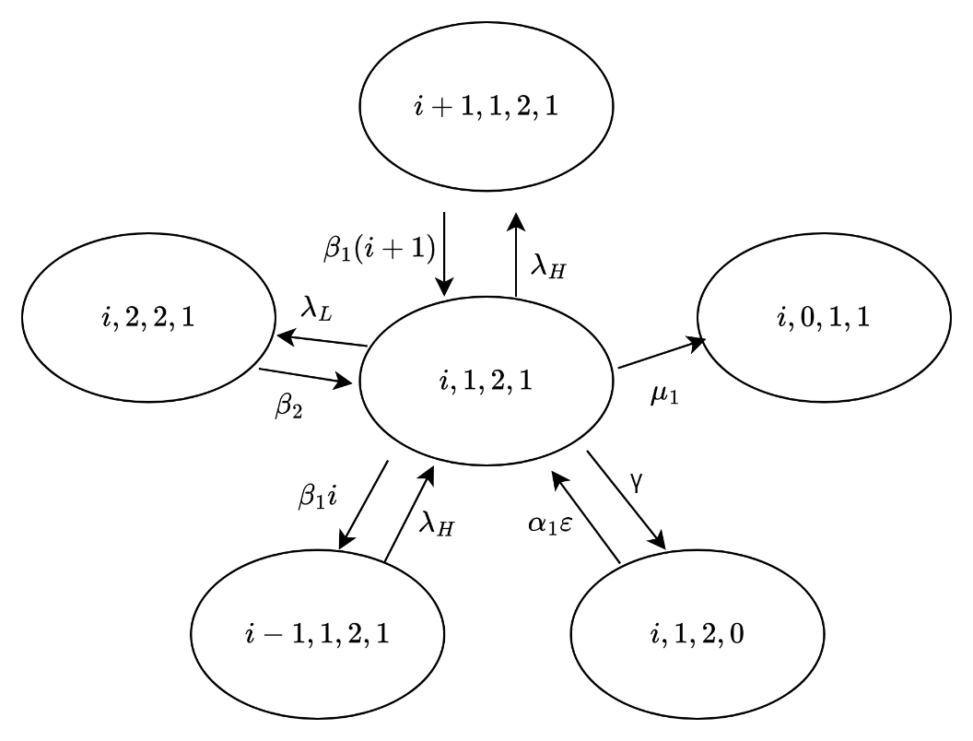

Figure 86 The state transition diagram of

**Case 40**: $0<i<Ν-R-1, j=1, k=2, and l=1$

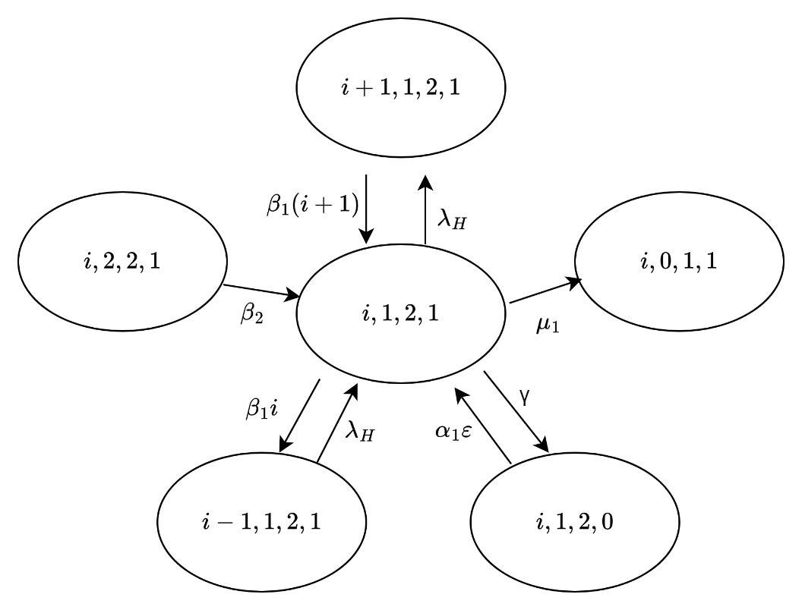

Figure 87 The state transition diagram of

**Case 41**: $Ν-R-1≤i<Ν-1, j=1, k=2, and l=1$

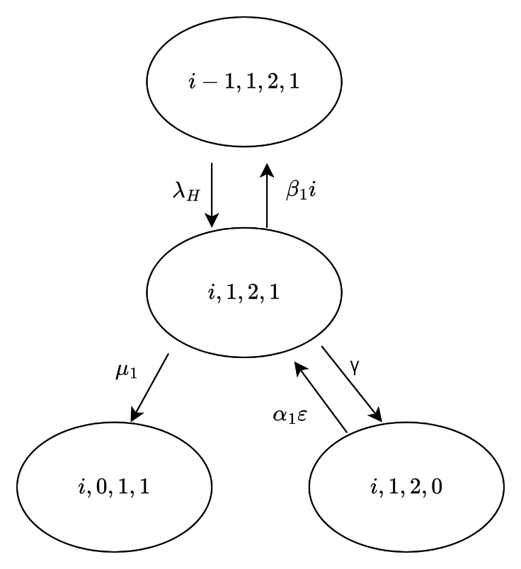

Figure 88 The state transition diagram of

**Case 42**: $i=Ν-1, j=1, k=2, and l=1$

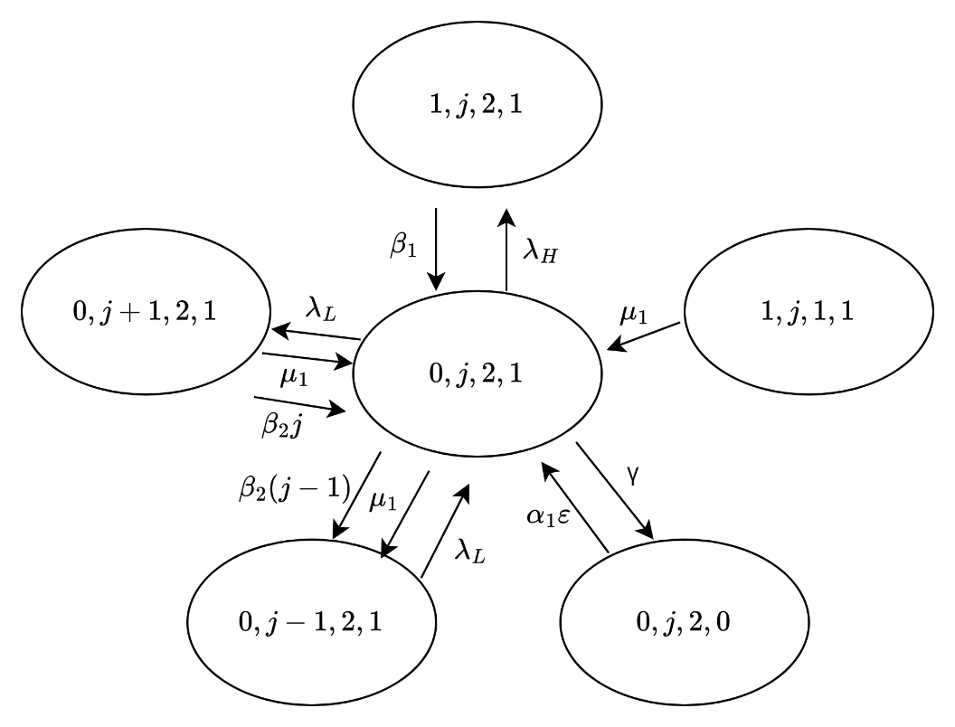

Figure 89 The state transition diagram of

**Case 43**: $i=0, 1<j<N-R, k=2, and l=1$

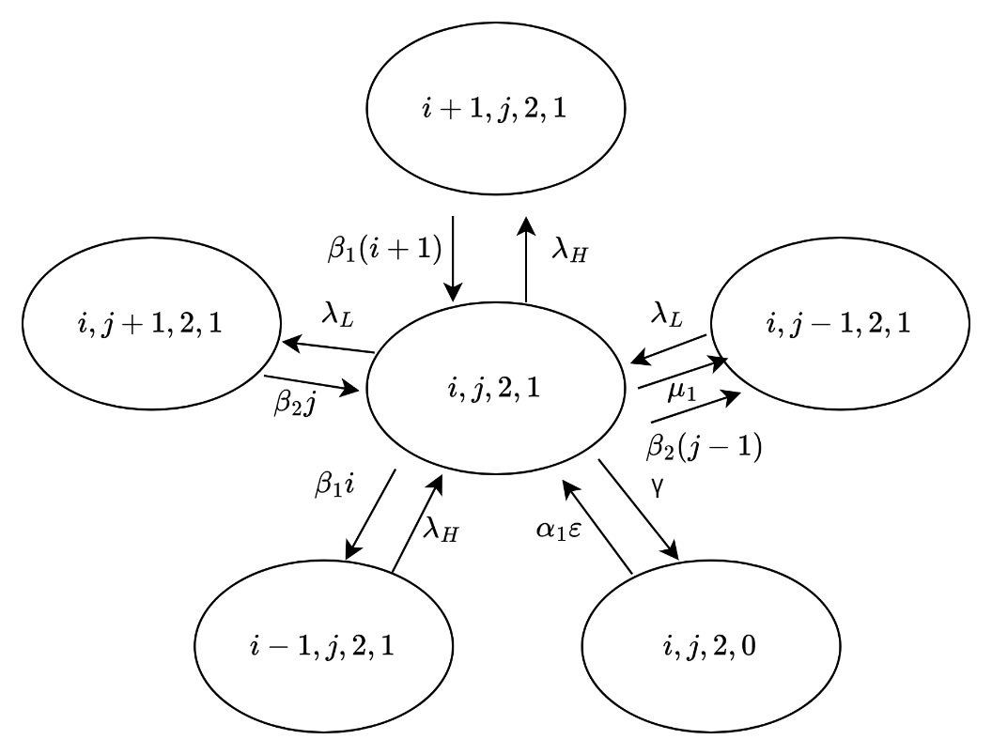

Figure 90 The state transition diagram of

**Case 44**: $0<i<N-R-j, 1<j<N-R, k=2, and l=1$

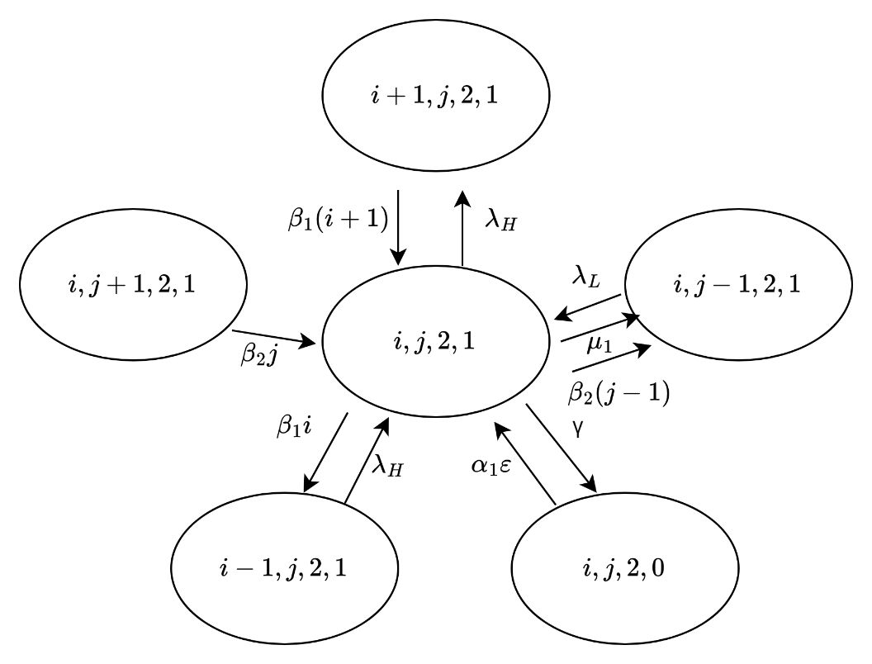

Figure 91 The state transition diagram of

**Case 45**: $i=N-R-j, 1<j<N-R, k=2, and l=1$

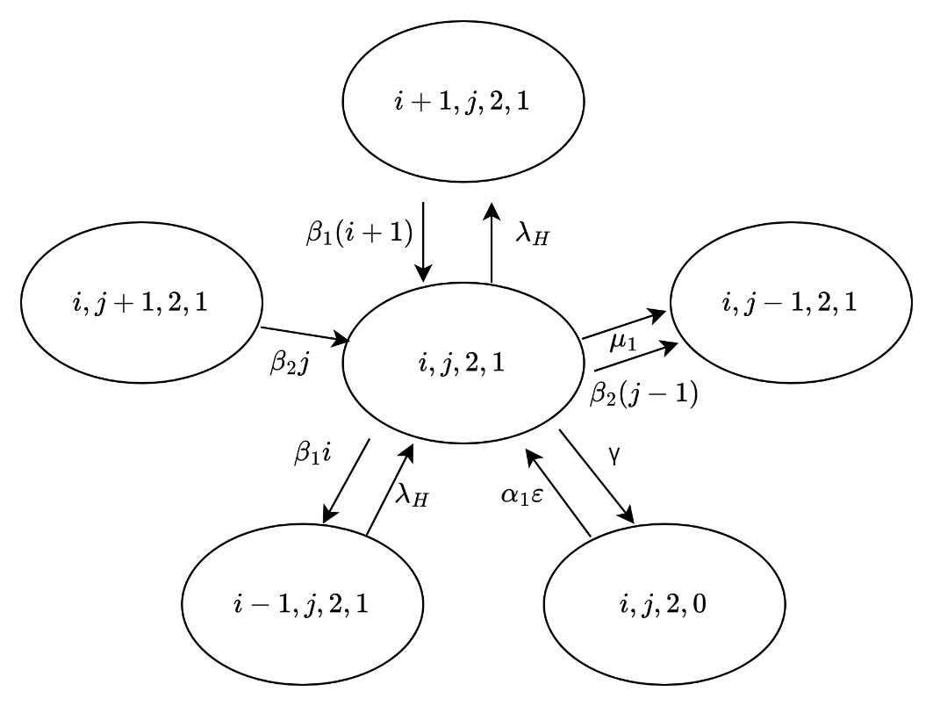

Figure 92 The state transition diagram of

**Case 46**: $N-R-j<i<N-j, 1<j<N-R, k=2, and l=1$

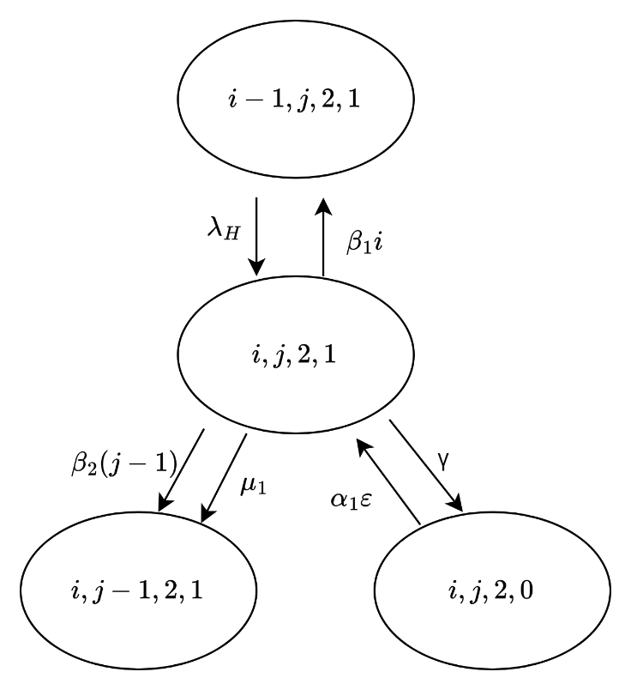

Figure 93 The state transition diagram of

**Case 47**: $i=N-j, 1<j<N-R, k=2, and l=1$

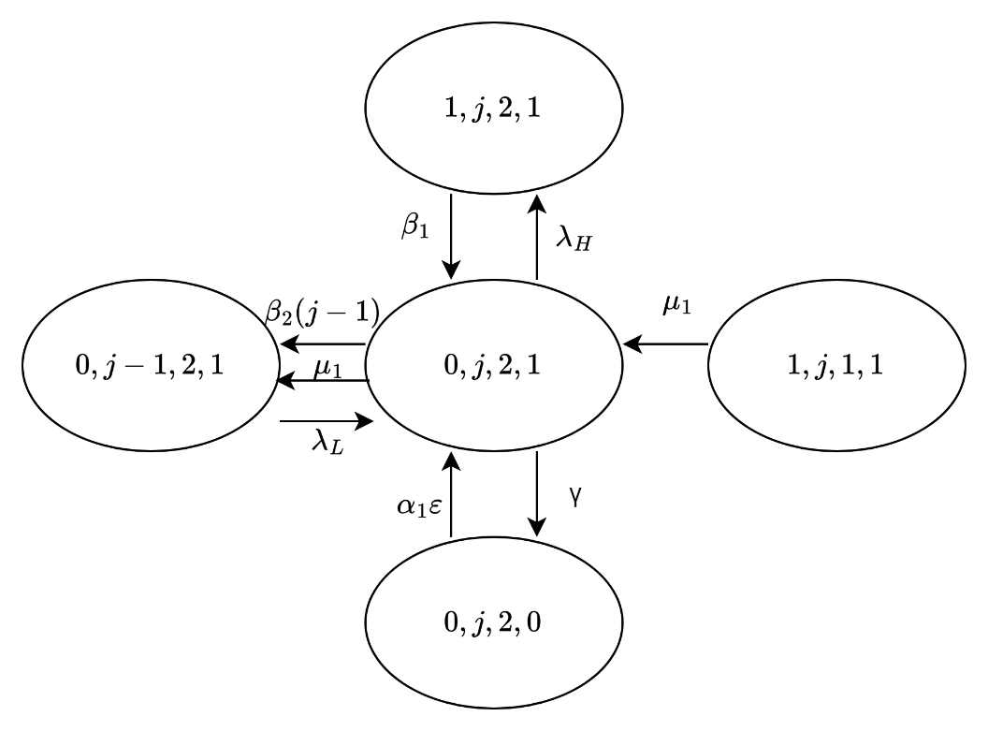

Figure 94 The state transition diagram of

**Case 48**: $i=0, j=N-R, k=2, and l=1$

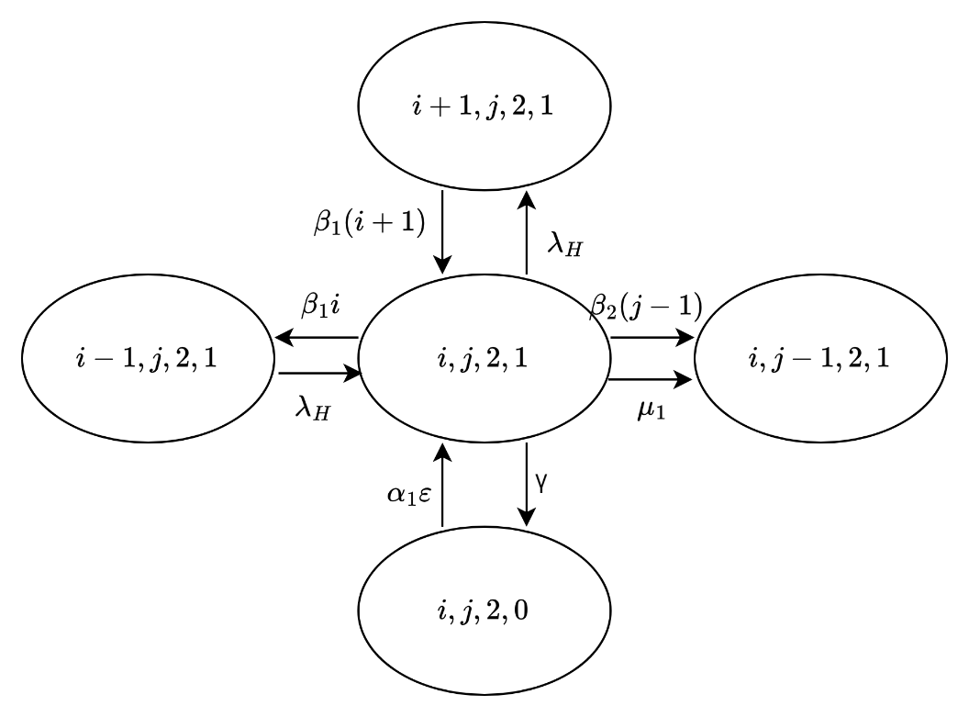

Figure 95 The state transition diagram of

**Case 49**: $0<i<N-j, j=N-R, k=2, and l=1$

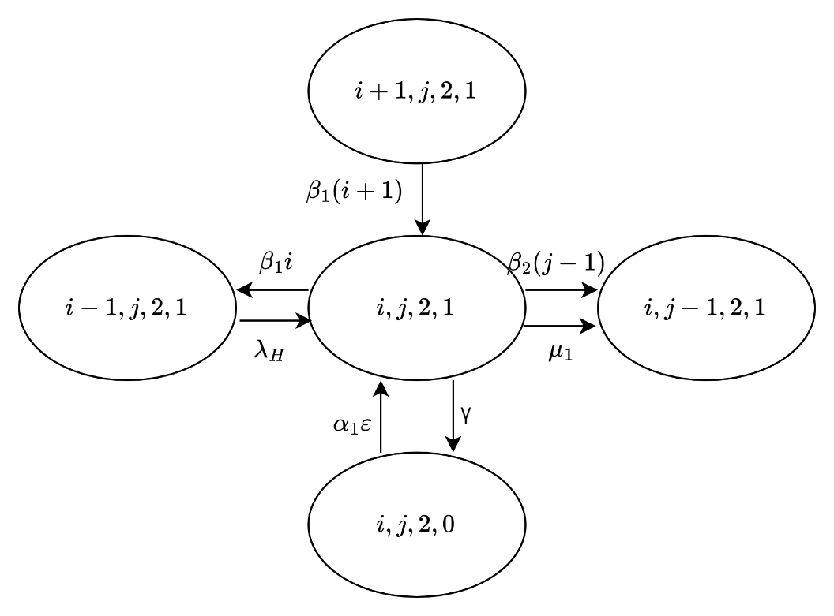

Figure 96 The state transition diagram of

**Case 50**: $i=N-j, j=N-R, k=2, and l=1$

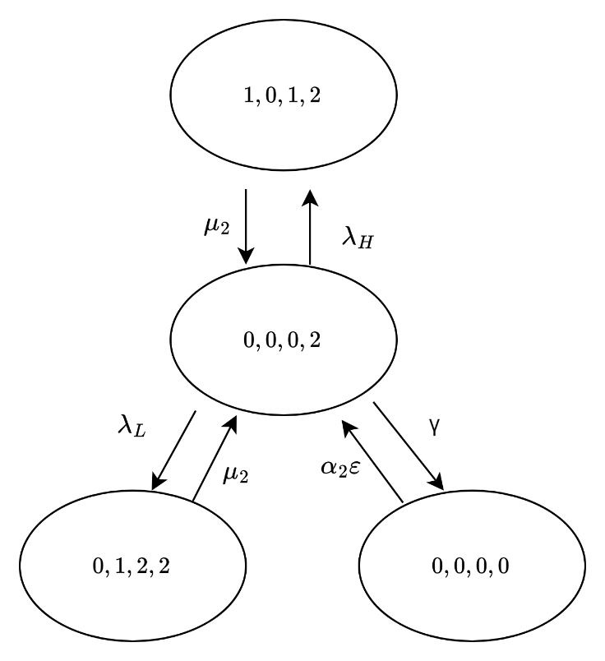

Figure 97 The state transition diagram of

**Case 51**: $i=0, j=0, k=0, and l=2$

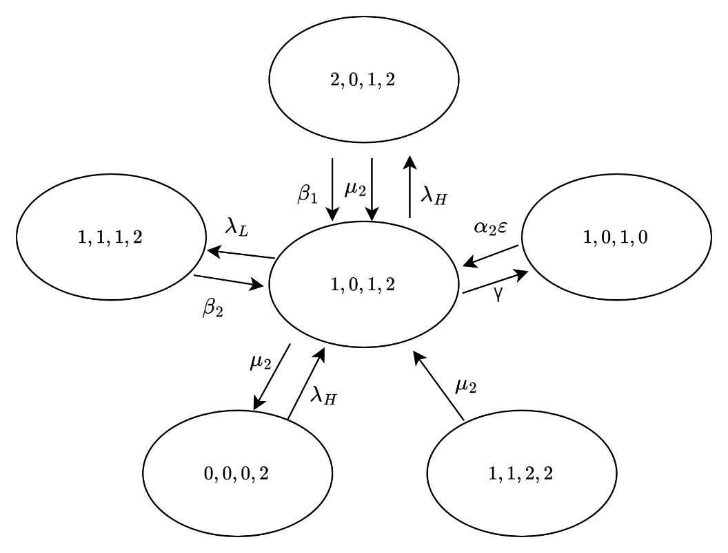

Figure 98 The state transition diagram of

**Case 52**: $i=1, j=0, k=1, and l=2$

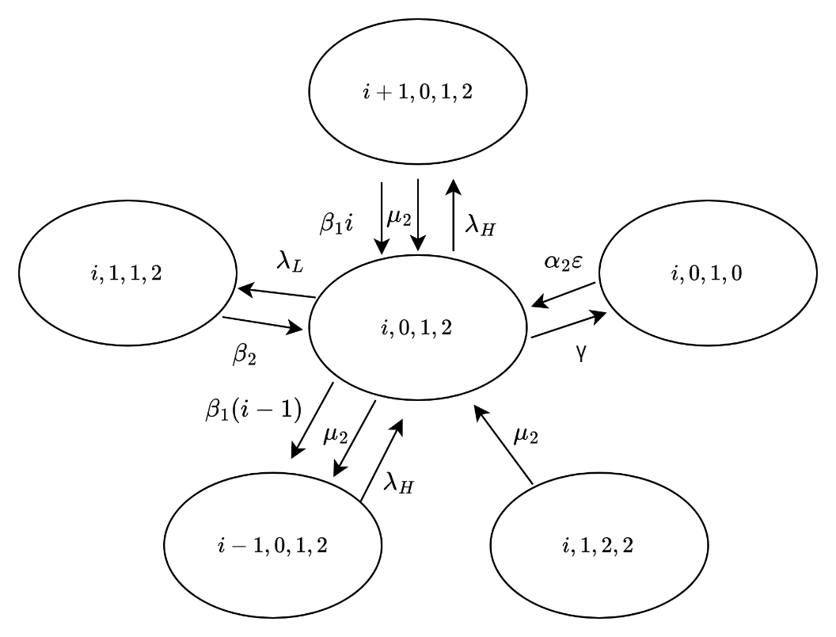

Figure 99 The state transition diagram of

**Case 53**: $1<i<N-R, j=0, k=1, and l=2$

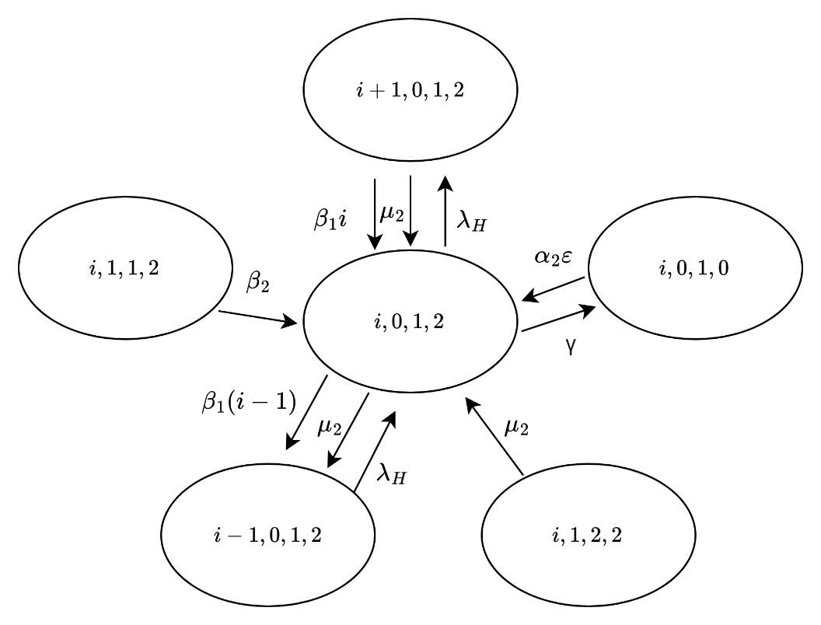

Figure 100 The state transition diagram of

**Case 54**: $N-R≤i<N, j=0, k=1, and l=2$

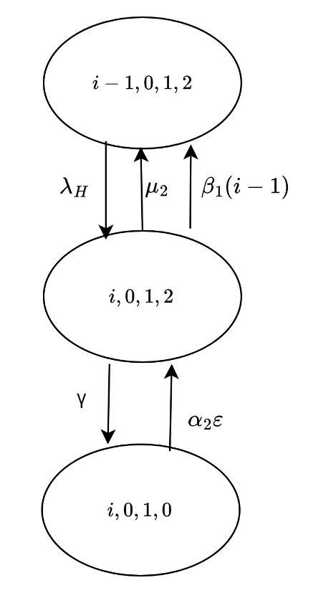

Figure 101 The state transition diagram of

**Case 55**: $i=1, j=0, k=1, and l=2$

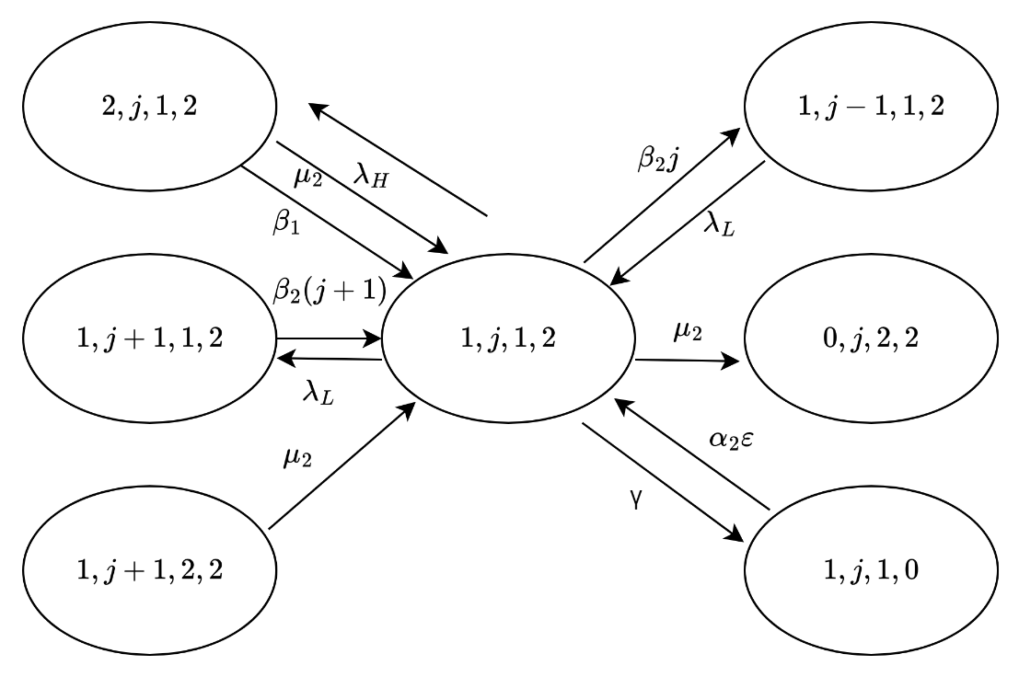

Figure 102 The state transition diagram of

**Case 56**: $i=1, 0<j<N-R-1,k=1, and l=2$

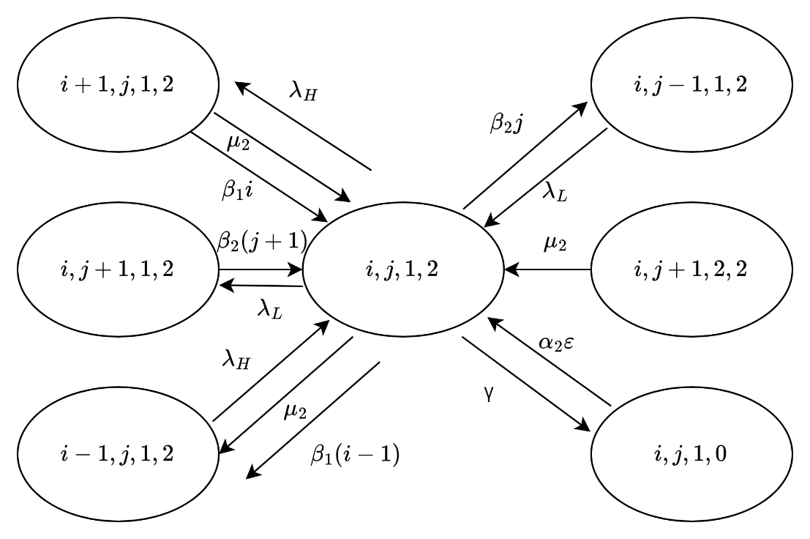

Figure 103 The state transition diagram of

**Case 57: $1<i<N-R-j,0<j<N-R-1,k=1, l=2$**

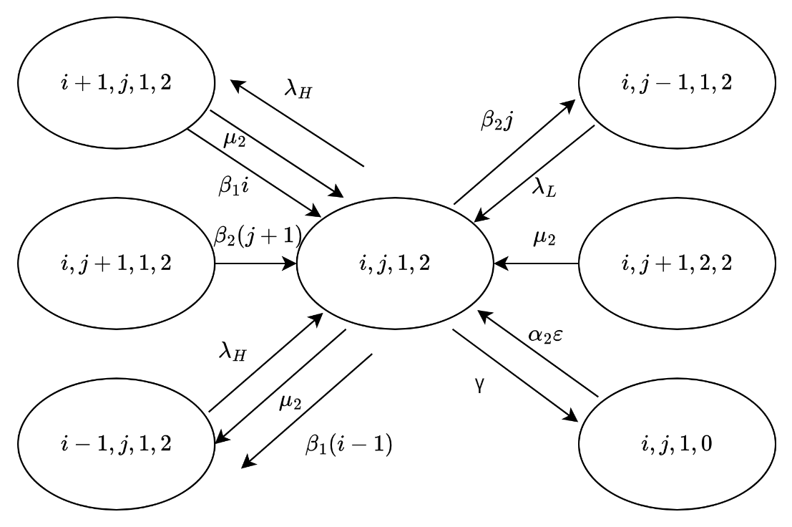

Figure 104 The state transition diagram of

**Case 58: $i=N-R-j,0<j<N-R-1,k=1, l=2$**

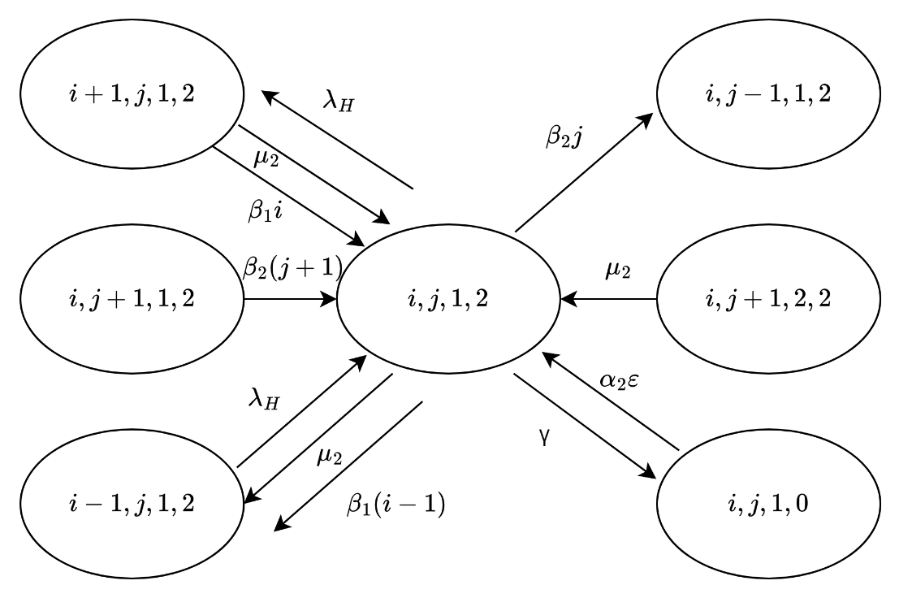

Figure 105 The state transition diagram of

**Case 59: $N-R-j<i<N-j,0<j<N-R-1,k=1, l=2$**

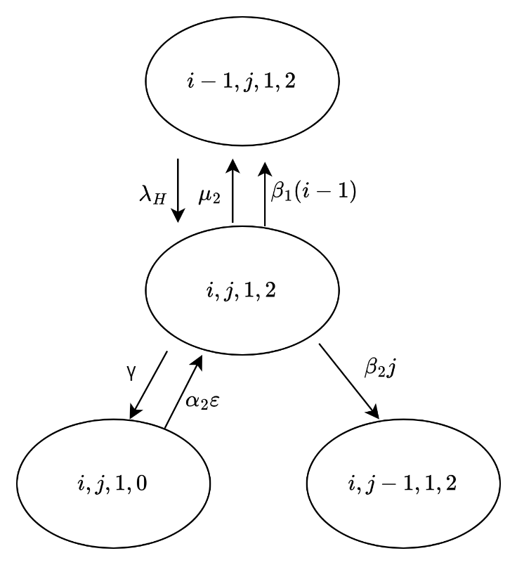

Figure 106 The state transition diagram of

**Case 60: $i=N-j,0<j<N-R-1,k=1, l=2$**

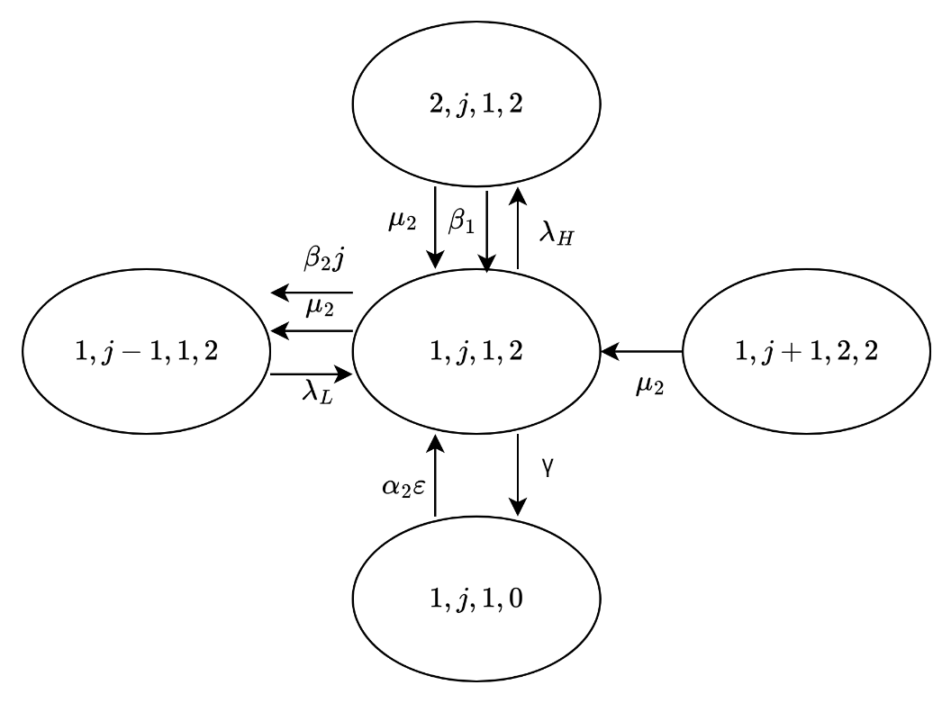

Figure 107 The state transition diagram of

**Case 61: $i=1,j=N-R-1,k=1, l=2$**

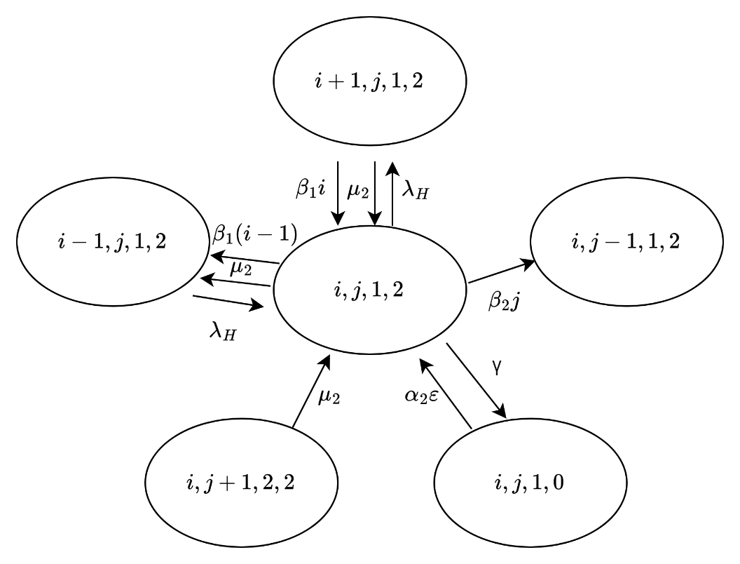

Figure 108 The state transition diagram of

**Case 62: $1<i<N-j,j=N-R-1,k=1, l=2$**

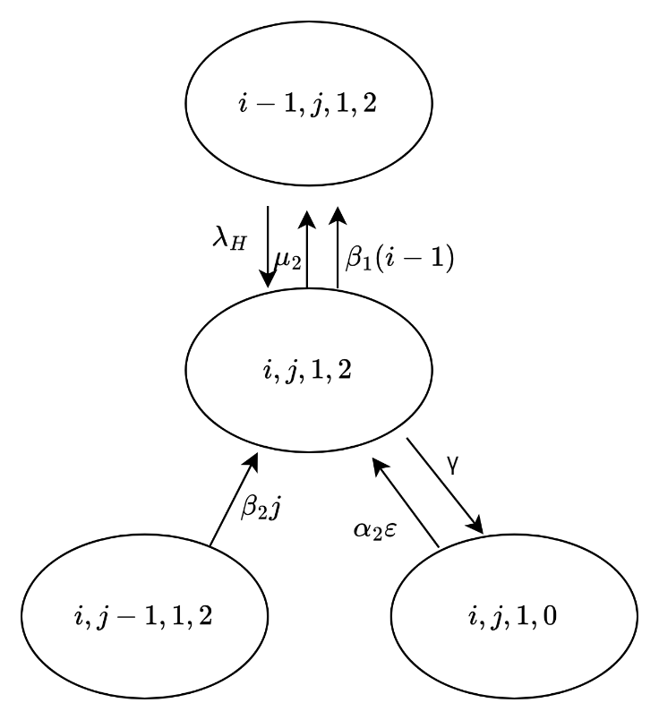

Figure 109 The state transition diagram of

**Case 63: $i=N-j,j=N-R-1,k=1, l=2$**

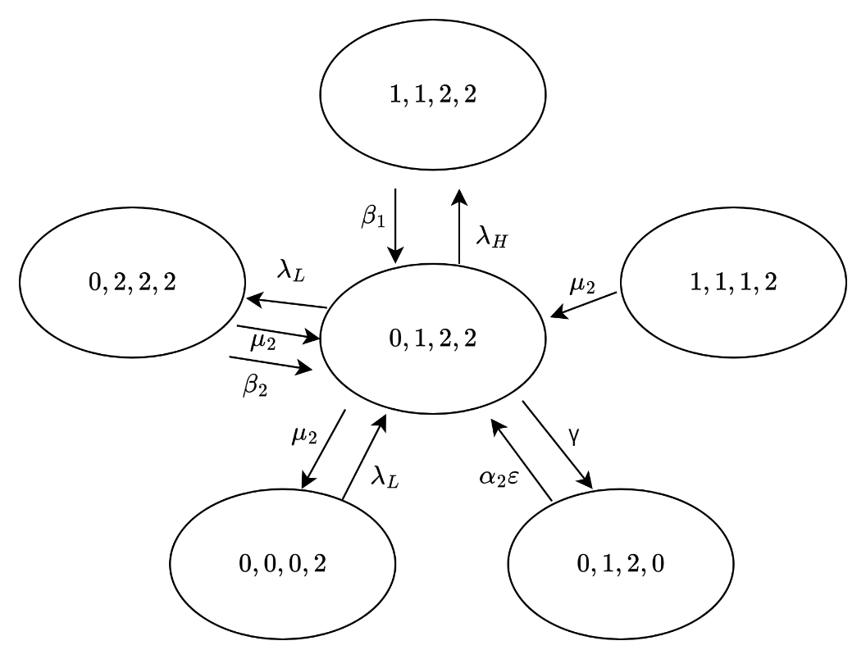

Figure 110 The state transition diagram of

**Case 64: $i=N-j,j=N-R-1,k=2, l=2$**

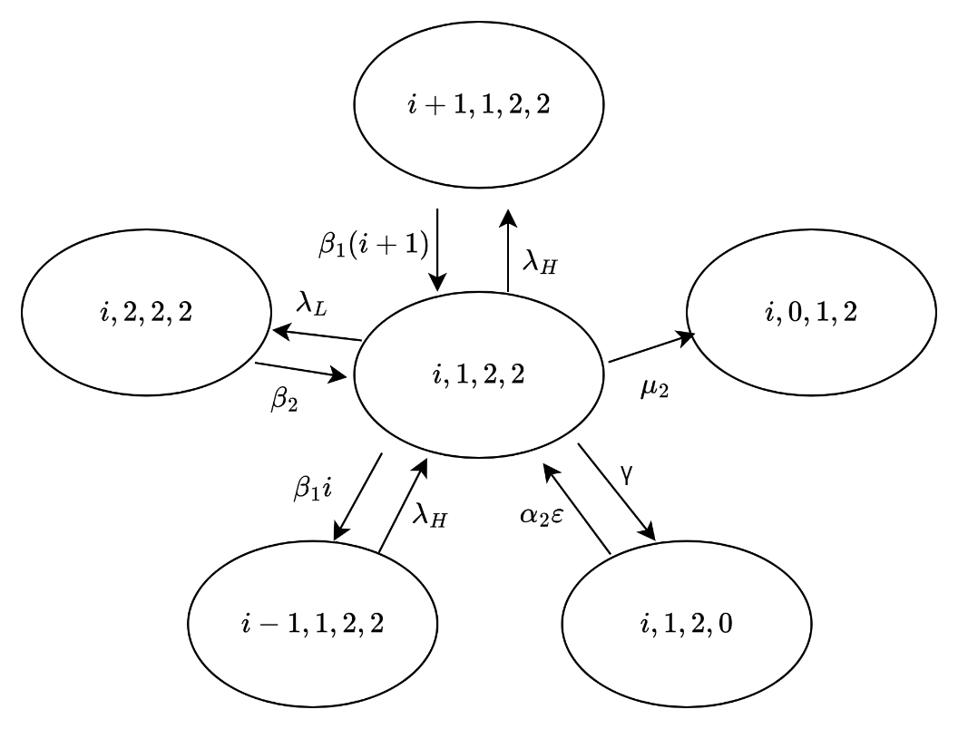

Figure 111 The state transition diagram of

**Case 65: $0<i<N-R-1,j=1,k=2, l=2$**

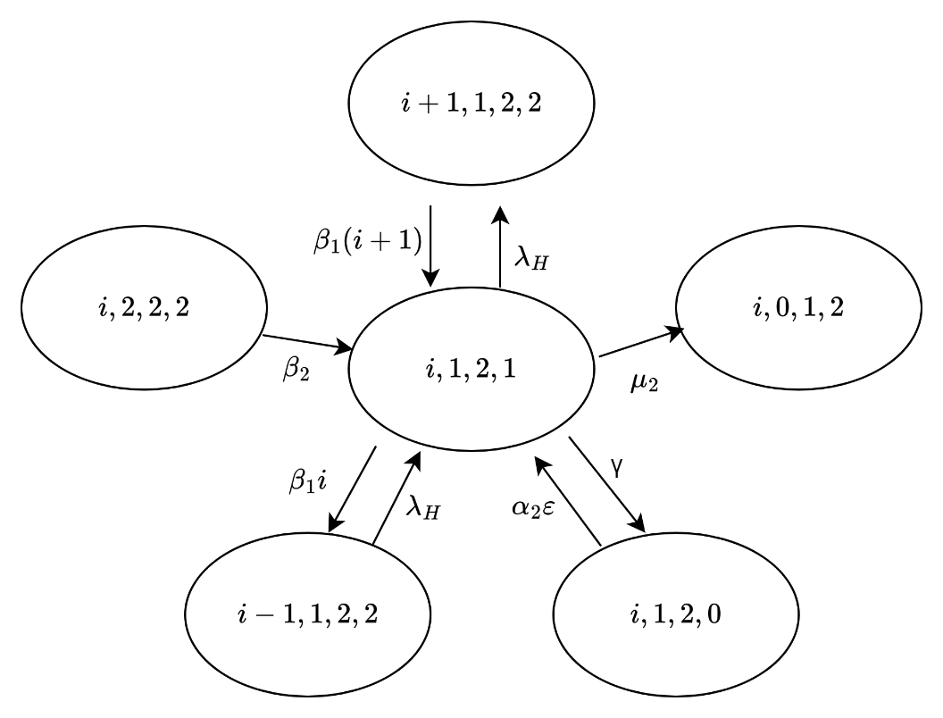

Figure 112 The state transition diagram of

**Case 66: $N-R-1≤i<N-1,j=1,k=2, l=2$**

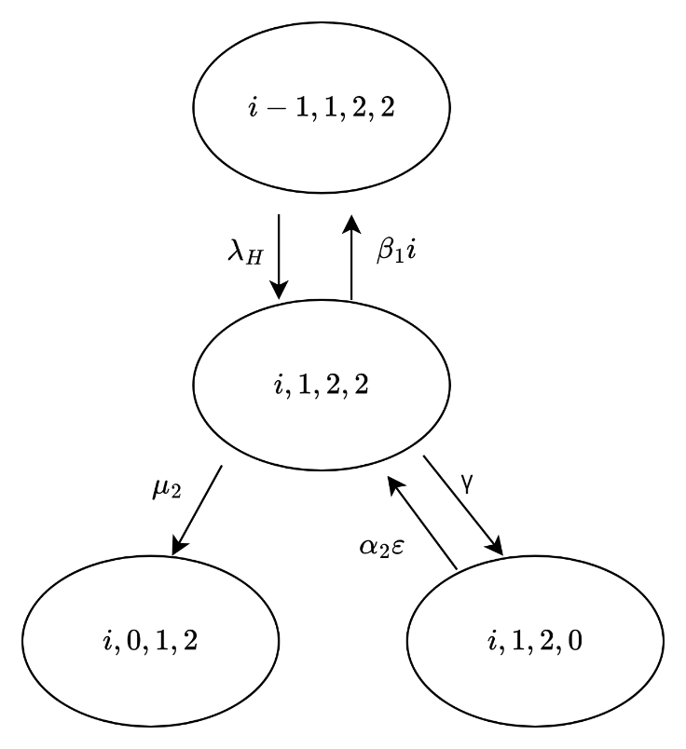

Figure 113 The state transition diagram of

**Case 67: $i=N-1,j=1,k=2, l=2$**

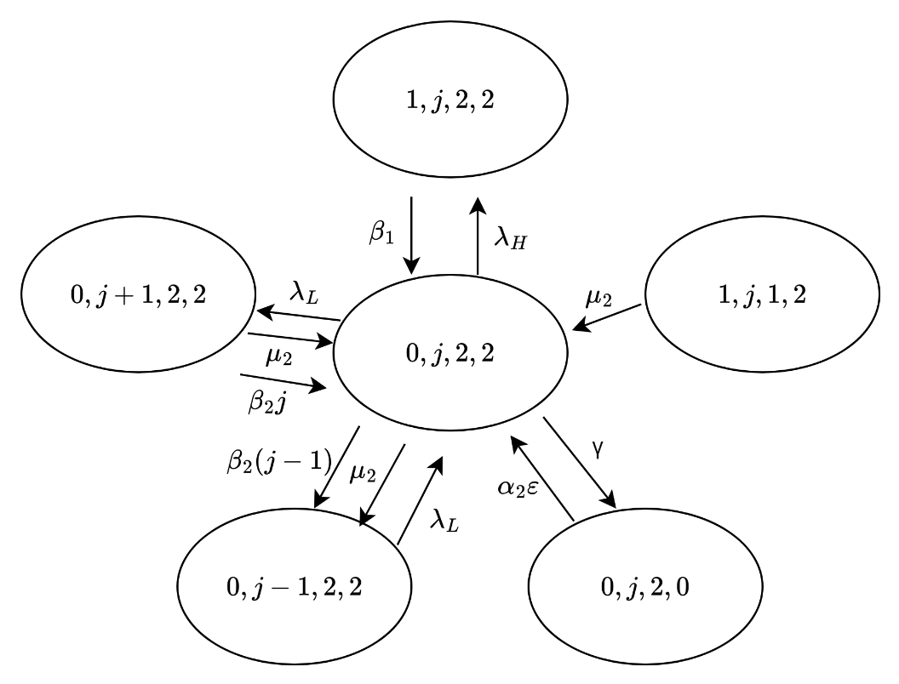

Figure 114 The state transition diagram of

**Case 68: $i=0,1<j<N-R,k=2, l=2$**

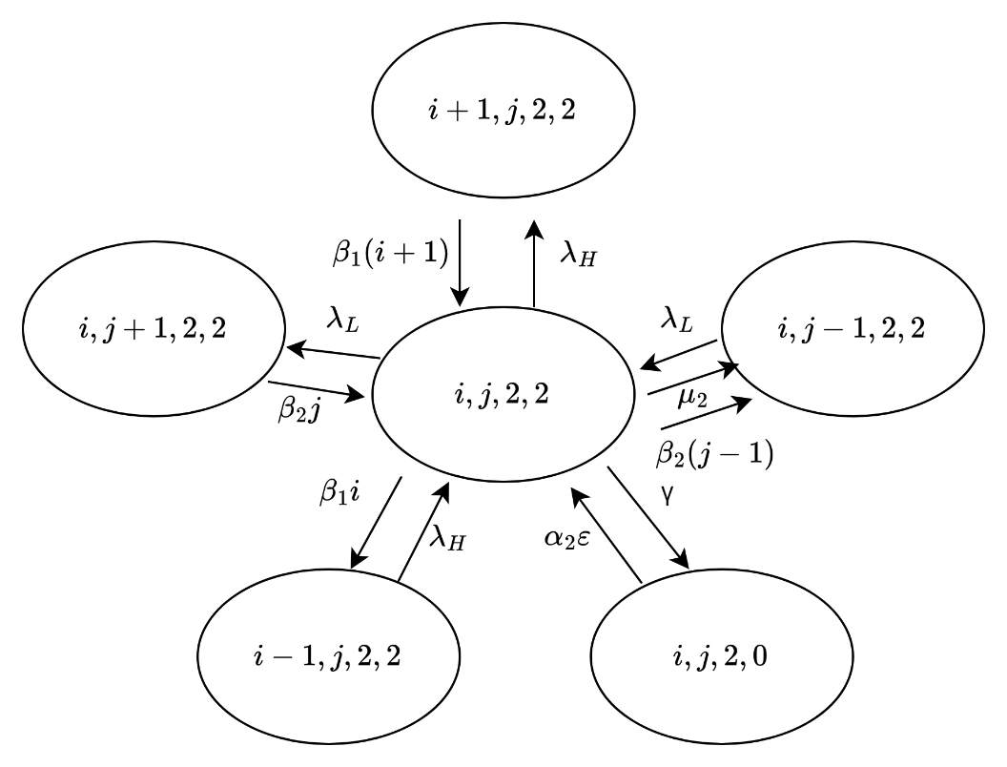

Figure 115 The state transition diagram of

**Case 69: $0<i<N-R-j,1<j<N-R,k=2, l=2$**

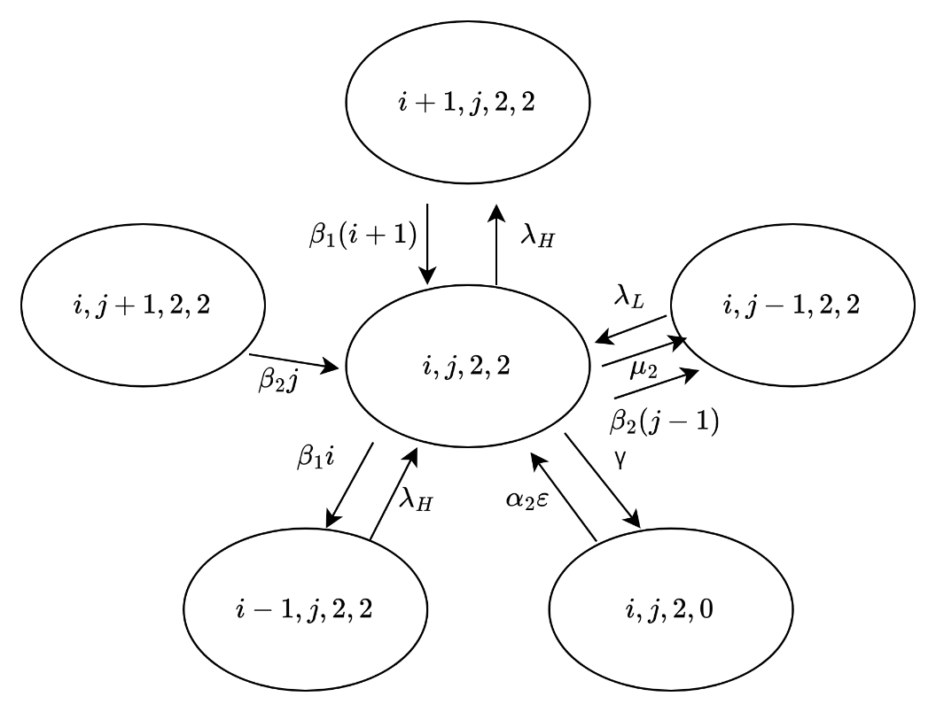

Figure 116 The state transition diagram of

**Case 70: $i=N-R-j,1<j<N-R,k=2, l=2$**

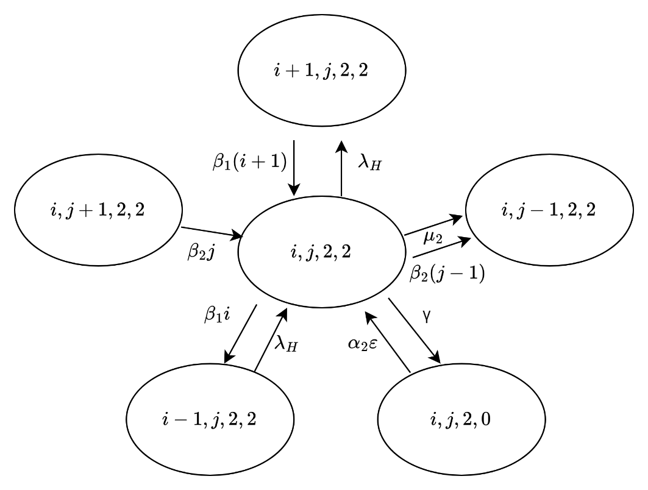

Figure 117 The state transition diagram of

**Case 71: $N-R-j<i<N-j,1<j<N-R,k=2, l=2$**

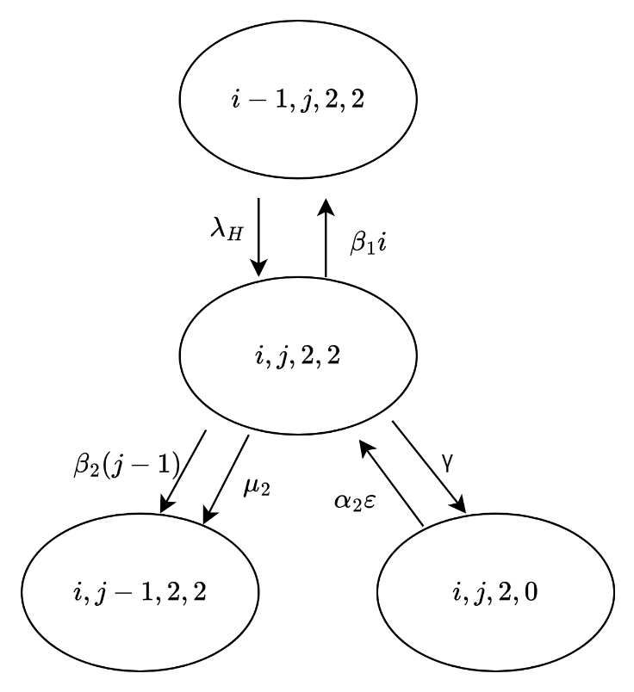

Figure 118 The state transition diagram of

**Case 72: $i=N-j,1<j<N-R,k=2, l=2$**

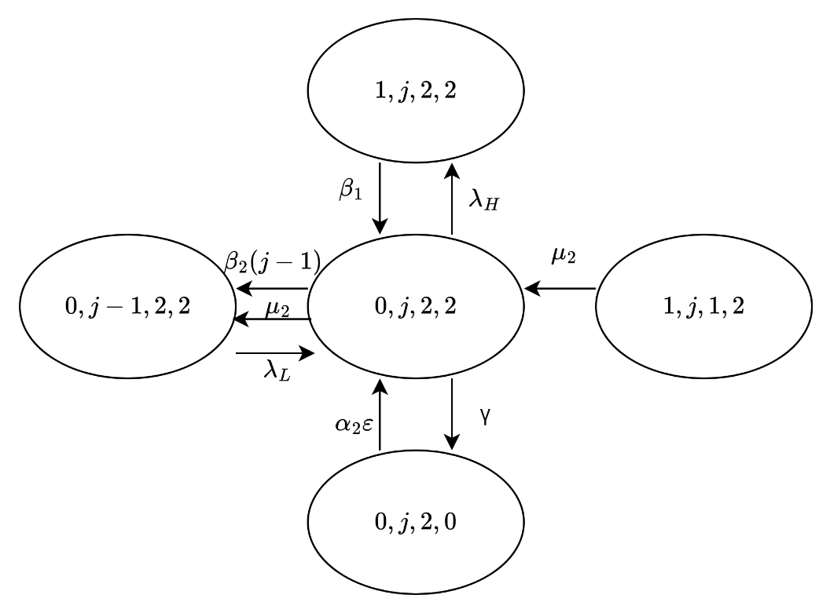

Figure 119 The state transition diagram of

**Case 73: $i=0,j=N-R,k=2, l=2$**

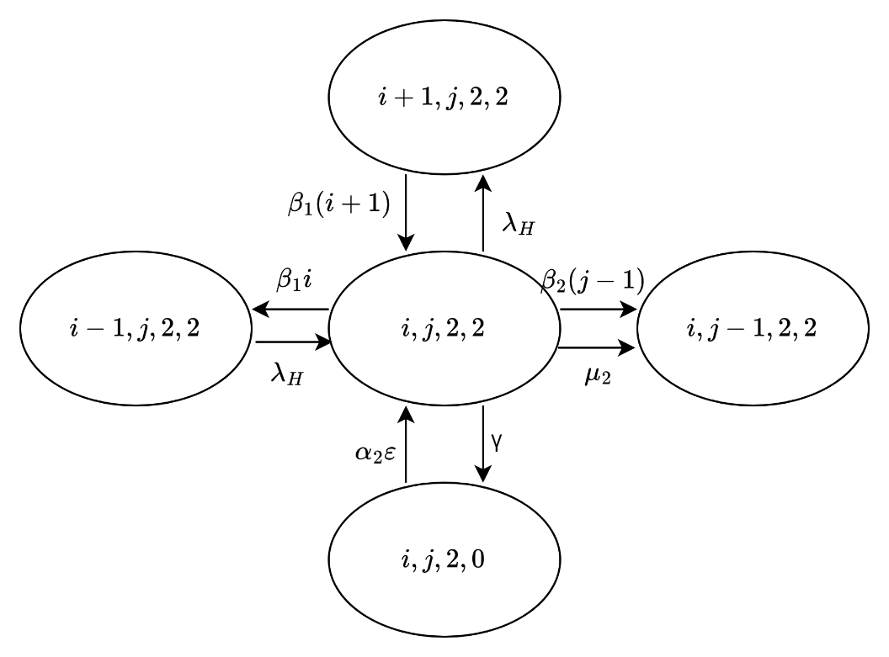

Figure 120 The state transition diagram of

**Case 74: $0<i<N-j,j=N-R,k=2, l=2$**

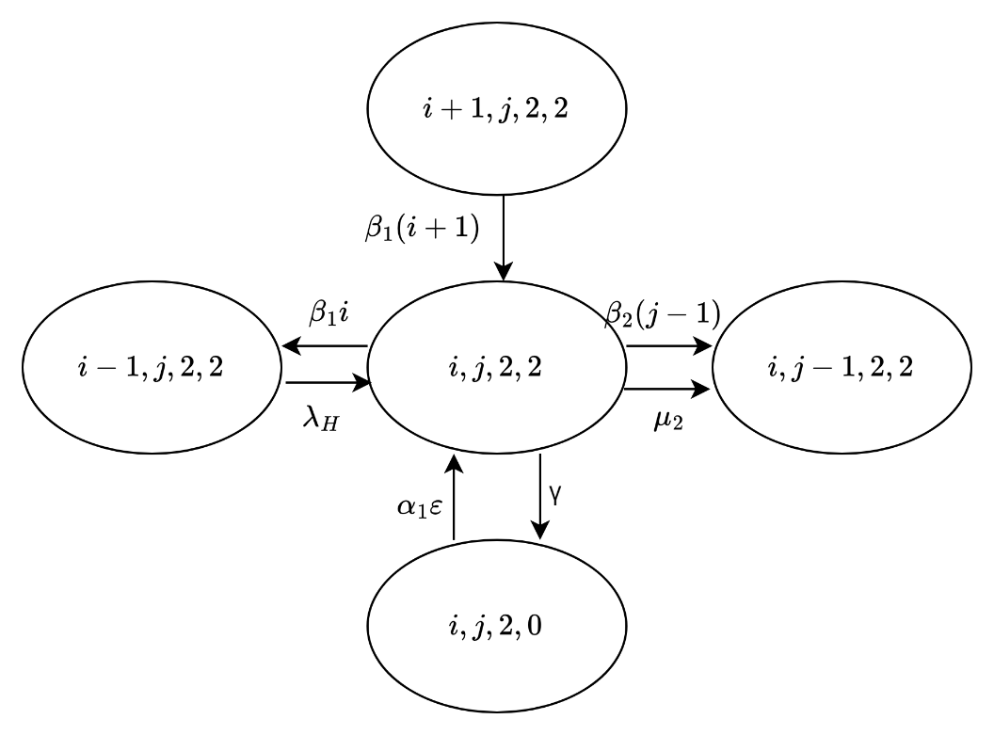

Figure 121 The state transition diagram of

**Case 75: $i=N-j,j=N-R,k=2, l=2$**